Senior Reading & Writing
Spring 2026

This course is structured in five three-week blocks, moving between reading and writing classes as so:
Weeks 1-3: Reading: Boy in the Striped Pyjamas
Weeks 4-6: Writing
Weeks 7-9: Reading: The Outsiders
Weeks 10-12: Writing
Weeks 13-15: Reading: A Monster Calls

Reading Course
For our reading classes together over this term, we will be exploring each book in three lessons, with the first offering a general overview, the second delving into the stylistic and narrative elements of the writing and the final lesson offering the students an opportunity for their own creative interpretations of the book alongside learning skills for close textual analysis, with particular attention paid to literary techniques and structural devices. These lessons are designed to help the students develop new frameworks through which to read and understand literature, equipping them with the vocabulary with which to discuss themes, genre and morals.
Lesson 1: Introduction & Context
In lesson 1 we will be starting our introductory work on the novel, where the class will begin by evaluating their feelings towards the book and the ways in which they felt the author told a powerful story. In these first lessons, our focus is on context and background, learning about the historical, authorial and literary background that the book is set against. We learn about the intentions and lives of the authors and often about what the book reflects of the society it stems from. The class will also be given time to ask any questions they had about the book and to give their opinions on how the story, characters and themes made them feel.
Lesson 2: Genre, Theme & Deeper Meaning
In lesson 2 we will dive further into the novel, thinking about the perspective of the book and the way themes, messages and genre are used. We will develop a framework of themes to work with, identifying where and how thematic ideas make the reader relate to and empathise with the characters. We will think about the perspective of the novel, discussing how narrative voice can influence how a story is told. The students will be encouraged to think about genre and how the conventions and expectations attached to certain genres shape the characterisation, symbolism and plot of a novel. Finally, the class will have an opportunity to consider elements particular to each book, such as the deeper meaning below the surface, any literary techniques used and how the book delivers what it wants to say.

Lesson 3: Plot & Structure
In lesson 3 we will dig into the structure of the text, discussing the ways in which the plot has been formed and how this fits into classical formulations of dramatic action. The students will be encouraged to think about genre and how the conventions and expectations attached to certain genres shape the characterisation, symbolism and plot of a novel.

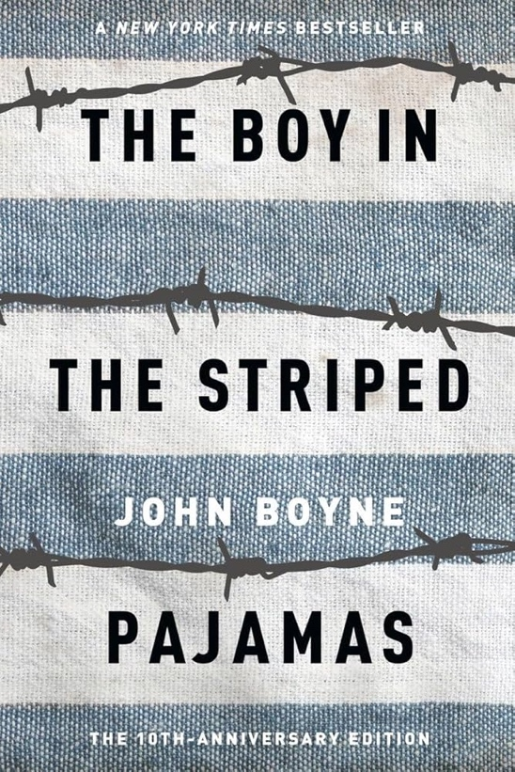
List of Books for Spring Term
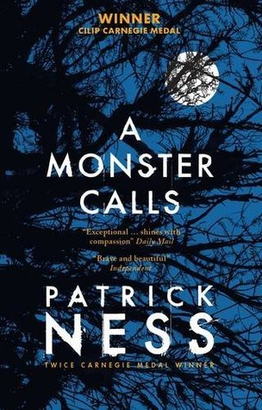
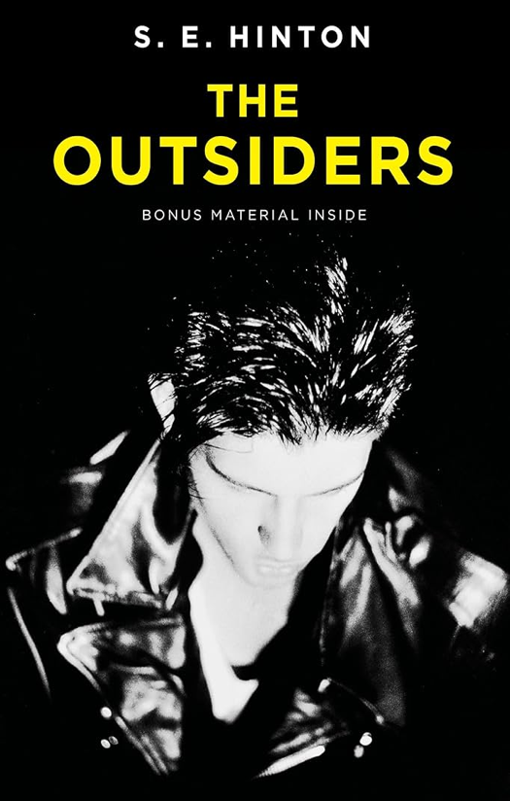

Writing Course
Writing Block 1
Week 4: Core Creative Skills: Students explore how voice is created through word choice, sentence length, and attitude. After analysing short extracts with distinctive voices, students write a personal piece titled “This is how I see it”, choosing a tone (angry, amused, reflective, detached).
Week 5: Making the Ordinary Strange: Students write about an ordinary object, place, or routine, but must make it feel unfamiliar or symbolic. Techniques such as metaphor, zoomed‑in description, and sensory detail are modelled.
Week 6: Playing with Poetry: Students are introduced to poetry as experimentation rather than rules. Through shared reading of contemporary and classic poems, they explore imagery, simile, metaphor, and sound devices. Students create a short poem based on an abstract idea (e.g. fear, freedom, jealousy) made concrete through images.

Writing Block 2
Week 10: New Forms of Argument: Students write a short argument defending an unpopular, silly, or unexpected position (e.g. Why homework should be illegal, Why Mondays are misunderstood). Emphasis is on reasoning, not seriousness- defending with flourish and verve.
Week 11: How to Think Like an Editor: Students learn about editing and re-drafting skills, how to streamline their ideas until there is no fat left. They will choose one previous piece and learn how to edit it purposefully. Lessons focus on cutting weak phrasing, improving verbs, varying sentence openings, and clarifying ideas.
Week 12: Mini Mock: In the final week of writing, students will complete a timed creative writing task, either a short narrative or descriptive response to a new visual or situational prompt. This will be marked with personalised feedback and targets for their writing goals.

