Junior Reading & Writing
Spring 2026

This course is structured in three-week reading blocks and two-week writing blocks, moving between reading and writing classes as so:
Weeks 1-3: Reading: Alex Rider
Weeks 4-5: Writing
Weeks 6-8: Reading: Goodnight Mr Tom
Weeks 9-10: Writing
Weeks 11-13: Reading: Inkheart
Weeks 14-15: Writing

Reading Course
For our reading classes together over this term, we will be exploring each book in three lessons, with the first offering a general overview, the second delving into the stylistic and narrative elements of the writing and the final lesson offering the students an opportunity for their own creative interpretations of the book alongside learning skills for close textual analysis, with particular attention paid to literary techniques and structural devices. These lessons are designed to help the students develop new frameworks through which to read and understand literature, equipping them with the vocabulary with which to discuss themes, genre and morals.
Lesson 1: Introduction & Context
In lesson 1 we will be starting our introductory work on the novel, where the class will begin by evaluating their feelings towards the book and the ways in which they felt the author told a powerful story. In these first lessons, our focus is on context and background, learning about the historical, authorial and literary background that the book is set against. We learn about the intentions and lives of the authors and often about what the book reflects of the society it stems from. The class will also be given time to ask any questions they had about the book and to give their opinions on how the story, characters and themes made them feel.
Lesson 2: Genre, Theme & Deeper Meaning
In lesson 2 we will dive further into the novel, thinking about the perspective of the book and the way themes, messages and genre are used. We will develop a framework of themes to work with, identifying where and how thematic ideas make the reader relate to and empathise with the characters. We will think about the perspective of the novel, discussing how narrative voice can influence how a story is told. The students will be encouraged to think about genre and how the conventions and expectations attached to certain genres shape the characterisation, symbolism and plot of a novel. Finally, the class will have an opportunity to consider elements particular to each book, such as the deeper meaning below the surface, any literary techniques used and how the book delivers what it wants to say.
Lesson 3: Plot & Structure
In lesson 3 we will dig into the structure of the text, discussing the ways in which the plot has been formed and how this fits into classical formulations of dramatic action. The students will be encouraged to think about genre and how the conventions and expectations attached to certain genres shape the characterisation, symbolism and plot of a novel.

List of Books for Spring Term
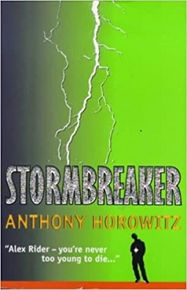
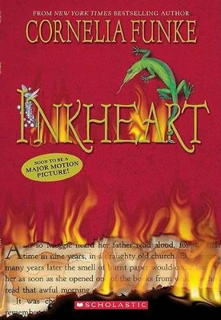
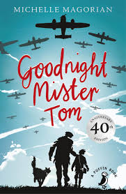

Writing Course
Lessons 4 & 5: Play Writing: In our first pair of lessons, we will focus on playwriting, starting in lesson one with considering the key elements and structure of a play. The students will learn what separates drama from other types of writing, thinking about what can and cannot be communicated in the same way when working from a script. This will be an introduction to the format and style of play writing where we will consider the different elements that can be found on the stage (i.e., audience awareness, costume, lighting, sound, stage directions). The students will be encouraged to think outside of the box in how they frame their own play scripts, completing some drama exercises in order to understand the genre of drama more fully. The main skills we will be learning in playwriting are to do with how to create and sustain suspense and drama, the names and functions of various dramatic terms and how to play with format and style in their writing.
Lessons 9 & 10: Poetry Writing: In our second pair of lessons, we will be looking at the genre and tradition of poetry writing, considering the myriad of different poetic styles and considering which best suit the students’ passions and ideas. We will consider the importance of features such rhythm and meter, rhyme, metaphors and similes etc., using the work of famous poets to study what actually makes a poem a poem and how we can define what poetry truly is. The students will be given the opportunity to write using multiple different poetic forms (limericks, sonnets, free-form, haiku) and will also complete work on writing based on character and theme. The students will be encouraged to think lyrically about poetry writing, finding music that they enjoy and considering the closeness between the two genres. The main skills we will be learning in poetry writing are to do with the importance of figurative language, using themes effectively & creatively, how to use word sound and rhythm to add texture, and how to identify the best structure to use in a poem.
Lessons 14 &15: Comedic Writing: In our final set of lessons, we will be focusing on comedic writing, looking at the way humour can be used to many different effects in crafting a story or piece of writing that grips and entertains the reader. The students will be encouraged to think about what they find funny and why, considering how to use different techniques, such as the unexpected, to write comedically. We will also look at differentiating different types of comic writing, trying our hand at comedies of error, slapstick and sarcasm. We will discuss the subjective nature of humour and ask if anything is universally funny, whilst also discovering how to come up with their own unique and ridiculous characters, such as in Shakespearean comedy, version of comedic tropes such as mistaken identity, and vivid descriptions of ridiculous and entertaining antics. The main skills we will be learning in comedic writing are to do with the importance of timing and pace in writing, how to write with an authoritative and confident tone, connecting with the audience or readership, and how to create compelling and unique characters.

