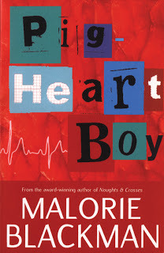Pig-Heart Boy

Lesson One: Background: context and the author:

Learning Objective: To explore the novel’s main scientific and philosophical concepts, as well as how Malorie Blackman is an influential children’s author.

Part One: Students will look at the key ideas surrounding animal organ transplantation, including contemporary science advancements, protest, animal rights, and unwanted fame. We will look at recent scientific progress surrounding pig heart transplantation, as well as assessing how we feel about the subject matter.

Part Two: We will explore the works of Malorie Blackman and how she writes on a particularly broad range of themes. Students will discuss which of Blackman’s books they would also be interested in reading, and where there is thematic crossover.

Homework: Students will write a short piece debating why it is meaningful that a pig’s heart is chosen, in the context of this lesson’s discussions.

Lesson Two: The Characters

Learning Objective: To analyse the range of characters and how they each contribute to the novel’s thematic complexity.

Part One: Students will explore the novel’s main as well as minor characters, with a particular focus on analysing the differences between the children and adults. Students will spend time discussing the ‘pig-heart boy’ Cameron, who represents a wide range of themes and is at once a defined symbol, as well as character.

Part Two: Students will discuss the novel’s blurring of protagonists and antagonists, before writing on which character they believe is the most memorable.

Homework: Students will write a short piece in which they create their own character about to receive a pig heart transplant. Students will focus on shaping the character’s emotional response.

Lesson Three: Themes and Scenes:

Learning Objective: To explore the novel’s main themes and scenes, as well as how they interrelate with contemporary society.

Part One: Students will discuss the novel’s broad range of themes, spanning family and scientific innovation, friendship and social pressure. Students will debate which theme they think is most resonant within the novel, as well as which theme(s) they think is the most complicated to understand.

Part Two: Students will then analyse several excepts within the novel with regards to the themes being expressed, as well as the literary devices used. Students will assess how well they think Malorie Blackman writes about the range of difficult themes in her writing, and whether they would read more of her books.

Homework: To write a short piece on which event in the book was the most impactful with regards to tackling complex themes.