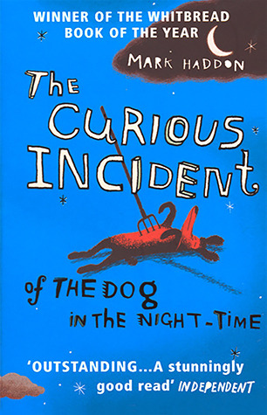The Curious Incident of the Dog in the Night-Time

Lesson One: Background: context, literary form and Style:

Learning Objective: To explore the novel’s literary style and the context, particularly the narrator’s sense of personhood and view of the world.

Part One: Students will firstly analyse the style in which the novel is written, as well as the effect of an author using the first person in a colloquial style. Students will debate to what extent they believe the book has a ‘diary-feel’ to it.

Part Two: We will then explore Mark Haddon’s intentions for the novel with regards to the narrative voice, and how he decided to depict Christopher Boone’s perspective. We will analyse the role of the deemed ‘outsider’ in literary works, and how this character-type offers readers particular insight into societal challenges.

Homework: Students will write a short piece arguing on why they like or dislike the narrative style of the novel.

Lesson Two: The Characters

Learning Objective: To analyse the human characters and also the animal character of Wellington within the novel, examining what they symbolise and contribute to the novel’s complex layers of meaning.

Part One: Students will study the human characters within the novel, and how they each contribute to different themes and ideas, such as betrayal, perspective and marginalisation. Particular attention will also be placed on analysing Haddon’s construction of family within the novel, where students will debate what his key messages are in depicting this crafted, dysfunctional unit.

Part Two: Students will then analyse the role of Wellington (the killed dog) and how the dog is both a character and a defining symbol. Students will explore what they think Wellington can symbolise/mean for multiple characters, and why they think Haddon chose a dog.

Homework: Students will write a short piece on what they think differentiates Christopher from other narrators they have encountered in various literatures.

Lesson Three: Themes and Contemporary Society:

Learning Objective: To explore and dissect the novel’s main themes and how they are relevant to the wider world.

Part One: Students will discuss and draw conclusions on the range of themes in the novel, such as family, loneliness, betrayal, escapism and intelligence. We will explore which theme may resonate the most with particular characters, as well as which themes we think Haddon explores particularly sensitively and well, in relation to contemporary society.

Part Two: Students will analyse several excepts, exploring the discussed themes as well as the language and structural devices used, from metaphors to the ‘rule of three’. We will then summarise our exploration on the novel’s themes through watching the trailer to the stage adaptation, assessing how well the themes come through.

Homework: To write a short piece stylistically imitating the narrative voice of Christopher , discussing the theme of either trust, family or the importance of mathematics, and what that means to Christopher.