The Thief Lord:

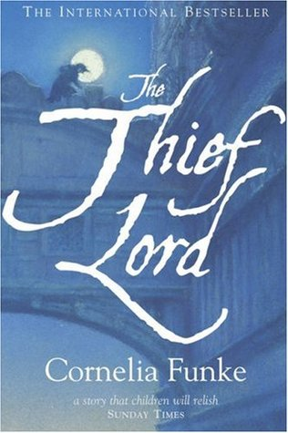

Lesson One ⸺ Setting and Fantasy Realism:

Learning Objective: To analyse the use of setting in *The Thief Lord,* and to explore the interconnections of space with the genre of fantasy realism.

Part One: Students will study the Italian city of Venice, its quirks and its socio-cultural aspects which make it a city fascinating for readers. Students will write a small paragraph on what makes Venice a unique city, as well as how this makes the book’s events increasingly dramatic and vivid.

Part Two: Students will learn about the genre of fantasy realism, its origins and famous authors of the genre. Students will identify tropes and themes of the genre within the novel, discussing how these ideas make Funke’s writing more engaging and different to a solely fantasy novel.

Homework: Students will write a short description of Venice, using literal as well as metaphorical imagery, and a range of other effective literary devices.

Lesson Two ⸺ Character Development:

Learning Objective: To explore and evaluate the personalities and actions of a range of characters.

Part One: Students will analyse a range of characters, with a focus on assessing the language/ literary devices used in selected excerpts. Students will also discuss the complicated nature of Funke’s characters, who tend to have both admirable but also negative traits.

Part Two: Students will have a more creative task next, creating their own cinema child member and follower of Scipio. This will involve talking about how their character will differ from those existing, as well as using aforementioned literary devices to write a short paragraph on their character’s personality.

Homework: To write a short paragraph on their character taking a walk through Venice on a Sunday morning.

Lesson Three ⸺ Themes and Imagery:

Learning Objective: To interpret and discuss varying themes and uses of imagery within the text.

Part One: Students will assess and discuss 4-5 themes, discussing how Funke handles them throughout the book, as well as which characters resonate most with a particular theme. Students will write a short paragraph on one theme and why it impacts them the most.

Part Two: Students will analyse several excerpts within the book of key spaces, such as the cinema. Students will also try and decipher symbols within these spaces, assessing how obvious or hidden they appear.

Homework: Students will write a short piece on whether they think Cornelia Funke’s book has taught them any valuable life lessons (as seen within the different themes).