*The Hitchhiker’s Guide to the Galaxy:*

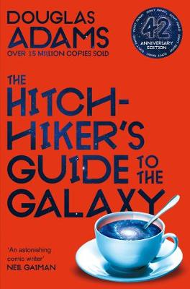

Lesson One – Genre and Style:

Lesson Objective: To understand the context and style of *The Hitchhiker’s Guide to the Galaxy.*

-Part 1: Students will explore the genre of science-fiction and the developments made up within this literary area throughout the 20th century. This will include analysing past novels and understanding which components make up the genre, continuing to captivate readers. This part of the lesson will include assessing past works by famous science-fiction writer H.G. Wells and exploring why this genre became gradually more popular.

Part 2: Students will analyse the science-fiction elements and tropes within Adams’ novel, deciding which components we think work best, and which may be slightly cliché. Students will also explore how they could write their own science-fiction novel, inspired by *The Hitchhiker’s Guide.*

Homework: To write a short description on a science-fiction world of the student’s own ideas within the lesson.

Lesson Two- Character Development:

Lesson Objective: To analyse the characters and explore their symbolic roles within the novel.

Part 1: Students will explore the novel’s protagonists and several symbolic minor characters, assessing their strengths and weaknesses. Students will then reflect on whether they admire them or find them frustrating, as well as why they are important within the book.

Part 2: We will then analyse multiple excerpts from the book, where we will look at the language used by Adams in order to skilfully create memorable characters (from humans to aliens). We will also link this part of the lesson to the first lesson, looking at what science-fiction tropes these characters embody.

Homework: To write a piece on one’s favourite character, using the PEE paragraph structure to argue to explain why they are particularly special.

Lesson Three- Action!:

Lesson Objective: To explore and investigate the meaning in the novel’s most important events.

Part 1: To read excerpts of selected, main events within the novel and to analyse how/why they are well-written (concerning style and language) and secondly, how they engage the reader.

Part 2: To discuss and debate the ending of the novel, and whether or not students thought it was well-crafted and satisfying. Students will discuss what they think a sequel could look like, and how they would make it an exciting read, looking at structure, character construction and themes within science fiction. We will then analyse how Adams constructs later books in the series.

Homework: To write a paragraph on a more frightening scene in the novel, and what makes it frightening (discussing language, style, structure and imagery).