A Tale of Two Cities:

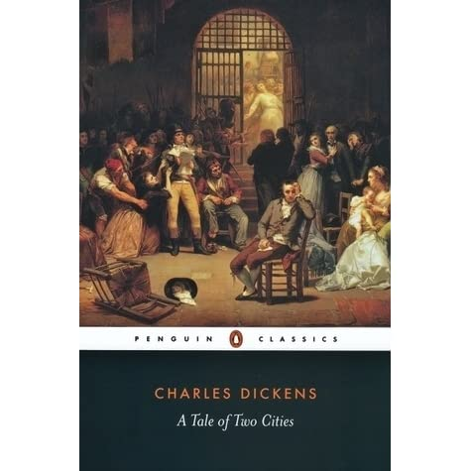

Lesson One- Historical Context and the Role of Place:

**Learning Objective:** To understand the historical context of *A Tale of Two Cities*, as well as the life of Charles Dickens*.*

-Part 1: We will look at the historical context surrounding the novel, being the Victorian period as well as more specifically, the French Revolution. We will discuss the differences between France and England during the 19th century, as well as the importance of the interplay between the two countries.

Part 2: We will assess the life and times of Charles Dickens, discussing how his own experiences affect his novels, thematic interests and writing style. We will also think about why the French Revolution fascinated Dickens.

Homework: To write a brief summary and argument on why using different locations in a novel is effective.

Lesson Two: Character Development:

Lesson Objective: To analyse the characters and explore their symbolic roles within the novel.

Part One: To ask students to write a short paragraph on their favourite character, after having created a mind-map comprised of selected adjectives which best describe the selected person. Students will then compare answers, before discussing their least favourite character.

Part Two: Students will debate why minor characters are important to a novel, before then discussing the roles of characters such as Jeremy Cruncher and Miss Pross. Students will be asked to imagine what a novel would be like without minor characters, and to also make up their own minor character for the novel.

Homework: To write a short description of one of the novel’s protagonists, using literal as well as metaphorical imagery.

Lesson Three: Themes and Symbols:

Lesson Objective: To explore, debate and discuss the meanings of the main themes and symbols.

Part One: To analyse the themes of the novel, debating which one is the most important and relevant overall. Students will write a short paragraph on which theme they think helps them learn the most, in the context of the novel’s historical events.

Part Two: A selection of symbols from the novel will be chosen; students will be asked to discuss the wide variety of meanings within them and how they interconnect with characters, such as the broken wine cask. Students will also explore why symbols help to make a novel more exciting and also, valuable to read

Homework: Students will write a short paragraph discussing the importance of Revolution or Justice in the novel.