**To Kill a Mockingbird: Lesson 1**

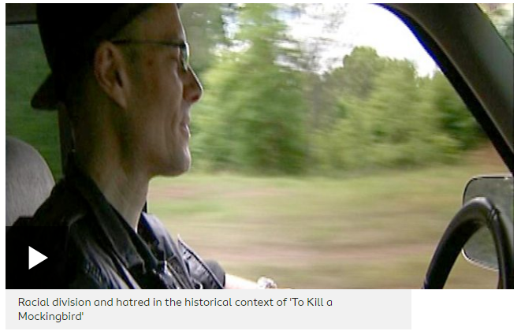

**Lesson Objectives:** This lesson aims to introduce *To Kill a Mockingbird* to the students and consider the context and history behind the text. By the end of the lesson the students should:

1. Understand the context of *To Kill a Mockingbird* and the effect it has on the novel.
2. Be able to understand the history of Deep South America and its importance to our understanding of the novel.
3. Be able to discuss the theme of racism, dealing with it in a sensitive and mature way.

Plan:

* Begin the class with a general discussion of the book. What did the students enjoy about the book? What did they not enjoy? What was interesting about the way the book was written? Ask the students to note down three things they liked and three things they did not and discuss this as a class.
* Ask the class where and when the book is set. What do they know about the Deep South in the 1930s?
* Watch the video about racial division and hatred in the context of the novel.
* Introduce some facts about slavery and its legacy. Remind the class that slavery was only abolished 70 years before the events of the book take place.
* Discuss the racial slurs used in the book. Talk about how to treat these sensitively and understand them in context.
* Open a discussion on the theme of racism. Have they read any other books where this is a theme? Why is it important to discuss?
* Consider the case at the centre of the plot. How does the theme of racism figure into how this is handled?
* Ask the class to write down their answer to this question: why do you think Harper Lee chose to tell this story?

Homework:

Read the article about Harper Lee’s only given interview and conduct some more research into her life. What can this tell us about why she might have written *To Kill a Mockingbird?* Come to next lesson with your research prepared.

**To Kill a Mockingbird: Lesson 2**

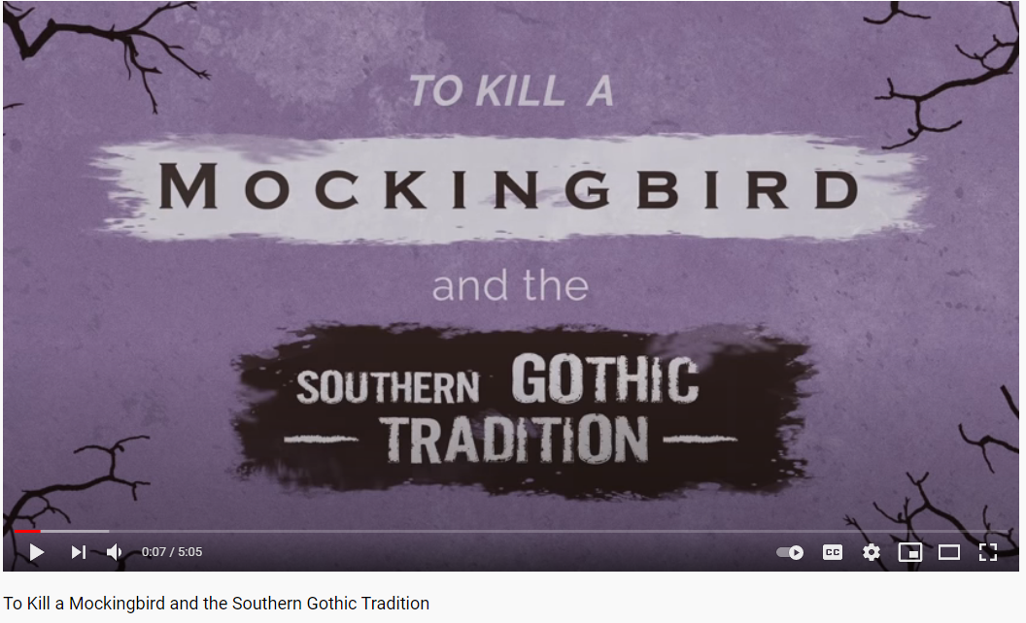

**Lesson Objectives:** This lesson aims to enable the students to dig deeper into the novel and consider the central themes and motifs used. By the end of the lesson the students should:

1. Be able to name at least three central themes of the story and explain the way in which these themes are explored and developed.
2. Be able to talk confidently about author intent, thinking about why Harper Lee wrote the book she wrote.
3. Be able to consider the genre of the novel, identifying moments the novel conforms and subverts its genre, whilst also interpreting this creatively.

Plan:

* As a starter activity, ask the students what the moral of the story is. Emphasise to them that they need to get to the very core of the story, what is at the heart of this story?
* Going back to their homework research, has their view of why Harper Lee wrote this story changed? What do they think may have been her intentions behind the novel?
* Remind students of the concept of a semantic field. Brainstorm what would be in the semantic field encompassed within *To Kill a Mockingbird,* what recurring symbols, themes and motifs can they find in the book (i.e., justice, racism, community)?
* Discuss the concept of genre in this novel, asking the class to guess at least two genres the book could be a part of. Introduce the three central genres (courtroom drama, southern gothic and bildungsroman)
* Watch the video on the Southern Gothic genre and ask the class to consider what elements of *To Kill a Mockingbird* can be described that way.
* Introduce the class to an extract of *To Kill a Mockingbird.* Ask them to pick an alternative genre and re-write the extract in the genre of their choice. Introduce the ideas around genre convention, asking them to think deeply about how to include this in their work.

Homework:

What do you think the title of the book means? If you had to pick a different title for the book, what would you call it and why?

**To Kill a Mockingbird: Lesson 3**



**Lesson Objectives:** This lesson aims to enable the students to think more broadly about the way in which *To Kill a Mockingbird* is written. By the end of the lesson the students should:

1. Be able to talk about the symbolism in the book and how it is developed.
2. Be able to discuss and understand notions of justice and law in the book.
3. Be able to compare the text of the novel to similar and related texts.

Plan:

* Start the lesson by introducing the key symbol of the book- the mockingbird. Watch the video on exploring symbolism in order to evaluate and analyse this symbol.
* Consider other key symbols in the book and ask the class to consider their meaning in the context of the video we just watched. They should then come up with their own symbol to represent a theme of their choice within the book.
* Introduce the idea of the primacy of justice, particularly with reference to this novel. Ask the class to complete the ‘justice survey’, thinking about how they relate justice to their own lives and how this differs from the book.
* Discuss and analyse the judicial quotation from 1944. What do they think this means?
* Introduce the case of the Scottsboro Affair, thinking about how this might contradict our assumptions about justice and the legal system. How can we fit our understanding of racism into our understanding of the law? Introduce the idea of a ‘courtroom lynching’.
* Read by speech by Bryan Stevenson. Does this explore similar themes to the book? Discuss the idea he raises about certain stories being neglected. What does this tell us about *To Kill a Mockingbird?* What does this tell us about American values?
* Ultimately, *To Kill a Mockingbird* illustrates the failure of justice, not the success of it. Do you agree or disagree with this statement? Conduct a debate on this question.

Homework:

Write a short speech from the perspective of a fictional lawyer, thinking about your character’s views on justice, the law and morality. You should utilise rhetorical devices to create a strong argument and think about persuasive speech writing techniques.