**The Wolves of Willoughby Chase: Lesson 1**

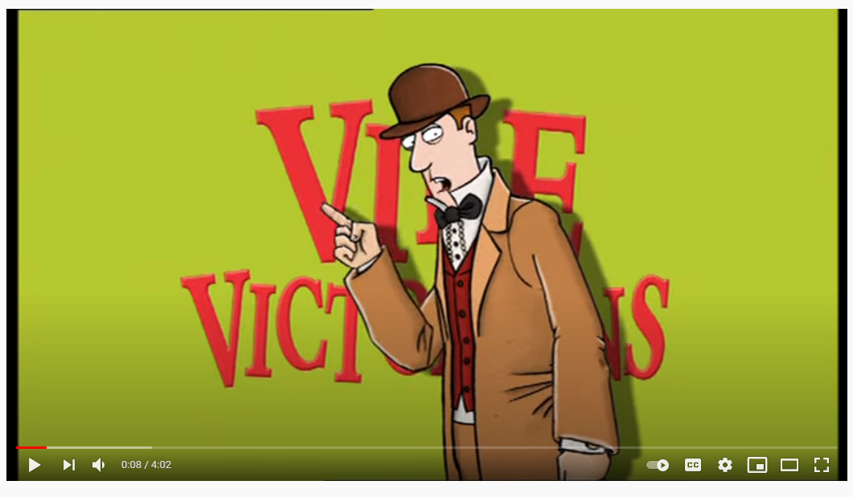

Plan:

* As a starter activity, ask the class if they know where and when the book is set. Introduce the idea of an alternative England. What is different about the England in the book?
* Ask the class what they know about England in the 1800s. Watch the Horrible Histories video on what it was like to be a child back then.
* What does it mean to be an orphan? The class should brainstorm words that they associate with the idea of being an orphan. Why do they think so many books include orphans?
* Explore photographs and paintings of Victorian workhouses and ask the class to describe what it must have been like to have been there. What emotions do they evoke? Compare with pictures and paintings of the interiors and exteriors of stately homes. What must it have been like to live there? How do the two settings compare? How would you feel if you had to move from one to the other? How would you behave in each setting?
* Discuss the idea of children being forced to work and complete hard labour. The class should imagine have of them have to give a speech to Parliament in 1832 arguing for why this should be made illegal, and half of them have to defend it. Split the class into groups and give them some persuasive techniques to help them write their speech. Each group should present their arguments in debate style. Show them a clip of Parliament before hand so they understand the structure of a Parliamentary debate.
* As a finishing activity, the class should write a one-sentence summary of the book. What would be the key message of the book that they would want to get across?

Homework:

* Conduct some research on 1800s England. You can look at questions such as: What was the role of a governess in the 1800s? What toys would a wealthy child have in the 1800s? What were Victorian homes for the wealthy like? How were girls expected to behave in the 1800s? What was an orphanage like in the 1800s? How were children treated and what were they expected to do? What became of many orphans when they left orphanages? You can create a mini-fact file on your findings.

**The Wolves of Willoughby Chase: Lesson 2**

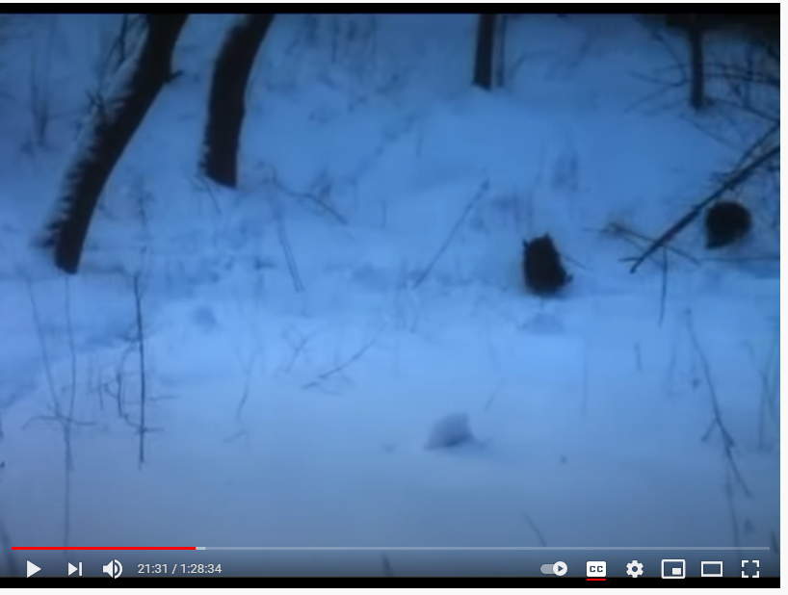

Plan:

* Consider the wolves in the novel. What effect do they have? Why might the author have included them? Do they symbolise or represent anything?
* Watch the clip from the film. What feelings do the wolves evoke? How do they make the audience react to the scene? Ask the class to use the wheel of emotion to come up with some high-level vocab to describe how this scene makes them feel.
* Ask the class to consider the title of the novel. What character could the word “wolves” represent? What are the things we associate with wolves? Why might Aiken have made this connection?
* Tell the students in this lesson we will be considering the characters in the book and what they represent. Ask the class to think about who their favourite character is and why.
* Open up the idea of protagonists and antagonists. Expand this out to encapsulate the full range of literary archetypes. Can they match these up with the characters from the book? They should come up with one interesting adjective to describe each character, using a thesaurus to help.
* What are the main similarities and differences between the two main protagonists: Bonnie and Sylvia? Is this an effective use of contrast?
* Introduce the class to the term “juxtaposition”. How is this relevant to the book?
* Complete the dialogue task, where students have to infer things about characters from what they say. They should now write an imagined piece of dialogue between two characters of their choice, thinking about how they can encapsulate this character’s personality in their words. They should then perform this to the class.

Homework:

* Is a rebellious nature a good or a bad quality? Why or why not? Write a mini paragraph giving your opinion on this; you can even give some examples from the book to help illustrate your points!

**The Wolves of Willoughby Chase: Lesson 3**

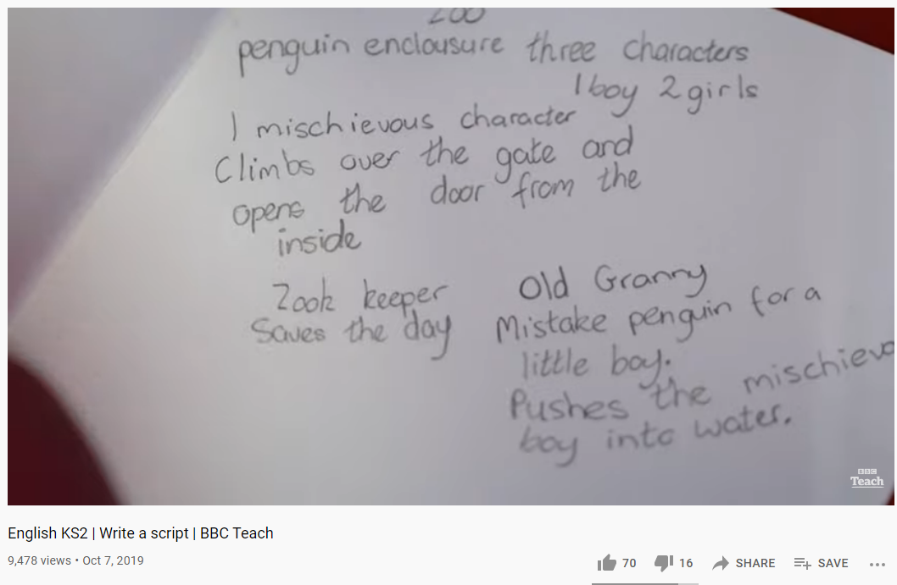

Plan:

* Explain that today we will be looking more closely at *how* the book is written, thinking about language techniques and style of writing.
* Ask the class to identify the funniest part of the book and the most terrifying part of the book. Do they think the mixture of comedy and horror is effective? Why or why not?
* Consider the ending. Did the class like the fact that it ended happily? Why or why not? They should each note down some ideas for an alternative ending.
* Discuss the use of assonance and alliteration in the book. Both of these are techniques that are designed to be read aloud. Why might Aiken have done this? Consider some literary analysis of the places in which these techniques have been used.
* Tell the students this story has been made into a play many times, partly because of how effective it sounds when read out loud. Watch the video on scriptwriting together.
* Go over the key elements of script writing, using visual prompts to help.
* The students are now going to write their alternative ending in a script format. They should think about the atmosphere they want to create, the show don’t tell rule, mirroring Aiken’s use of assonance and alliteration (and possibly other sound-based techniques such as onomatopoeia) and whether they want to write something in the style of comedy or horror.
* The class should discuss what they have learnt from this story. Consider the central themes of the book, looking at where the students can see those themes being explored.
* As a finishing activity, think about the importance of secrets in the book. What is the biggest secret or plot twist for them? How does it effect the tone of the book overall?

Homework:

* What do you think is the moral of this story and why? Try to use evidence and quotations from the book to back up your answer!