**The Book Thief: Lesson 1**

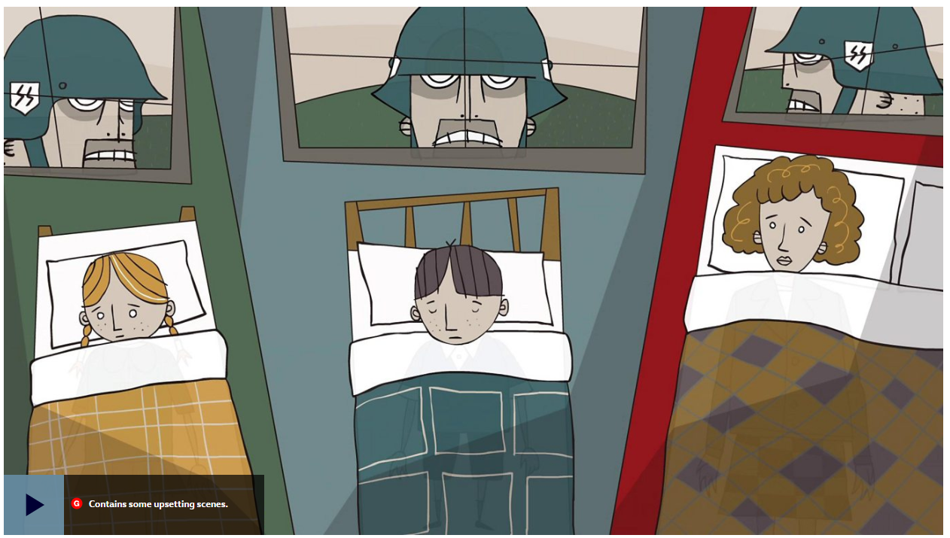

**Lesson Objectives:** This lesson aims to introduce *The Book Thief* to the students and consider the context and history behind the text. By the end of the lesson the students should:

1. Understand the context of *The Book Thief* and the effect it has on the novel.
2. Be able to understand the history of Nazi Germany and its importance to our understanding of the novel.
3. Be able to discuss the idea of book burning; why is it such a powerful historical theme?

Plan:

* Begin the class with a general discussion of the book. What did the students enjoy about the book? What did they not enjoy? What was interesting about the way the book was written? Ask the students to note down three things they liked and three things they did not and discuss this as a class.
* Ask the class where and when the book is set. What do they know about Nazi Germany?
* Watch the video of Martin Kapel’s experience of the Holocaust. What can this tell us about the book? Why is the Holocaust still so important to learn about today?
* Introduce some facts about Nazi Germany. Talk about the meaning of the word ‘Holocaust’.
* Introduce Heine’s famous quotation “Where they burn books, they will too in the end burn people”. How do the class interpret this quotation? How is it relevant to the story?
* Open a discussion on the history of book burnings, using other examples of where books have been burnt. Why do authoritarian regimes do this? What does it tell us about the power of ideas and literature?
* Watch the video on the history of book burnings. Remind the class to consider the Nazi book burnings in their historical context. Which books did they burn? Why?
* Ask the class to consider this: is Liesel the true book thief? Is the title of the book ironic? What does this tell us about Zusak’s thoughts on the preservation of ideas?

Homework:

Could *The Book Thief* have been set anywhere other than Nazi Germany? If you think it could have, then where else could it have been set? Remember to answer with refence to the text and the historical context of the novel.

**The Book Thief: Lesson 2**

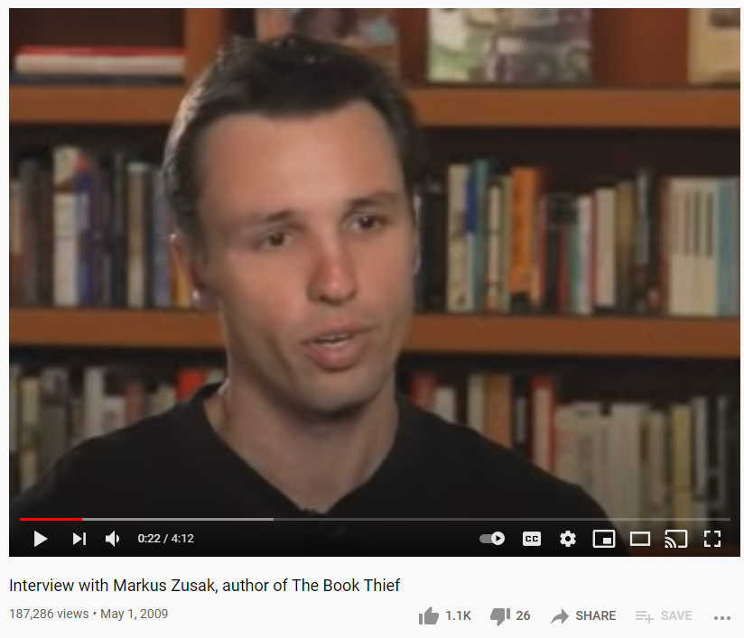

**Lesson Objectives:** This lesson aims to enable the students to dig deeper into the novel and consider the central themes and motifs used. By the end of the lesson the students should:

1. Be able to name at least three central themes of the play and explain the way in which these themes are explored and developed.
2. Be able to talk confidently about author intent, thinking about why Zusak wrote the book he wrote.
3. Be able to identify the moral of the story and the message Zusak is sending.

Plan:

* As a starter activity, ask the students to summarise the entire book in one sentence. Emphasise to them that they need to get to the very core of the story, what is at the heart of this story? Encourage them not to just sum up the plot but to think more deeply about the key ideas explored within it.
* Remind students of the concept of a semantic field. Brainstorm what would be in the semantic field encompassed within *The Book Thief,* what recurring symbols, themes and motifs can they find in the book (i.e., storytelling, hardship, Nazism)?
* Discuss the most important themes of the book. Open up a discussion about the theme of Anti-Semitism. How does Zusak develop this theme through the use of symbols? What symbols can they identify? Write a P.E.E. paragraph on this as a class.
* Now, ask the class to imagine that they are going to interview Zusak. They should write down three questions that they would ask him if they could. One member of the class should ‘hotseat’ Zusak and answer the other students’ questions, thinking about how to infer author intent.
* Watch a real interview with Zusak about why he wrote *The Book Thief*. Ask the class to consider how similar the questions and answers they came up with are to the real thing.
* Drawing on the past couple lessons, what do the class think the moral of *The Book Thief* is?

Homework:

Either ‘Discuss the theme of the individual vs. society, and how characters either conform to or rebel against societal expectations.’ OR ‘How does the novel explore the idea of family? How is family defined at the beginning of the novel vs. the end?’ Answer using quotations.

**The Book Thief: Lesson 3**

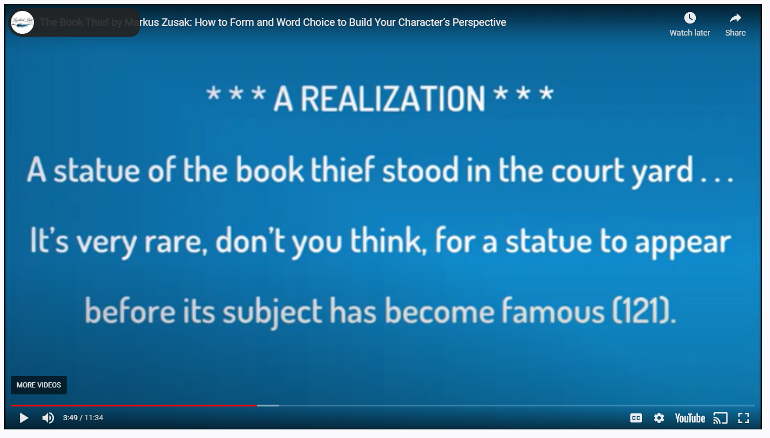

**Lesson Objectives:** This lesson aims to enable the students to think more broadly about the way in which *The Book Thief* is written. By the end of the lesson the students should:

1. Be able to think about narration and perspective in the book and how this influences the themes and moral of the story.
2. Be able to track character development throughout the novel and understand it in relation to the context of the book.
3. Be able to understand, explain and identify the concept of irony.

Plan:

* Start the lesson by asking the class to identify the narrative voice in the novel. What is unique about the perspective this story is told from? Introduce some poems in which Death is personified; what is different, what is the same?
* Watch the video dissecting the narrative voice. Draw up a contrast map of expectations from a novel narrated by Death and how Death is portrayed in the book.
* Discuss character development in the book. How does his character change? Why does he change? Does his character arc surprise you> How does this relate to Liesel’s development?
* Ask the class to discuss the question “how would this story be different if Liesel had narrated it?”. Would they prefer that? Why or why not?
* The students should pick a different historical event to narrate from death’s perspective and write a short passage doing so, remembering to keep in mind how Zusak presents his character and personality.
* Discuss the main characters from the book; can the class identify an antagonist? Why or why not? Why might this book not have such a clear ‘good guy’ and ‘bad guy’?
* Moving on, ask the class if anyone can define the term ‘irony’. Introduce the examples of irony from the passage and ask the class to answer the comprehension questions related to Zusak’s use of irony throughout. Discuss as a class.

Homework:

* Either ‘What purpose does Rudy’s death play in the novel?’ OR ‘Why does Death say, “I am haunted by humans”? What effect does this have on the novel?’. **Also, you need to pick a favourite quotation to bring to our next lesson!**

**The Book Thief: Lesson 4**



**Lesson Objectives:** This lesson aims to enable the students to engage creatively with *The Book Thief*. By the end of the lesson the students should:

1. Be able to creatively engage with *The Book Thief,* reinterpreting parts of the novel in their own words.
2. Be able to identify and analyse the way figurative language is utilised throughout the novel and talk about Zusak’s language.
3. Be able to analyse an example of allegory and think about its symbolic significance.

Plan:

* Start the lesson by asking the students to produce their favourite quotations that they identified for homework. Watch the video on analysing quotations and ask each student to analyse theirs, thinking carefully about literary techniques & powerful word choice.
* Each student should present why they chose that quotation as their favourite and briefly outline their analysis of the quote.
* *The Book Thief* is written in a very poetic style. Consider some particularly poignant examples of figurative language in the novel as a class.
* Now, split the class up into small groups. Each group should consider each member’s quotation from the beginning of the lesson and re-work them, thinking about how they would communicate a similar idea in their own words. They should think about using figurative language and interesting vocab.
* Each group should present to the class the new quotations they came up with.
* As a finishing activity, discuss the use of allegory in the novel, focusing on the symbolic importance of *The Word Shaker.* What is it an allegory for?

Homework:

* Write a poem based on *The Book Thief.* This can be in any form you like, it is completely up to you, but I want you to consider how to communicate the main message of the story and how to uphold the original language and themes.