**Kensuke’s Kingdom: Lesson 1**

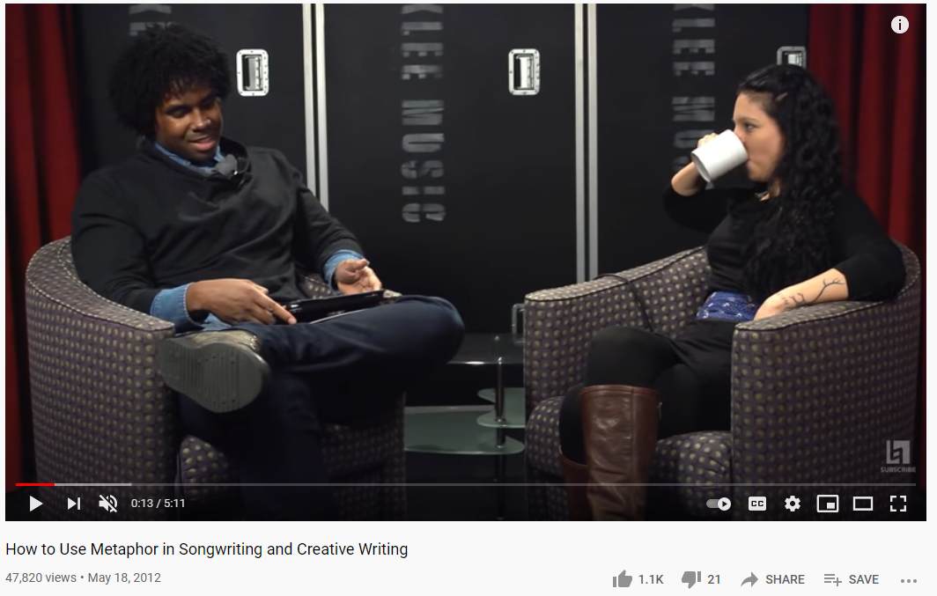

Plan:

* As a starter activity, ask the students to imagine that they have been shipwrecked on a desert island but are allowed to keep three things. What three things would they want in this situation? What would they do first?
* Ask them to write down three descriptive words of the desert island they have been shipwrecked on and to sketch a drawing of it.
* Read Morpurgo’s description of the island in Chapter 4. Is this similar to the island in their minds? Analyse this passage using VIPERS questions, focusing particularly on the literary techniques used and how Morpurgo paints an image in the reader’s mind.
* Watch the video and introduce the idea of coming up with unusual literary techniques to describe the island (like Morpurgo’s comparison of the island to a peanut). Ask the class to find two unlikely things to compare to come up with a metaphor or simile about their island, demonstrating this with the example of the sea and a cobra or ink pot.
* They should now write their own short description of their island, using their descriptive words and literary techniques to do so.
* Ask the students to put themselves in Michael’s shoes when he first arrives on the island. What would he be able to hear/see/smell/taste/feel? How might this make him feel emotionally? They should write a message in a bottle to his family detailing all this.
* One person should hot-seat Michael and the others should ask him questions about his feelings when washing up on the island.
* As a finishing activity, the class should write a one-sentence summary of the book. What would be the key message of the book that they would want to get across?

Homework:

* Design your own front cover and blurb for this story. You can use the original as inspiration but try to come up with your own unique interpretation. What should be on the front cover to entice the reader? What parts of the story would you want to communicate through the blurb? How can you show the reader what this book is all about from the cover alone?

**Kensuke’s Kingdom: Lesson 2**

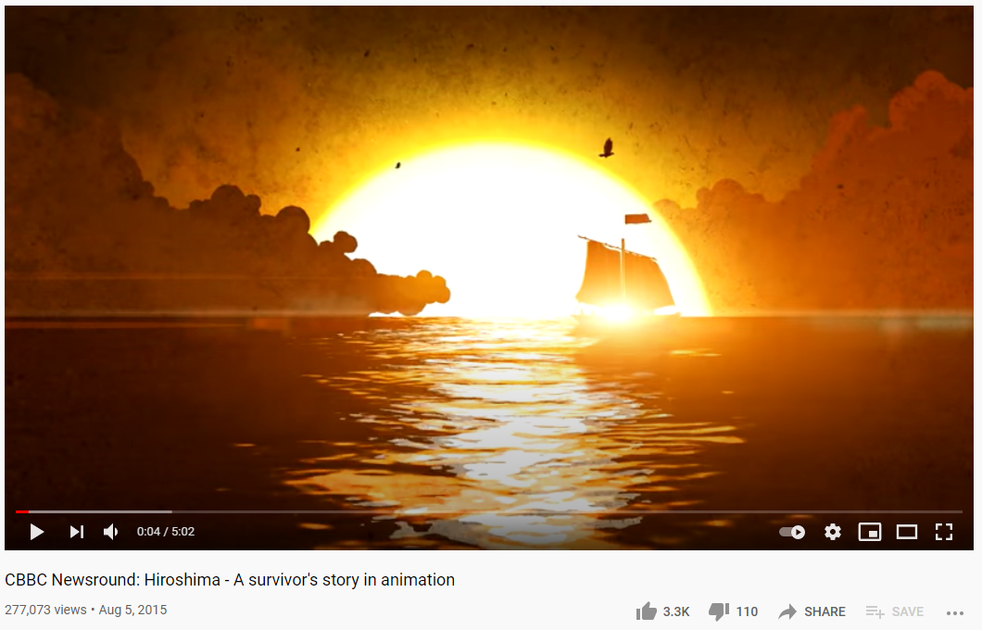

Plan:

* To begin with the class should think of one word that describes the relationship between Kensuke and Michael in the book.
* Tell the students in this lesson we will be considering the characters in the book and what they represent. The students should think of some similarities and differences between Kensuke and Michael, and support this with textual evidence.
* Open a debate on the question “would Kensuke and Michael have been friends if they had met somewhere else?”. Half the class should argue for one side, and half for the other. They should try to think about both sides of the argument.
* Ask the class to write down the three most important facts about Kensuke’s character.
* Introduce the idea of Kensuke’s past. Ask them if they know which war he is referring to when he explains how he came to be on the island. Ask them what they know about the dropping of the atomic bombs.
* Watch the video about the dropping of the atomic bomb. Ask the class to discuss how this might have affected Kensuke. What can we learn about his character from this?
* Look at the newspaper clippings about Japanese soldiers in the mountains.
* Why does Kensuke decide not to go home at the end of the book? The students should share their ideas on why they think he makes the choice he does. Do they think this is a happy ending or a sad one? Why?
* Consider the postscript at the end of the book; do they like this ending or would they have preferred the book without it?
* Introduce the letter writing task to the students, reading through the homework prompt together. How does Michiya’s letter make them feel? How would it make Kensuke feel?

Homework:

* Write a letter as Kensuke in response to Michiya’s letter, explaining what happened. Use the video we watched, the newspaper articles and the text to help you. You can also do your own research on the war too and remember to write in the style and format of a letter.

**Kensuke’s Kingdom: Lesson 3**

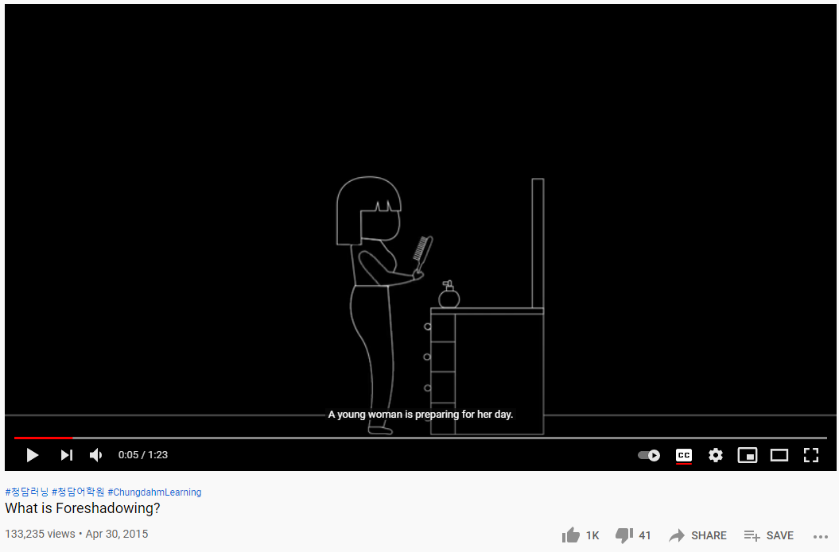

Plan:

* Go back to the very beginning of the story and consider the family’s decision to go sailing around the world. Play a game of ‘Fortunately, Unfortunately’ imagining you are trying to persuade or discourage Michael’s family from going.
* Read the corresponding passage from the book and complete some VIPERS questions on it, analysing the language Morpurgo uses. Is there any inkling at the end of Chapter 1 that things may go wrong for Michael and his family? Do they class know what this technique is called? Introduce the idea of foreshadowing, watching the video on it and discuss.
* Discuss the first line of the whole book, do the class think it is effective? They should come up with their own first line to replace Morpurgo’s. How does it change the tone? Is it still an example of foreshadowing?
* Remind the class that we never get to see what happens to Michael’s family after he goes missing. They should reimagine the scene where Michael falls overboard from his family’s perspective. Why do they think might have happened after he disappeared?
* The students should write a piece of dialogue between Michael’s parents after he has fallen off the ship, considering the interactions we have seen between the two characters in the early chapters of the book. They should write this in dialogue format and then perform it with a partner, acting out the scene and thinking about the emotions both may be feeling. Will both parents be feeling the same way? Why or why not?
* Complete a free-writing exercise, using ‘The Great Wave off Kanagawa’ by Hokusai and ‘La Mer’ by Debussy to inspire the students. Tell them to imagine they are living inside of the world of the book and to explore whatever they would like to on this theme in their writing.
* The class should discuss what they have learnt from this story. What do they believe the moral of it is? What are the most important themes?

Homework:

* Write a newspaper article about Michael’s safe return. Remember to include a headline, a lead paragraph, quotations from witnesses and to write it in the format of a newspaper.