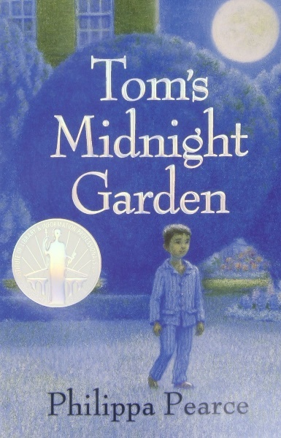Tom’s Midnight Garden- Lesson Plan:

**Lesson I- *Tom’s Midnight Garden’s* Literary Context, Plot and the Role of the Author:**

**-Summary:** This lesson will be divided into three parts, with each section helping students to better understand and evaluate the literary context of the novel, the novel’s events, as well as Philippa Pearce’s style and influences.

**-Lesson Objectives:**

i- To reflect on the genre of the novel, the idea of ‘fantasy-realism’, dreaming and philosophical ideas of time and space.

ii- To reflect on Philippa Pearce as a writer, and how she writes *Tom’s Midnight Garden* effectively, ultimately producing a book which is considered a children’s classic.

iii-To identify the key events of the novel and why they are effective/ important within the narrative and genre.

**-Part 1: Literary Context:**

-We will start the lesson by discussing varying concepts within the book, being genre, the idea of ‘fantasy-realism’, dreaming and philosophical ideas of time and space. We will explore why they are effective within the novel, as well as how they have been used historically. We will also explore philosophical ideas around time and space, and why this is so fascinating to explore in a children’s novel. We will focus on an inspiration for Pierce, being J.W. Dunne’s influential 1927 work *An Experiment with Time.*

**-Part 2: Philippa Pierce and Writing a Classic:**

-We will learn about the life and experiences of Philippa Pierce, and what the book means to her. We will learn about what inspired her to write the book, as well as what has helped make her book a classic. We will also explore what makes a classic, ‘classic’.

-We will then assess several books, on whether we think they are classics, as well as if we think Tom’s Midnight Garden is more of a classic and, if this is even possible to judge. Students will write a short PEE paragraph on why they think Tom’s Midnight Garden is considered a classic by many.

**-Part 3: The Events:**

-We will look at the main events of the novel and what emotions, feelings as well as purposes these events convey. We will debate our thoughts on the plot’s efficacy, as well as whether the ending was inevitable or not. We will then debate on what we think Pierce’s intentions were when crafting her novel.

-We will spend time on a short writing task too, where students will describe a new place, rather than a Victorian garden, where a child much like Tom could explore at night, and why this place would be effective.

**-Homework:**

-Students will write a short piece describing their own invented garden, of around 250 words.

**Lesson 2- *Tom’s Midnight Garden’s* Characters and Symbols:**

**-Summary:** This lesson will analyse the novel’s main characters and symbols. Students will analyse each character, their role in the novel, as well as looking at how they described. Students will then draw their own conclusions on the characters based on the analysis in the lesson, and will do the same exercise for symbols.

**-Lesson Objectives:**

i- To form opinions and understand the novel’s main characters as well as their literary roles.

ii-To analyse the descriptive language used to create the characters, and how it is effective.

iii- To perform the same analysis and opinion formation as above, but for the novel’s symbols.

**Part 1: Characters:**

-We will analyse all the main characters in turn, looking at descriptions as well as events to better understand the variety of personalities. We will discuss individual questions personal to specific characters, and students will be encouraged to place themselves in the characters different ‘shoes’. We will also discuss the character’s tangibility, the idea of ghostliness, as well as how the characters may be different in another setting/century.

-There will also be a writing task, where students will create an extra character (human or animal!) for *Tom’s Midnight Garden.*

-We will then do a further writing task alongside this, writing a PEE paragraph on whether they prefer the characters of *Toms Midnight Garden,* to other previously read books, such as *Once.*

**Part 2: Symbols:**

-We will discuss the many symbols within the novel and what they signify. We will come up with alternate ideas of symbolism not found in the book, and why our examples may also be effective.

-Students will also look at sections within the book, analysing language whilst also identifying and determining more obscure examples of symbolism. These sections which largely focus on the setting, such as the garden and the apartment.

**Homework:** Students will write a short persuasive piece on which flower/tree/animal they would find the most illuminating and fascinating symbol within their own, invented ‘midnight garden’,

**Lesson 3: *Tom’s Midnight Garden’s* Themes and Topics:**

**-Summary:** This lesson will outline all the novel’s most important themes, where students will assess why each theme is important and why Philippa Pearce chose to focus on these ideas. Students will analyse why these themes are important in adventure novels and where else these themes appear in literature. Students will also investigate Pearce’s writing style, assessing it in comparison to other literature and also how it supports the themes explored within the novel.

**Lesson Objectives:**

i-To understand and recognise the novel’s most influential themes, and why they are invaluable within the plot.

ii- To assess the importance of these themes and how they are effectively written about by Pearce.

iii-To explore Philippa Pearce’s writing style and to understand how it makes the book so readable.

**Part 1- Identifying and Understanding Themes:**

-Students will identify the novel’s main themes, where each theme will be evaluated in turn regarding importance, as well as how Philippa Pearce chooses to construct it. Students will also analyse excerpts which engage with the themes particularly well, exploring the linguistic and structural techniques used. We will also ink how symbolism supports the themes, as well as the novel’s historical, social and philosophical context.

-Students will also discuss which theme they feel is most prevalent within the novel, which theme is the most important to them, as well as which theme could be brought about more by Pearce. Students will discuss which themes could be interesting to explore in the novel which are not present, such as love, death etc.

-There will be a short writing task, where students will write on which theme they think links most directly to Tom’s experiences within the novel.

**Part 2- Philippa Pearce’s Style:**

- Students will read several excerpts from the novel, comparing and contrasting the linguistic and structural decisions within each extract, whilst also providing their opinion regarding how the different scenes make them feel/react as a reader. We will aim to go through 5-6 extracts, which use a variety of language and discuss different settings as well as moments of action.

-Students will compare Pearce’s writing to Louis Sachar’s in *Holes,* where they will write a short piece explaining why the author’s style is suited to their particular genre(s) (around 5-10 minutes in which to write).

-Students will finally discuss and summarise their thoughts on Pearce’s style, whether they like the way she writes, and how they would write a sequel. We will then look at the summaries and ideas within her other books, and whether we think *Tom’s Midnight Garden s*ounds like her best book idea.

**Homework:**

-Students will write a short piece on which theme they think strikes them the most within the book.