-The Secret Garden-

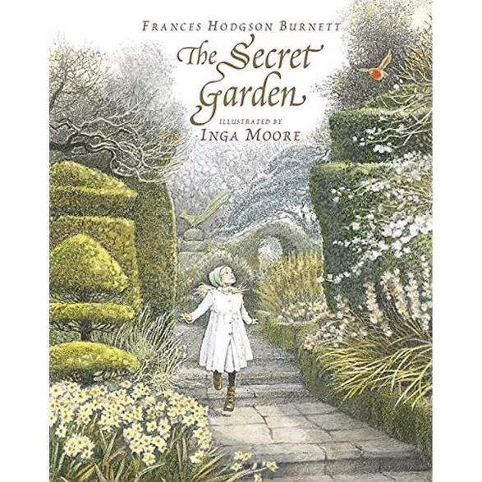

Lesson 1- *The Secret Garden’s* Context and Structure:

-Learning Objective: To understand the historical context and the main events of *The Secret Garden.*

-Part 1: We will look at the historical context surrounding the novel, being England after the Victorian period at the turn of the century. We will also examine the importance of nursery rhymes within the novel, and the concept of the manor house. Finally, we will review the author, Frances Hodgson Burnett, and how her own life affected the novel.

Part 2: We will analyse and explore the main moments and ‘scenes’ within the book, and we will watch the trailer of the 2020 film and evaluate whether the trailer does an effective job at showing glimpses of the most important and/or interesting scenes. We will also do some speedwriting, where we will write on what genre we think the book is.

Homework: To write a short description describing your own invented, ‘Secret Garden’.

Lesson 2- *The Secret Garden’s Characters:*

Learning Objective: To understand, analyse and explore the main characters in *The Secret Garden.*

-Part 1: We will analyse the main characters from the book (Mary, Ben, Dickon, Colin, Mrs Medlock), evaluating their purpose and meaning in the book and also taking time to analyse the effective language choices within the except. We will discuss the role of each of the main characters and why we think they are important, or perhaps, overrated within the novel. Students will write a short PEE paragraph on who their favourite character is and why. We will also go through some more creative tasks, such as inventing new human characters, as well as animal characters for the story, and we will discuss the characters through writing our own more detailed descriptions of them, too.

Homework: To write a short description on an invented animal character.

Lesson 3- *The Secret Garden’s* Themes and Setting:

Learning Objective: To analyse and interpret the themes and setting of *The Secret Garden.*

-Part 1: This first lesson half will explore the themes within the novel, discussing 4-6 of the main themes with accompanying extracts. Students will also be encouraged to analyse the linguistic and structural devices within the extracts, and how they make the writing effective at conveying the select theme/ any emotions.

-Part 2: The second lesson half will focus on the novel’s use of setting, where we will go over the role of the garden and the manor house. Students will reflect on the purpose of the novel’s landscapes, and whether they are impactful to us still as twenty-first century readers. We will discuss how different the novel would be if it were set in a city, and students will also aim to describe (briefly) the manor house, if it were haunted.

Homework: To write a short, persuasive piece on which theme is the most important throughout the novel.