**The Butterfly Lion: Lesson 1**

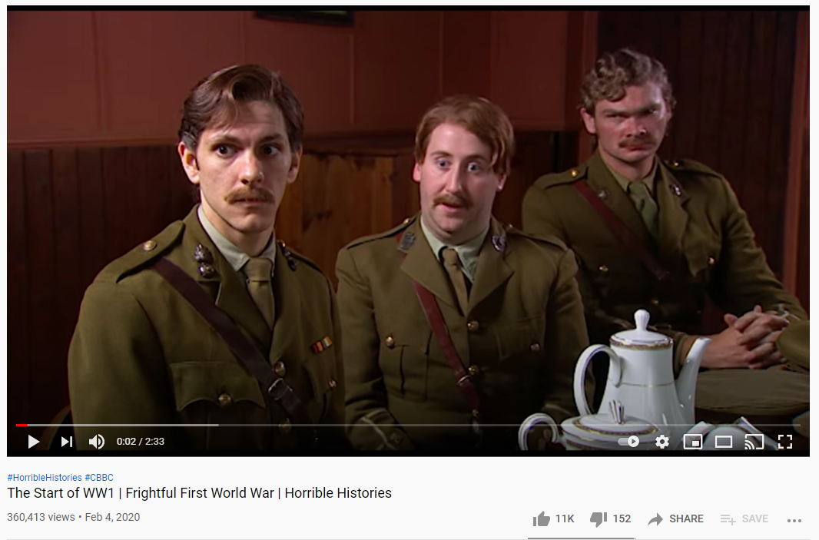

Plan:

* As a starter activity, ask the students to summarise the entire book in one sentence. Emphasise to them that they need to get to the very core of the story, what is at the heart of this novel? Encourage them not to just sum up the plot but to think more deeply about the key ideas explored within it
* Introduce the blurb to the class. How similar is it to their summaries of the book?
* Ask the class to write down as many words as possible that describe the book
* Open a discussion on themes. What are the main themes of the novel? Do any of the words the students wrote down before count as themes? Why or why not? What do they think the moral of the story might be?
* Now explain to the class that we’re going to have a think about the history and context of this book. Can they identify when the book is set?
* Watch the Horrible Histories video on the First World War. Ask the class to note down some ideas of how life was different back then. Why is this relevant to the story?
* Use some VIPERS questions to explore the theme of war in the novel, focusing on how Morpurgo creates tension. Analyse the description of trench warfare as a class, thinking about the advanced vocabulary Morpurgo uses and encouraging the students to make an educated guess as to the meaning of words such as ‘whizzbangs’ and ‘bayonet’
* Ask the students to put themselves in Bertie’s shoes. What would he be able to hear/see/smell/taste/feel from the trench? How might this make him feel emotionally? They should prepare a short dramatic speech from his perspective to perform to the class
* Tell the class they will be writing a diary entry for homework. Briefly go over the conventions of diary writing and discuss how to use emotive writing.

Homework:

* At the start of the book, the young boy is at boarding school in Wiltshire. Write a diary entry from his point of view, explaining how he feels about being there. Think about why he might choose to run away.

**The Butterfly Lion: Lesson 2**

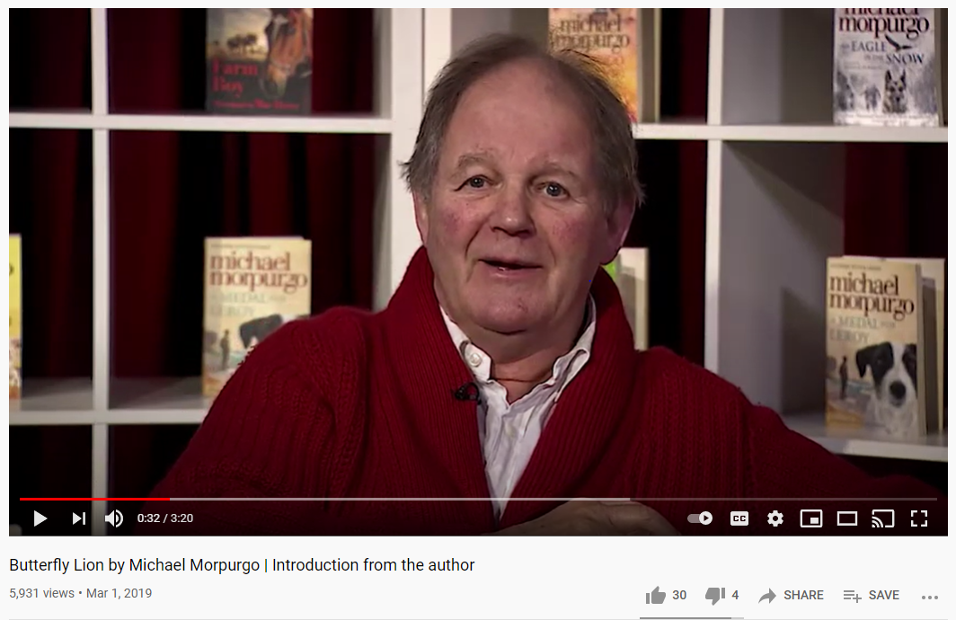

Plan:

* Read the preface for *The Butterfly Lion* and ask the students if it changes the way they understand the story. What new information does it give them?
* Tell the students in this lesson we will be considering why Michael Morpurgo might have written *The Butterfly Lion.* Open by showing them the video of his introduction to the book
* Ask the class what they have learnt from that video. Did anything surprise them?
* Discuss the idea of the skill of inference or being ‘reading detectives’, touching on subtext and ideas of show don’t tell
* Tell the students that they will be writing an interview for Michael Morpurgo. What questions would they ask him about this book if they could? Remind them that they should use their inference skills to work out some probing questions to ask
* Now one student should hot-seat Morpurgo and the rest should interview them. The student hot-seating the author should think about how they can read between the lines to infer the kinds of answers he might give
* Considering Morpurgo’s reasoning for writing this story, tell the class that now they are going to be thinking about one of the key moments in the book; the debate over whether to sell the lion cub. Play a game of ‘fortunately, unfortunately’ with the ‘fortunately’ side arguing to keep the lion cub and the ‘unfortunately’ side arguing they should sell it. The arguments can be as silly or as serious as the students like!
* Tell the class they will be writing a persuasive letter for homework, from Bertie’s perspective. Run through some persuasive techniques, thinking about how they would try to convince their own parents to keep a lion cub like Bertie has to!

Homework:

* Write a persuasive letter from Bertie’s perspective to his father, arguing for why he should be allowed to keep the lion cub. Remember to use lots of persuasive techniques and some rich, descriptive language!

**The Butterfly Lion: Lesson 3**

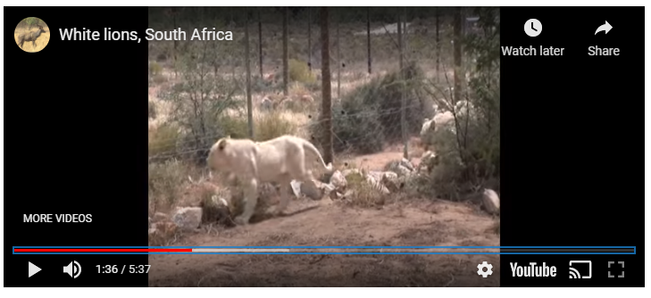

Plan:

* Start the lesson by asking the students what jumps into their head when they think of Africa. Can they think of a reason Morpurgo might have chosen Africa to set part of his story?
* Watch the video of the white lions in South Africa. Is this scene similar to how Morpurgo described it? Why or why not? Can the class think of two high-level adjectives to describe the lions in the video?
* Place the corresponding description of the lions from the book on the board. Analyse the passage using VIPERS, paying particular attention to Morpurgo’s writing style and use of language. Ask the class what the effect of this is.
* The class should now up-level it, using a thesaurus to make the passage even more interesting and descriptive than it already is
* Place on the board a list of some of the most interesting vocabulary from *The Butterfly Lion.* The class should use the word attack method to try to figure out some synonyms for the words on the board. Then they should use two of the words in their own sentences
* Discuss the characters in the book, thinking particularly about narrative perspective. Why do the students think Morpurgo wanted to tell the story from the perspective of the old lady? Why do we never learn the boy’s name? Is there any character whose perspective they would have liked to hear more from? How would that change the story?
* Now they should rewrite the story of Bertie and the lion’s first meeting but from the lion’s perspective. Ask the class to make sure they include at least three literary techniques, and think about how a lion might react to a human.
* Finally, the class should discuss what they have learnt from this story. What do they believe the moral of it is? What are the most important themes? What would they put on the front cover of this book if they had written it to communicate this?

Homework:

* The blurb on the back of the book has a quote from Bertie: "All my life I'll think of you, I promise I will. I won't ever forget you." Could you use this as the starting point for your own story, written in the style of Michael Morpurgo? Try to use some of the interesting vocab we have studied this lesson, and think about how he uses description in his writing.