**Macbeth: Lesson 1**

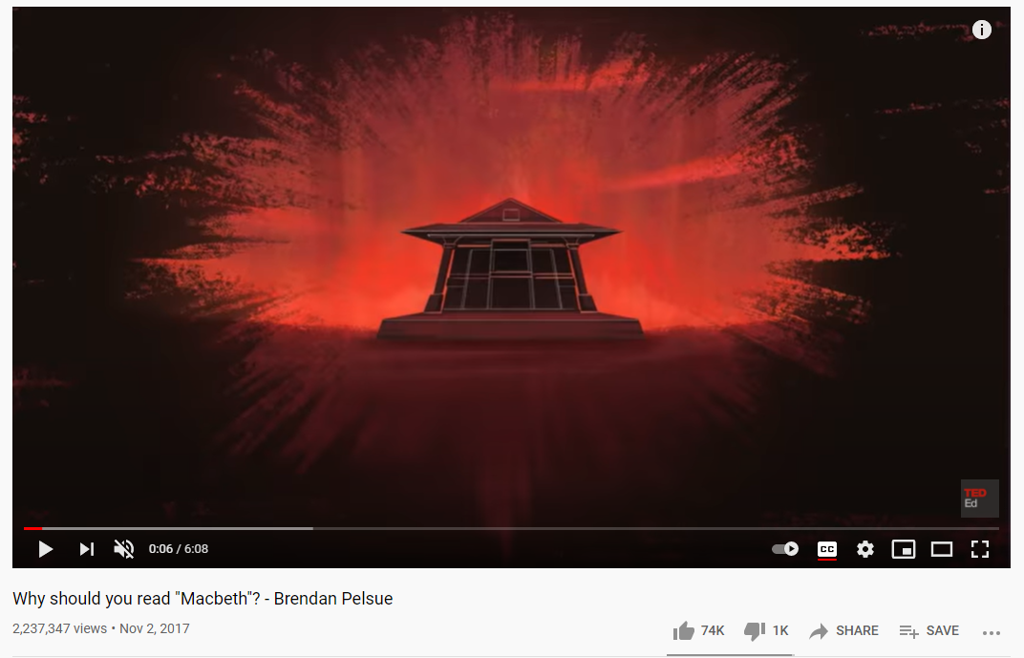

**Lesson Objectives:** This lesson aims to introduce *Macbeth* to the students and consider the central themes and motifs used in the text. By the end of the lesson the students should:

1. Understand the context of *Macbeth* and the effect it has on the play
2. Be able to name at least three central themes of the play and explain the way in which these themes are explored and developed
3. Be able to discuss the moral of the play, connecting this to the distinctive moral framework of the 17th century

Plan:

* As a starter activity, ask the students to summarise the entire play in one sentence. Emphasise to them that they need to get to the very core of the story, what is at the heart of this story? Encourage them not to just sum up the plot but to think more deeply about the key ideas explored within it
* Introduce the idea of it being called ‘the Scottish play’. Why do they think that is?
* Ask the class to write down as many words as possible that describe the play.
* Open a discussion on themes. What are the main themes of the novel? Do any of the words the students wrote down before count as themes? Why or why not?
* Watch the video on the importance of reading Macbeth. Ask the students to note down anything that helps them understand the context of the novel
* Introduce some facts about Shakespeare and the 17th century. Discuss the notion of regicide, the historical context of witchcraft and ideas on kingship
* Discuss the Gunpowder Plot of 1605. How could this related to Macbeth?
* Open a debate on the question “was Macbeth a dangerous play to write in the historical context of the 17th century?”. Have them consider the fate of Macbeth and Lady Macbeth as a result of their acts, does that change how controversial the ideas within the play are?
* Ask the class what they think the moral of the story in Macbeth is. Give them some options from famous critical interpretations of the play to help them think more deeply about the complicated moral fabric of the play

Homework:

Choose between the question “Is justice served at the end of Macbeth?” or “Do you think Macbeth has a happy ending?”. Remember to answer with refence to the text and the historical context of the play. Use quotations if possible!

**Macbeth: Lesson 2**

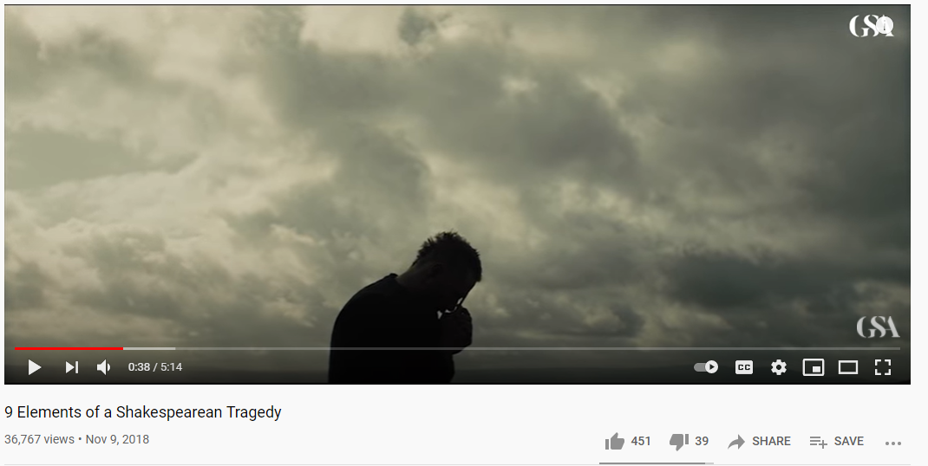

**Lesson Objectives:** This lesson aims to enable to students to think more broadly about the way in which *Macbeth* is written. By the end of the lesson the students should:

1. Be able to understand the genre of tragedy and how it functions in Macbeth
2. Be able to conduct character analysis within the play, thinking about the notion of the antihero in Shakespearian writing
3. Be able to tie historical context into their analysis, critically assessing why Shakespeare may have presented certain characters and issues in the way he did

Plan:

* Begin the lesson by asking the students who they think is the hero and who is the villain of Macbeth. If they find this difficult to identify, draw attention to this fact. Why might Shakespeare have created such morally complicated characters?
* Introduce the idea of tragedy as a literary genre. Watch the video on Shakespearean tragedy and ask the students to note down five tragic elements of Macbeth
* Ask the class whether the play was always going to end badly. Do they think it could have ended any other way? Why or why not?
* Hone in on the character of Lady Macbeth. Introduce the idea that she is often one of the most studied and maligned characters in all of Shakespeare’s work. Ask the class if they believe Lady Macbeth is truly evil or not.
* Introduce some ideas about women in the Elizabethan times. What can this tell the students about Lady Macbeth and the other female characters, i.e. the Weird Sisters?
* Tell the class to write down questions they would ask Lady Macbeth. Now one student should hot-seat Lady Macbeth and the rest should interview them. The student in the hot-seat should think about how they can read between the lines to infer the kinds of answers she might give and the way she might deliver them
* Ask the class to discuss whether the play can be understood as sexist towards women. Why or why not? Introduce some critical ideas and theories on this point, thinking in particularly about how Lady Macbeth diverges from the typical Elizabethan Queen
* Go over the conventions of diary writing in preparation for homework

Homework:

* Write a diary entry from the perspective of Lady Macbeth after King Duncan has been murdered. You should decide first whether you think she is evil or suffering from her own tortured mind to help inform your presentation of her emotions.

**Macbeth: Lesson 3**

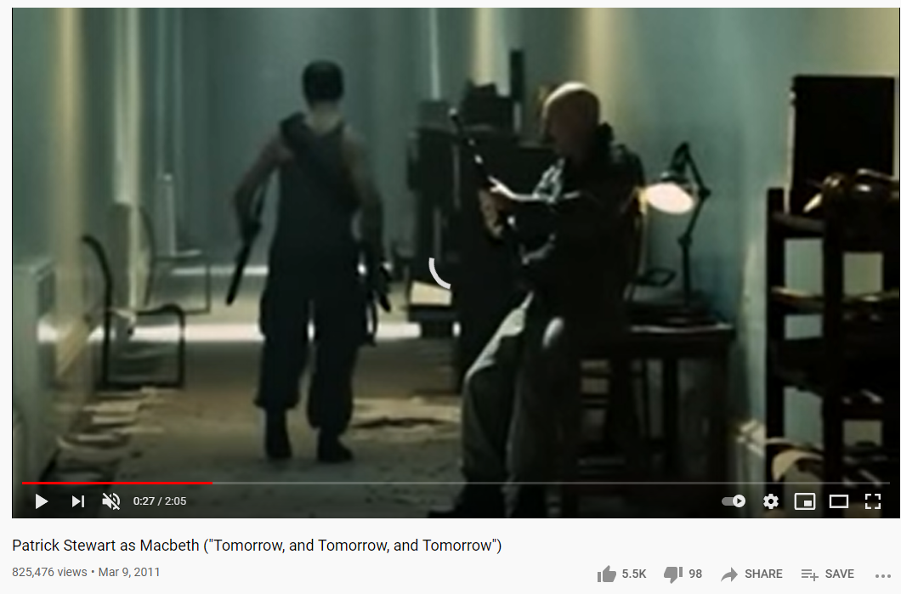

**Lesson Objectives:** This lesson aims to enable the students to engage creatively with *Macbeth*, considering . By the end of the lesson the students should:

1. Be able to comment on different dramatic interpretations of the play, thinking about the different effects of each
2. Be able to analyse and modernise a soliloquy from the play, using skills of close textual analysis to better understand the way the play is crafted
3. Be able to offer their own dramatic interpretation of the play, working with the conventions of playwriting to write their own scenes

Plan:

* Start the lesson by watching the video of Macbeth’s final soliloquy. Ask the class to write down words that describe the mood of this final soliloquy.
* Introduce the original text of the soliloquy with a modern translation to help the students in their analysis. Analyse it line-by-line as a class, commenting on the language effect throughout and thinking about what it tells us about Macbeth’s downfall
* Now the class should consider how they would modernise this final soliloquy. How would the language be different? How might the sentiment be different? Would they set it somewhere different?
* The student should write a few lines of their own modern version of the text
* Introduce some examples of the different dramatic renderings of Shakespearean texts. Watch the different versions of the Weird Sisters and ask the class which they find most effective and why. Can they think of a more effective way to portray them?
* Tell the students they will be coming up with their own modern versions of Macbeth. As an initial task, they should discuss what they would change and keep the same about the characters, the setting and the plot. Ask the class to brainstorm and share some ideas in small groups, and then discuss the effect of modernisation as a class
* Finally, the class should discuss whether they would change the ending or moral of Macbeth

Homework:

* Choose a scene from the play to rewrite as your own modern version. Remember to write it in the style of a play, identifying factors such as setting, costume, characters, and remember to think about the way the language and dialogue might change.