***Once-* Lesson Plan:**

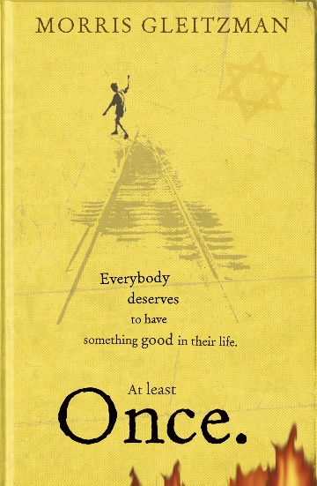

**Lesson I- *Once’s* Historical Context, Plot and Morris Gleitzman:**

**-Summary:** This lesson will be divided into three parts, with each section helping students to better understand and evaluate the historical context of the novel, the novel’s events, as well as Morris Gleitzman’s style and influences.

**-Lesson Objectives:**

i- To understand the events of World War II, and how they form/influence the events within the novel.

ii-To identify the key events of the novel and why they are effective/ important within the narrative and genre.

iii- To reflect on Morris Gleitzman as a writer, and how he writes *Once* effectively.

**-Part 1: The Period of History:**

-We will start the lesson by discussing what students already know about World War II. We will look at key events of the World War, as well as the situation specifically in Nazi-occupied areas within Europe. We will also reflect on the reasons as to the beginning of the war, and how the war impacted the everyday citizen. We will write short PEE paragraphs on why they think the war had such a big impact on peoples’ lives under occupation in Europe.

**-Part 2: The Events:**

-We will look at the main events of the novel and what emotions, feelings as well as purposes these events convey. Students will have to reorganise the novel’s events which will be jumbled up, before discussing them. We will also evaluate the novel’s structure and interweaving of different settings and periods of history.

-Students will be asked to do a short writing task, commenting on which scene they feel is best-written within the novel and why.

**-Part 3: Morris Gleitzman:**

-We will learn about the life and experiences of Gleitzman, and what the book means to him. We will also compare *Once* to other war novels, and why perhaps *Once* is more revealing and sensitive in comparison to other war books. This will include a writing task, where students will write a PEE paragraph-based persuasive piece on *Once* versus a selected novel.

**-Homework:**

-Students will write a short piece describing their own, determined hero, like Felix, in a war novel.

**Lesson 2- *Once’s* Characters and Symbols:**

**-Summary:** This lesson will analyse the novel’s main characters and symbols. Students will analyse each character, their role in the novel, as well as looking at how they described. Students will then draw their own conclusions on the characters based on the analysis in the lesson, and will do the same exercise for symbols. We will also ensure to revisit the definition of symbolism again.

**-Lesson Objectives:**

i- To form opinions and understand the novel’s main characters as well as their literary roles.

ii-To analyse the descriptive language used to create the characters, and how it is effective.

iii- To perform the same analysis and opinion formation as above, but for the novel’s symbols.

**Part 1: Characters:**

-We will analyse all the main characters in turn (6), looking at descriptions as well as action scenes to better understand the variety of personalities. We will discuss individual questions personal to specific characters. Moreover, we will compare the characters in *Once* to other, courageous characters in *War Horse.*

-There will also be a writing task, where students will create an extra character for *Once.*

-We will then do a further writing task alongside this, writing a PEE paragraph on whether they prefer the characters of *War Horse*, or of *Once.*

**Part 2: Symbols:**

-We will discuss the many symbols within the novel and what they signify. We will come up with alternate ideas of symbolism not found in the book, and why our examples may also be effective.

-Students will also look at sections within the book, analysing language whilst also identifying and determining more obscure examples of symbolism.

**Homework:** Students will write a short persuasive piece on which instance(s) of symbolism they find most illuminating.

**Lesson 3: *Once’s* Themes and Topics:**

**-Summary:** This lesson will outline all the novel’s most important themes, where students will assess why each theme is important and why Gleitzman chose to focus on these ideas. Students will analyse why these themes are important in adventure novels and where else these themes appear in literature. Students will also investigate Gleitzman’s writing style, assessing it in comparison to other literature and also how it supports the themes explored within the novel.

**Lesson Objectives:**

i-To understand and recognise the novel’s most influential themes, and why they are invaluable within the plot.

ii- To assess the importance of these themes and how they are effectively written about by Gleitzman.

iii-To explore Morris Gleitzman’s writing style and to understand how it makes the book so readable.

**Part 1- Identifying and Understanding Themes:**

-Students will identify the novel’s main themes, where each theme will be evaluated in turn regarding importance, as well as how Morris Gleitzman chooses to construct it. Students will also analyse excerpts which engage with the themes particularly well, exploring the linguistic and structural techniques used. We will also revise work from last lesson and link how symbolism supports the themes, as well as the novel’s historical context.

-Students will also discuss which theme they feel is most prevalent within the novel, which theme is the most important to them, as well as which theme could be brought about more by Gleitzman.

-There will be a short writing task, where students will write out the penultimate question (which theme is most important to them), aiming to use some persuasive writing techniques.

**Part 2- Morris Gleitzman’s Style:**

- Students will read several excerpts from the novel, comparing and contrasting the linguistic and structural decisions within each extract, whilst also providing their opinion regarding how the different scenes make them feel/react as a reader. We will aim to go through 5-6 extracts, which use a variety of language and discuss different settings as well as moments of action.

-Students will compare Gleitzman’s writing to Michael Morpurgo’s in W*ar Horse,* where they will write a short piece explaining which author’s writing style they prefer and why (around 5-10 minutes in which to write).

-Students will finally discuss and summarise their thoughts on Morris Gleitzman’s style, whether they like the way he writes, and how they would write a sequel. We will then look at the sequels *Then, Now, After, Soon* and *Maybe*, paying special attention to their titular naming.

**Homework:**

-Students will write a short piece on which theme they think most directly relates to Felix in the novel and why, using PEE paragraphs.