**The Wind in the Willows: Lesson 1**

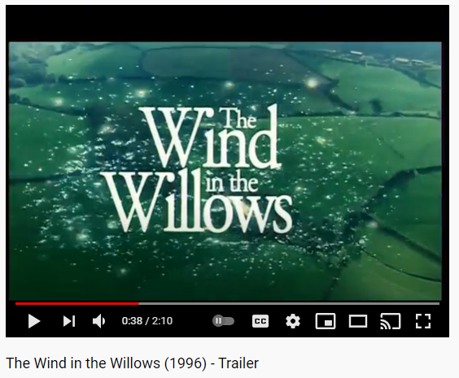

Plan:

* Watch the trailer for *The Wind in the Willows* and ask the students as they are watching to write down as many words and phrases to describe the story as possible
* Open a discussion on themes. What are the main themes of the novel? Do any of the words the students wrote down before count as themes? Why or why not? What do they think the moral of the story might be?
* Put the quote from a review of *The Wind in the Willows* on the board (“This shows that to [Kenneth Grahame](https://www.bartleby.com/topics/kenneth-grahame), the plot of the story is not what is important but rather the morals and the themes that he makes very apparent.”) Do the class agree with this? Why or why not?
* Now have a think about the narrative perspective of the book. Whose eyes do we see the story through? Is it written in 1st or 3rd person? Why might the author have chosen this?
* Considering the character of Mole, who serves as the reader’s lens into the story, the students should think about how he develops as a character throughout the story. How does he change? Who helps him on this journey?
* The students should write down three adjectives to describe Mole at the beginning of the story and three to describe him at the end. They should use a thesaurus and try to come up with the most interesting high-level vocabulary possible!
* The students should now imagine they are interviewing Mole at the end of the story. What kinds of questions would they ask him? The students should write two questions they would ask him, and then someone should volunteer to ‘hot-seat’ Mole. The rest of the class can ask their questions which the person playing Mole should answer using inference skills
* Tell the class they will be writing a letter for homework. Briefly go over the conventions of letter writing and discuss how to use emotive writing.

Homework:

* Imagine you are Mole at the end of the story writing a letter to his younger self. What kinds of advice might he give his younger self if he could? What has he learned through the course of the story that he would want his younger self to know? Remember to use the conventions of letter writing in this task, and try to include some interesting vocab and literary techniques such as similes, metaphors or onomatopoeias.

**The Wind in the Willows: Lesson 2**

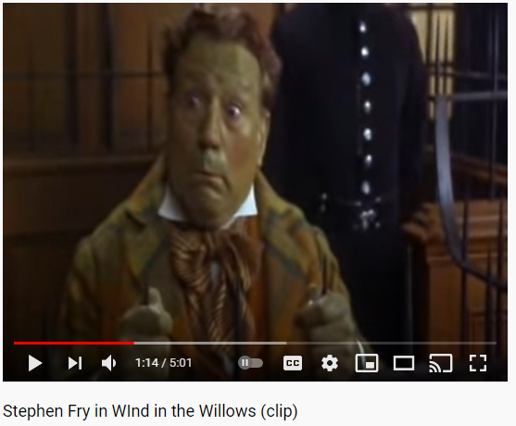

Plan:

* Tell the students in this lesson we will be considering one of the most dramatic scenes in the book. What scene do they think this might be? What do they think the climax of the novel is? Briefly touch on the idea of a story mountain to facilitate this
* Watch the video of the courtroom scene where Toad is sentenced to twenty years. Tell the class that we are going to be doing some role-play in order to help us understand this scene
* Discuss the idea of the skill of inference or being ‘reading detectives’, touching on subtext and ideas of show don’t tell
* Tell the students that today we are recreating the courtroom scene, however this time we will give Toad a fair trial and some decent representation! Split the class in two. Half the class should be acting as Toad’s defence arguing why he does not deserve a 20 year prison sentence. The other half should act as the prosecution arguing that he does deserve it.
* Remind the students of some key persuasive devices they can use in order to make their case to the court. Give the students a few minutes to prepare their arguments
* Recreate the courtroom scene, with each student making their case for or against Toad. One student should role-play the judge, it is their duty to deliver a verdict on Toad’s guilt. They should also say why they have reached the decision they have
* Discuss the importance of this scene in the book, raising the idea of Toad representing the upper class of Britain. What does this tell us about Kenneth Grahame’s feelings on this?
* As a finishing activity, consider this quote from the book: 'Rouse thee, old loon, and take over from us this vile Toad, a criminal of deepest guilt and matchless artfulness and resource”. Do they think this is a fair depiction of Toad. Why or why not?

Homework:

* Write a P.E.E. paragraph answering the question “Does Toad ultimately grow up by the end of the novel. Why or why not?”. Answer this with reference to quotes and scenes from the book and any of the wider context in the novel.

**The Wind in the Willows: Lesson 3**

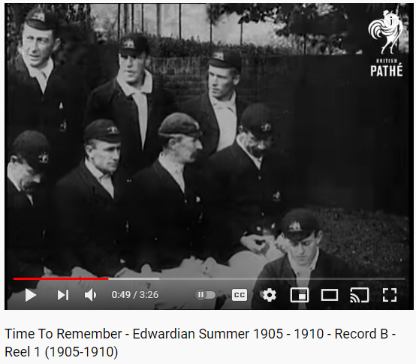

Plan:

* Start the lesson with a short video showing what Britain looked like when *The Wind in the Willows* was written. Ask the students to write down similarities and differences between life in the early 1900s and modern life. How does this affect the way the book is written?
* Place on the board a list of some of the most interesting vocabulary from *The Wind in the Willows.* Draw the students’ attention to the fact some of it is quite old-fashioned
* The class should use the word attack method to try to figure out some synonyms for the words on the board. Then they should use two of the words in their own sentences
* Now consider some of the figurative language used in the book. Analyse the scene where Mole visits the Wild Wood. Can the class come up with two examples of language that builds tension? Consider the idea of the Wild Wood as a metaphor- what could it represent?
* Ask the students to imagine they are Kenneth Grahame’s editor. They should add in six different literary techniques to this extract that they have made up themselves: a simile, a metaphor, onomatopoeia, oxymoron, and an example of personification and alliteration
* Now highlight some of the verbs in the extract. The students should use a thesaurus to find words that transform the tone and meaning of the extract. Give an example of this, using word choice to change the feeling of the extract from sinister to idyllic
* Introduce the idea of genre. What genre does the class think *The Wind in the Willows* might be. Give them a list and some definitions to chose from and ask them to explain their choice
* Now ask the class to rewrite the passage in a different genre. How does this affect the tone of the book? Spin the genre/technique wheel as a finishing activity for the class to complete

Homework:

* Come up with an extra scene from *The Wind in the Willows,* written in the style of Kenneth Grahame. You should use as much high-level vocab as possible, paying attention to the kinds of language he uses, and also some literary techniques to make your writing really beautiful!