**Harry Potter and the Order of the Phoenix**

Chapters Twenty-Three to Thirty-One

**Opening Activity**

* Power and the abuse or misuse of power is a big theme in this Harry Potter book. If you were Minister for Magic, what changes would you make, and how would you run the Wizarding world?

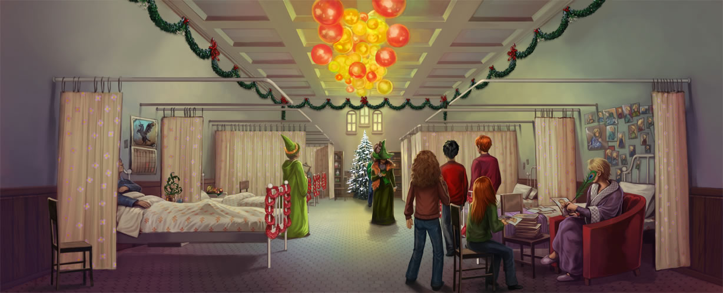

**Chapter Twenty-Three – Christmas on the Closed Ward**

Harry begins to wonder if he himself is the weapon Voldemort seeks. Back at Grimmauld Place, Harry decides the best and safest thing for him to do is return to Little Whinging. As Harry packs his trunk, Phineas Nigellus appears in his portrait with a message from Dumbledore, telling Harry to stay where he is.

The following evening, Hermione admonishes Harry for his behaviour. Ginny and Ron join them, and Ginny points out that she’s the only one who knows what it feels like to be possessed by Voldemort and does not believe Harry is experiencing what she experienced. Relieved, Harry finally joins the festivities. At St. Mungo’s, visiting Arthur Weasley, Hermione, Ron, Ginny, and Harry spot Neville and his grandmother, who are visiting Neville’s parents. Mr. and Mrs. Longbottom were tortured into lunacy by Bellatrix Lestrange.

**Questions**

* Why is Hermione angry at Harry?
* How does seeing Neville at St. Mungo’s give us an insight into his character?

**Chapter Twenty-Four – Occlumency**

Dumbledore has asked Snape to teach Harry Occlumency, which is the defence of the mind against outside penetration. Harry is unhappy about extra lessons with Snape, but he agrees to learn. As Harry leaves for Hogwarts, Sirius hands him a wrapped package, which he claims Harry should use only if he needs him.

Back at Hogwarts, Harry arranges a Hogsmeade date with Cho for Valentine’s Day. Harry reports to Snape’s office for his Occlumency lessons. Snape explains that Voldemort is an expert at Legilimency, which is the ability to extract feelings and memories from another person’s mind. Snape uses Legilimency to shoot himself into Harry’s mind, rifling through Harry’s memories. Harry fights back and returns to the present. They try again, and Harry once again fails to block Snape. The next time, Harry is dragged back into his recurring dream, in which he is running down a corridor at the Ministry of Magic with Mr. Weasley. This time, Harry recognizes the hallway as leading to the Department of Mysteries. He asks Snape about the Department, but Snape dismisses his question. Later that night, Harry’s scar starts to burn. Voldemort is very happy.

**Questions**

* What do we think is the significance of Harry’s recurring dream? Why do we think Voldemort is happy?
* 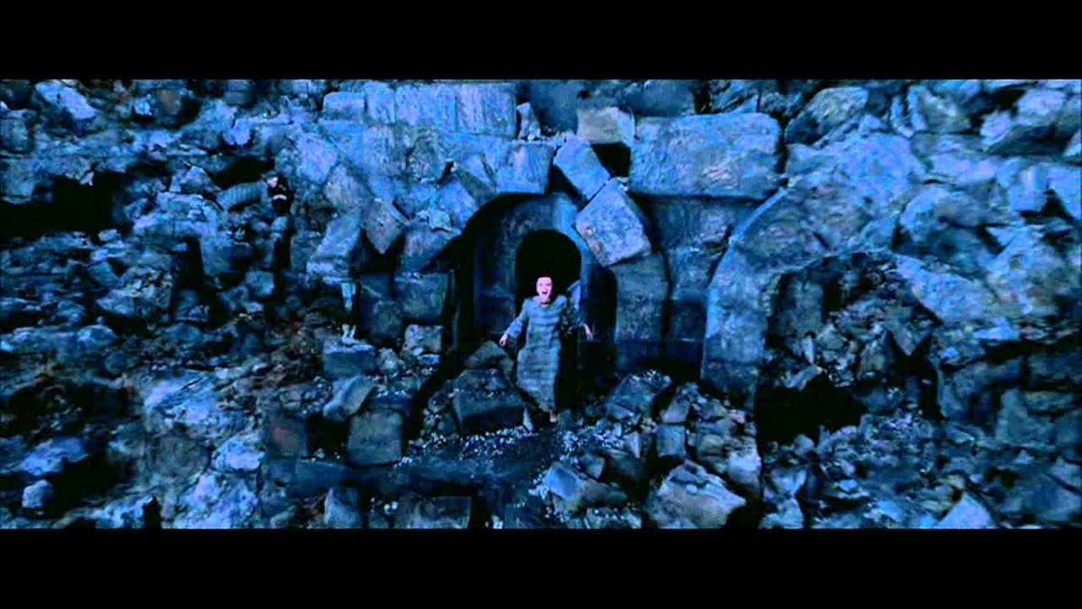

**Chapter Twenty-Five – The Beetle at Bay**

The next morning, Hermione’s *Daily Prophet* reveals a mass breakout at Azkaban. Ten former Death Eaters, including Lestrange, are loose. Harry realizes this is why Voldemort was so happy. They also read that a Ministry of Magic worker named Bode died at St. Mungo’s after being strangled by a dangerous potted plant. Ron recalls his father talking about Bode and remembers that Bode worked in the Department of Mysteries. Umbridge has posted a new Educational Decree, banning all Hogwarts teachers from discussing with students anything not directly related to their subjects.

Umbridge attends every Divination and Care of Magical Creatures lesson, and students begin to wonder whether Trelawney or Hagrid will be fired first. Hagrid bans Harry, Ron, and Hermione from visiting his cabin, claiming it’s too dangerous.

**Questions**

* Who do we think will be fired first out of Hagrid and Trelawney?
* Can we spot any foreshadowing in this chapter?

**Chapter Twenty-Six – Seen and Unforeseen**

Harry’s *Quibbler* story appears. By mid-morning, Umbridge has posted a decree banning any students from reading or possessing the *Quibbler*. When Harry goes to bed that night, his scar aches. He has another vision of himself as Voldemort, this time discussing Bode’s death with Rockwood, a Death Eater who escaped from Azkaban. Harry wakes up screaming. Ron again suggests he go to Dumbledore, but Harry refuses. The next morning, Hermione figures out that Bode must have been under an Imperius Curse. When Bode tried to get the mysterious weapon Voldemort is searching for, he went mad and ended up in St. Mungo’s.

Harry continues studying Occlumency with Snape. He has made little progress but does manage to get inside Snape’s mind for a brief moment. Professor Trelawney interrupts their lesson by screaming from the entrance hall. Umbridge has fired her. Dumbledore appears and permits Trelawney to stay and live at Hogwarts, although he cannot reinstate her teaching position. Dumbledore then introduces the new Divination teacher, a Centaur named Firenze.

**Questions**

* Why doesn’t Umbridge want anyone reading the Quibbler?
* Why has Umbridge fired Trelawney, and what does that mean for Hogwarts?
* 

**Chapter Twenty-Seven – The Centaur and the Sneak**

Firenze assumes Trelawney’s duties, explaining to the students that nothing, even centaurs’ knowledge, is foolproof. After class, Firenze asks Harry to tell Hagrid that his attempt is not working and he must abandon it. Harry relays the message, but Hagrid ignores it.

The D.A. begins working on conjuring Patronuses. Dobby interrupts to warn the group that Umbridge is on her way, and the students scatter. Malfoy trips Harry and hands him over to Umbridge. Umbridge drags Harry to Dumbledore’s office, where Cornelius Fudge is waiting, and fetches her informant, a Ravenclaw named Marietta. Because Hermione jinxed the scroll with the D.A.’s names against snitches, Marietta’s face is covered in giant purple pimples spelling the word “Sneak.” Marietta refuses to uncover her face to speak. Dumbledore takes full responsibility for the D.A. He points to the title on the parchment, identifying the group as Dumbledore’s Army. When the Minister attempts to arrest him, Dumbledore sends a streak of silver light through his office and disappears.

**Questions**

* Why does Dumbledore take the blame for the D.A.?
* What do we think is the meaning of Firenze’s messages?

**Chapter Twenty-Eight – Snape’s Worst Memory**

Umbridge replaces Dumbledore as Headmistress and appoints an Inquisitional Squad of students, which is comprised mostly of Slytherins, to do her bidding. The Squad has the power to take points from Houses, which Malfoy does happily. Fred and George swear to make Umbridge’s life at Hogwarts difficult, and they set off a crate of fireworks in the Great Hall. Umbridge’s magic does not work, and the teachers refuses to help her.

Harry dreams of the Department of Mysteries again. This time he gets through the doors and into a room lined with dusty glass spheres. He heads toward one but wakes up before he reaches it. The next day, Harry resumes lessons with Snape. Malfoy interrupts to say that Umbridge needs Snape’s help. While Snape is gone, Harry climbs into the Pensieve, hoping to gain insight into the Department of Mysteries. Harry sees Snape taking his O.W.L.s and then sees his father, James Potter, with Sirius, Lupin, and Moody. Sirius and James catch sight of Snape. They torment and humiliate him in front of the other students. Lily, Harry’s mother, attempts to intervene, but Snape calls her a Mudblood, and she backs off. Snape returns to his classroom and yanks Harry out of the Pensieve, enraged. Harry is devastated by James and Sirius’s behaviour.

Questions

* Why is Harry embarrassed about his father’s behaviour?
* Why does Umbridge give the students power to take points?

Chapter Twenty-Nine – Career Advice

Snape refuses to give Harry additional Occlumency lessons. Harry wants to talk to Sirius about what he saw in the Pensieve but knows it is too dangerous. A notice for Career Advice is posted on all the bulletin boards. Fifth-years must meet with their Heads of House in the following week.

Fred and George offer to create a distraction so Harry can use the fire in Umbridge’s office to talk to Sirius. Harry leaves for his Career Advice meeting with McGonagall, which Umbridge also attends. McGonagall approves of Harry’s aspirations to become an Auror and encourages him to study hard. Umbridge suggests that he consider another path, since the Ministry would never employ him. Harry leaves and prepares for his break-in. He thinks about how Sirius had told him that James enjoyed taking risks. Harry wonders if he even wants to be like his father anymore.

Harry sneaks into Umbridge’s office and uses Floo power to transport his head to the fireplace at number twelve. Harry tells Sirius what he saw in the Pensieve, and Sirius insists that he and James were just young and foolish. Harry mentions that Snape has since stopped Occlumency lessons, and Lupin insists that Harry convince him to continue. Harry leaves the fire and returns to find that Fred and George have turned the school into a swamp. Umbridge threatens serious punishment, but Fred and George decide, instead, to drop out of Hogwarts.

**Questions**

* Why won’t the Ministry employ Harry?
* How has Harry’s impression of his father changed throughout the book?

**Chapter Thirty – Grawp** 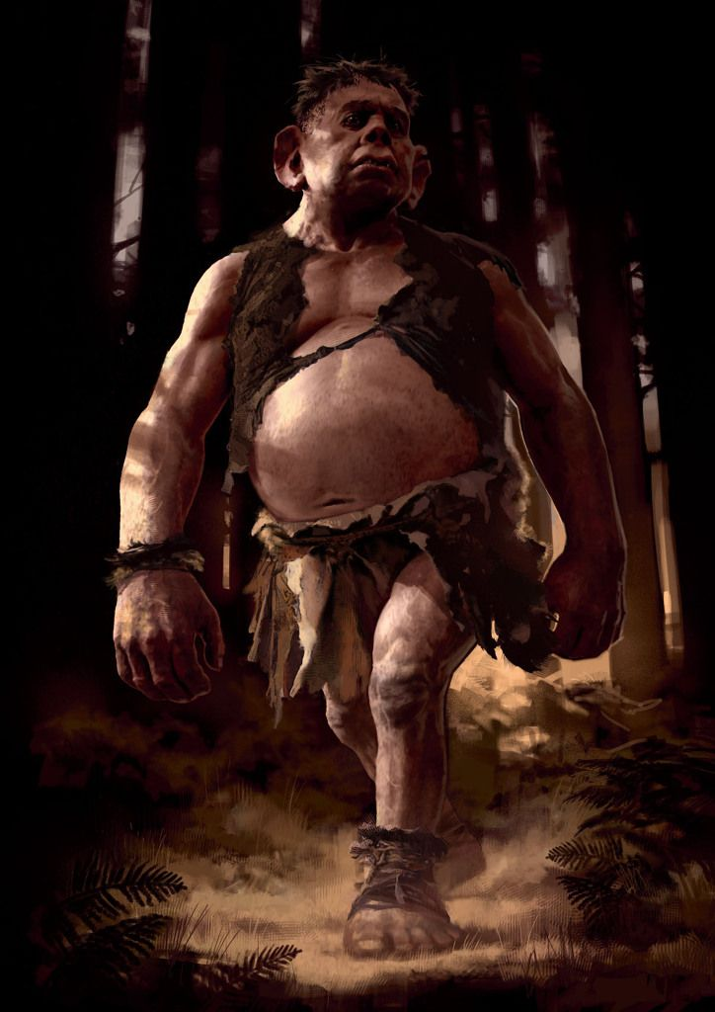

Harry and Hermione take their seats for the final Quidditch match of the season. Hagrid sneaks up behind them and asks them to follow him into the Forest. Eventually, they run into a Giant. Hagrid believes that the Giant is his half-brother and is trying to teach it English. The Giant’s name is Grawp, and he had been bullied by the other Giants for being too small. Hagrid introduces Harry and Hermione to Grawp, who is pulling up trees by their roots. Hagrid asks the young wizards to visit Grawp and help him with his English if Hagrid is fired. On their way out of the forest, Hagrid is surrounded by a herd of threatening Centaurs, who are angry with Hagrid for bringing Grawp to the forest. Harry and Hermione return to the Quidditch pitch to hear a new version of “Weasley is our King.” Gryffindor has won the match and the Quidditch cup. Ron is ecstatic.

**Questions**

* What does Grawp reveal about Hagrid’s character?

**Homework**

* You are a journalist working for a secret, underground newspaper. Write a report on what is happening at Hogwarts, sharing the secrets with the world.