**Harry Potter and the Order of the Phoenix**

Chapters Sixteen to Twenty-Two

Opening Activity

* Dreams and visions play a big role in this book. Write a story about the last dream that you can remember. Do you think it was significant?

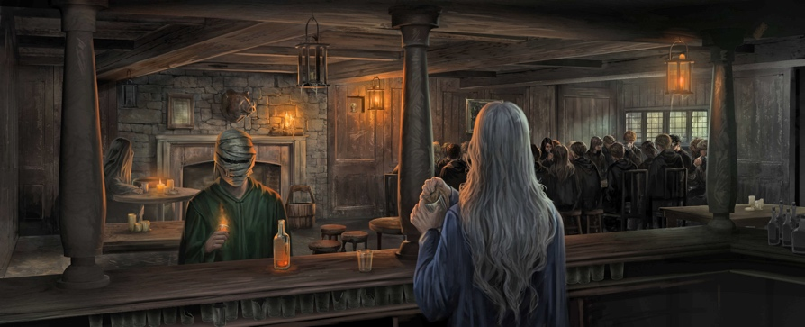

**Chapter Sixteen – In the Hog’s Head**

Hermione asks Harry if he has thought any more about teaching Defense Against the Dark Arts. Harry finally agrees to lead the group. Hermione quietly spreads the word about a meeting to discuss a student-run Defense Against the Dark Arts group on the next Hogsmeade trip and arranges for everyone to meet at the Hog’s Head. Hermione tells Harry she expects only a few people to come, but twenty-five arrive. Hermione introduces Harry, explaining that the students need to learn real, practical Defense since Voldemort has returned. Hermione passes around a piece of parchment, and everyone signs his or her name.

Questions

* How does Harry grow up in this chapter? Why is this an important development for him?

### Chapter Seventeen – Educational Decree Number Twenty-Four

Umbridge posts an Education Decree forbidding all student organizations, including the Quidditch teams, from meeting again until they receive her approval. Ron and Harry suspect that Umbridge knows about their Defense group, but Hermione explains that she put a jinx on the piece of parchment, and if anyone had snitched, they would know. Later that morning, in History of Magic, Harry sees Hedwig in the window. Her feathers are ruffled, and she is holding her wing at an odd angle. Harry takes Hedwig to Professor Grubbly-Plank. She agrees to mend Hedwig and removes a letter from Hedwig’s leg. The letter is from Sirius, and reads: “Today, same time, same place.”

Umbridge is sitting in on Potions, and Snape is visibly irritated. Later, Sirius appears in the fire. Sirius knows about their secret Defense Against the Dark Arts group and encourages them. Their reunion is cut off when Sirius sees Umbridge’s hand groping through the flames.

Questions

* Why is Umbridge banning organizations? What is she afraid of?
* 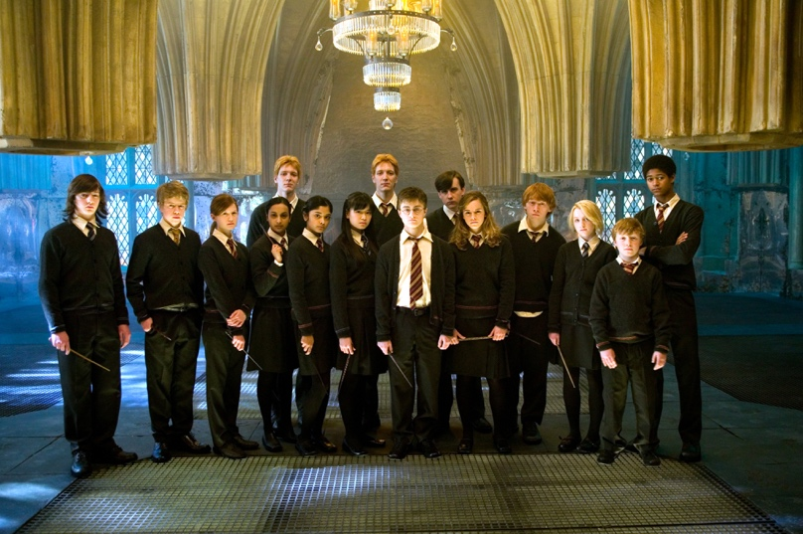Do we think Sirius should be encouraging Harry?

Chapter Eighteen – Dumbledore’s Army

Hermione blames Hedwig’s injuries on Umbridge reading Harry’s mail. Harry agrees. After classes, Angelina receives permission to reform the Gryffindor Quidditch team. When Ron and Harry arrive at the Pitch, it is rainy and cold. Harry’s scar hurts, and he senses that Voldemort is upset that something he wants is not happening fast enough. Studying in the Common Room later, Harry falls asleep by the fire. Dobby, the House Elf, wakes him up. Harry asks Dobby if he knows of a room where the students could practice Defense secretly. Dobby tells Harry about the Room of Requirement, which appears only when it is needed. Harry calls a meeting for the next night. Students arrive, and Hermione suggests that they decide on a name. Cho Chang suggests the D.A., for Defense Association, and Ginny points out that it can also stand for Dumbledore’s Army. Hermione writes Dumbledore’s Army on a piece of parchment with everyone’s names and pins it to the wall. They begin practicing.

Questions

* Why is the pain in Harry’s scar worrying in this chapter?
* Why do you think the students participate in classes with such enthusiasm?

### Chapter Nineteen – The Lion and the Serpent

The first Quidditch match of the season, Gryffindor versus Slytherin, approaches. On the morning of the match, Ron is too nervous to speak. The Slytherin team is wearing badges that read “Weasley is our King.” From the stands, the Slytherins sing a song of the same name, mocking Ron’s Keeper skills. Embarrassed, Ron misses several shots. Fortunately, Harry catches the snitch, and Gryffindor wins.

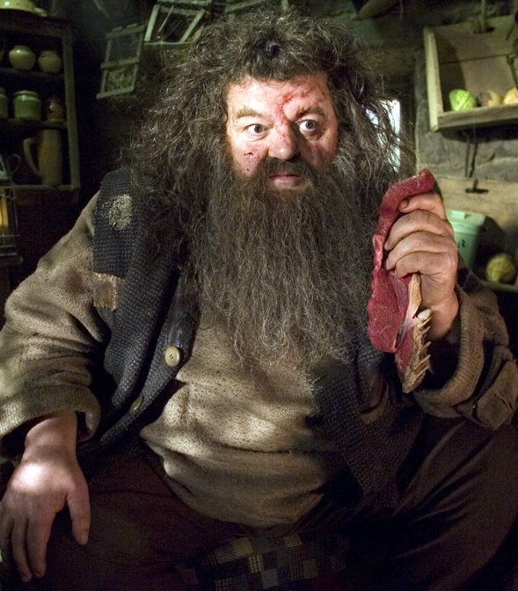Malfoy and his thugs scream insults, and Harry and George leap at Malfoy, landing themselves in McGonagall’s office. She gives them each a week of detention. Umbridge appears and produces another Decree from the Ministry, this time giving her authority over all punishments. McGonagall is livid, but cannot stop Umbridge from banning Harry, George, and Fred, who was not even involved in the fight, from ever playing Quidditch again. Umbridge confiscates their brooms. Harry is devastated. Later, Hermione realizes Hagrid is back.

Questions

* Why can’t McGonagall do anything to stop Umbridge?
* What is the significance of fairness in this chapter?

**Chapter Twenty – Hagrid’s Tale**

Harry, Ron, and Hermione grab Harry’s Invisibility Cloak and scurry off to Hagrid’s cabin. Hagrid’s face is badly bruised and bleeding. Hagrid explains that he had gone into the mountains to talk to Giants and rally support for Dumbledore but ultimately failed to enlist their help. Umbridge knocks at the door, and Harry, Ron, and Hermione duck under the Invisibility Cloak. Hagrid refuses to tell her about the Giants. After she leaves, Hermione warns Hagrid about Umbridge and her class inspections, cautioning him against teaching anything too dangerous or unconventional. Hagrid appears unconcerned.

Questions

* Hagrid seems unconcerned that Umbridge is scrutinising him. Do we trust Hagrid to keep the secret?

**Chapter Twenty-One – The Eye of the Snake**

The next day, Hagrid leads his class into the forest. The horrible horse-like creatures Harry saw pulling carriages appear again, and Hagrid asks who can see the creatures. Harry, Neville, and a Slytherin boy raise their hands. Hagrid explains that the creatures are called Thestrals and are visible only by those who have witnessed death.

Angelina, the Gryffindor Quidditch captain, chooses Ginny Weasley to replace Harry as Gryffindor Seeker. At the last D.A. meeting before Christmas break, Harry is left alone with Cho Chang. Cho starts to cry and admits that she is thinking about Cedric. Standing under the mistletoe, Harry and Cho kiss.

Harry returns to the Common Room and tells Ron and Hermione what happened. Harry falls asleep with his head full of thoughts. He dreams that his body feels smooth and powerful. He is a snake, slithering toward a man sitting on the floor, guarding a door. Harry rears from the floor and strikes the man, plunging his fangs into the man’s flesh. Harry wakes up with Ron standing over him. Neville arrives with McGonagall. Harry tells her that Ron’s dad has been attacked by a snake. McGonagall nods and takes Harry to Dumbledore’s office.

Questions

* 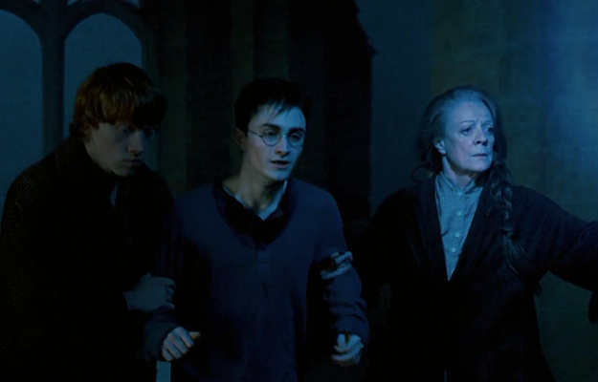What is significant about Harry’s dream, and how does this feed into the idea of powerful dreams in the book as a whole?

**Chapter Twenty-Two – St Mung’s Hospital for Magical Maladies and Injuries**

Harry tells Dumbledore about his vision, and how he inhabited the snake’s body during the attack. Dumbledore calls to the portraits of former headmasters and headmistresses hanging on the walls of his office and asks them to raise the alarm. When the portraits return, they explain that members of the Order have found Mr. Weasley at the Ministry and taken him to St. Mungo’s Hospital. McGonagall wakes the other Weasley children, and they prepare to travel to Twelve Grimmauld Place by Portkey. As they are leaving, Harry’s scar starts to burn. He looks up at Dumbledore with a powerful hatred, fighting the urge to attack him. He is thrust back to number twelve. Harry tells Fred, Ginny, George, and Sirius about his vision but does not mention that he actually inhabited the snake. A letter from Mrs. Weasley arrives, announcing that Mr. Weasley is still alive.

Mrs. Weasley returns from St. Mungo’s and thanks Harry for his vision, which she believes saved Mr. Weasley’s life. The Weasleys and Harry agree to stay with Sirius for the holidays. Harry tells Sirius the whole truth about his vision, including the rage he felt at Dumbledore right before they left Hogwarts. Sirius tells him not to worry.

Questions

* Do we think Sirius is right to tell Harry not to worry?
* What might his vision mean?

Homework

* Write a letter from Sirius to Harry talking about the time that he has spent at 12 Grimmauld Place. Think about what his daily routine would be like, and consider his emotions and feelings at this time.