**Harry Potter and the Order of the Phoenix**

Chapters Thirty-One to Thirty-Eight

Opening Activity

* Harry Potter Christmas Quiz!

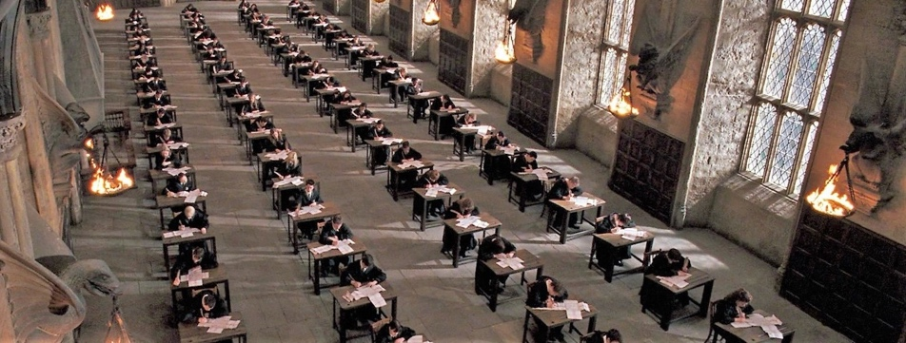

Chapter Thirty-One – O.W.L.S

Harry and Hermione explain Hagrid’s request. Ron is horrified by the prospect of visiting with a Giant but does not want to let Hagrid down. The students begin taking their O.W.L. exams. As they are filling in their star charts in the Astronomy Tower, Harry spies a team of six people entering Hagrid’s cabin. The team attempts to stun Hagrid but Hagrid successfully deflects the spells. Professor McGonagall runs across the lawn to help. Four red beams strike her down. Hagrid disappears past the gates. McGonagall is taken by Professor Trelawney to the hospital wing. That night, Harry gets almost no sleep.

The following morning, Harry is exhausted for his History of Magic O.W.L., falling asleep in the middle of the test. He has another vision. This time, he reaches the room with the glass spheres and, in Voldemort’s voice, instructs a black shape to lift a sphere down for him. The shape on the floor refuses, saying he would die first. Harry realizes that the shape is Sirius.

Questions

* Who are the people attacking Hagrid and why do they want to take him away?
* Why is Harry finding it hard to focus on his exams?

**Chapter Thirty-Two – Out of the Fire**

Harry leaves the Great Hall to find McGonagall. Madam Pomfrey tells Harry that McGonagall has been taken to St. Mungo’s. Realizing that he has no one else to turn to, Harry runs to find Ron and Hermione. Hermione warns Harry that Voldemort may be attempting to lure Harry to the Department of Mysteries.

Harry doesn’t want to take any chances and insists they get to the Ministry as soon as possible. Ginny and Luna walk in and offer their help. Hermione convinces Harry to use the fire in Umbridge’s office to first see if Sirius is actually at number twelve. Inside Umbridge’s office, Harry uses Floo powder to transport himself to number twelve. Kreacher appears and tells Harry that Sirius is at the Department of Mysteries. Harry is pulled from the fire by Umbridge, who demands to know to whom he was speaking. Harry sees that Ginny, Hermione, Ron, Luna, and Neville have been captured by Umbridge’s Squad. Snape enters Umbridge’s office, and Harry yells “He’s got Padfoot at the place where it’s hidden!” in hopes that Snape will contact someone in the Order.

Umbridge admits she was the one who sent the dementors to Little Whinging last summer. Before she can use an illegal Cruciatus Curse on Harry, Hermione screams and tells Umbridge that Harry was trying to contact Dumbledore. When Umbridge asks why, Hermione tells her that Dumbledore has asked the students to build a weapon. Umbridge demands that she and Harry lead her to the weapon.

Questions

* Do we think Snape will understand or help Harry? What reason does he have to help him?
* 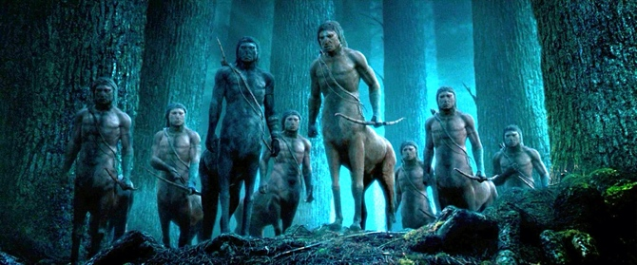What is revealed about Umbridge’s character here?

**Chapter Thirty-Three – Fight and Flight**

Harry follows Hermione out of Hogwarts, with Umbridge in tow. Harry has no idea where Hermione is taking them. They enter the Forbidden Forest. Moments later, a herd of Centaurs surrounds them. Umbridge insults the Centaurs, and they carry her away. Grawp appears and recognizes Hermione. In broken English, he demands to know where Hagrid is. Hermione screams that she doesn’t know, and, in the chaos, she and Harry run to safety. On their way out of the forest, they run into Ron, Ginny, Neville, and Luna, who escaped their captors and left to find Harry and Hermione. Harry wants to go to the Ministry alone, but his friends insist on helping. Luna spots a herd of thestrals, who can take them to the Ministry.

Questions

* Why are the Centaurs angry at Umbridge?
* Why is Harry insistent on going to the ministry alone?

**Chapter Thirty-Four – The Department of Mysteries**

Harry, Ron, Hermione, Luna, Neville, and Ginny ride thestrals to the Ministry, where they take the elevators to the Department of Mysteries. Harry recognizes the corridor from his dreams and knows exactly which one to enter. There are more doors in the next chamber, and Harry doesn’t know which one to use. They try several. One room houses a tank full of brains, and the next has an ancient archway with tattered black curtains. Harry hears whispering behind the curtains. Finally, they find the right door and move toward the dusty spheres, realizing that Sirius is not there. Harry begins to think Hermione’s suspicions were correct. Ron notices that one of the dusty spheres has Harry’s name on it, as well as Voldemort’s. Harry picks it up. Moments later, he hears Lucius Malfoy order him to hand it over.

Questions

* Harry realises in this chapter that he has made a mistake. How might it have been avoided?

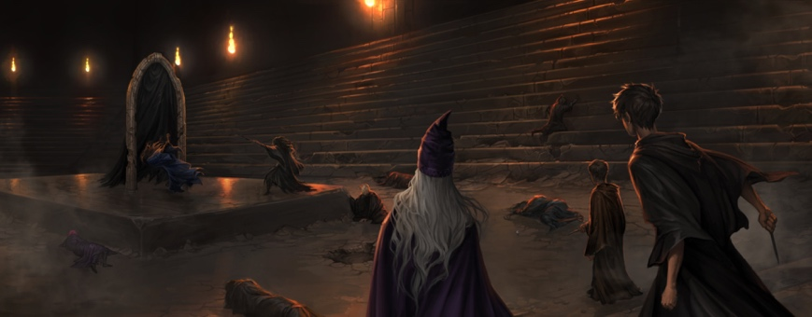**Chapter Thirty-Five – Beyond the Veil**

Harry demands to know where Sirius is. Malfoy asks Harry to give him the prophecy, but Harry refuses to relinquish the sphere, threatening to smash it if the encroaching crowd of Death Eaters attack his friends. Malfoy tells him the sphere contains the story of his scar and explains that only those about whom a prophecy has been made can safely retrieve it. Voldemort could not come himself so they lured Harry here by manipulating his dreams.

At Harry’s signal, the students use their wands to shatter the rows of spheres. Harry sprints from the chamber, gripping his prophecy. The Death Eaters follow. Hermione is stunned by a Death Eater and falls to the ground. Neville’s nose is broken in the fray. Ron falls under some sort of lunacy spell, and Ginny’s ankle is broken by a Death Eater. Dragging Hermione, they keep moving, but five Death Eaters corner them in the brain room. The brain jar bursts open, and Ron picks one up. Tentacles shoot out and try to strangle Ron. Death Eaters stun Ginny and toss Luna into a desk. Both lie unconscious, leaving only Neville and Harry to fight the remaining Death Eaters. Harry, still clutching the prophecy, runs into the room with the arch. Neville follows, and Lestrange begins to torture Neville with the Crucio curse.

Suddenly, Sirius, Lupin, Moody, Tonks, and Kingsley appear. Sirius yells for Harry to take Neville and the prophecy and run. As Harry attempts to grab Neville, the prophecy slips from his robes and cracks open. Dumbledore appears. Lestrange, duelling with Sirius, sends a jet of red light right into his chest, and he falls through the curtains. Harry runs to the arch, but Lupin holds him back. Lupin tells Harry that Sirius is gone.

Questions

* This is one of the most exciting and action-packed chapters in any of the books so far. How is the action handled here, and how does J.K. Rowling create excitement and tension?

**Chapter Thirty-Six – The Only One He Ever Feared**

Harry refuses to believe that Sirius is dead. He spots Lestrange and runs after her. He catches up to her in the Atrium. Harry shouts at Lestrange that the prophecy is gone and that she will have to kill him. Voldemort and Dumbledore appear. Voldemort strikes Dumbledore, but Dumbledore’s bird, Fawkes, takes the blow. Voldemort disappears, and Harry’s scar bursts open. Voldemort uses Harry’s voice to speak to Dumbledore, asking Dumbledore to kill him by killing Harry. Suddenly, Harry feels Voldemort leave his body, and he crumples to the floor. Harry learns that Voldemort had grabbed Lestrange and Disapparated from the Ministry. Cornelius Fudge runs in, confused. He demands to know what has happened, and Dumbledore promises to tell him after he sends Harry back to Hogwarts. Still stunned, Dumbledore gives Harry a Portkey and Harry whizzes back to Dumbledore’s office.

Questions

* Why does Harry run after Lestrange? And why can’t he believe that Sirius is dead?
* Why does Voldemort decide to speak through Harry?

**Chapter Thirty-Seven – The Lost Prophecy**

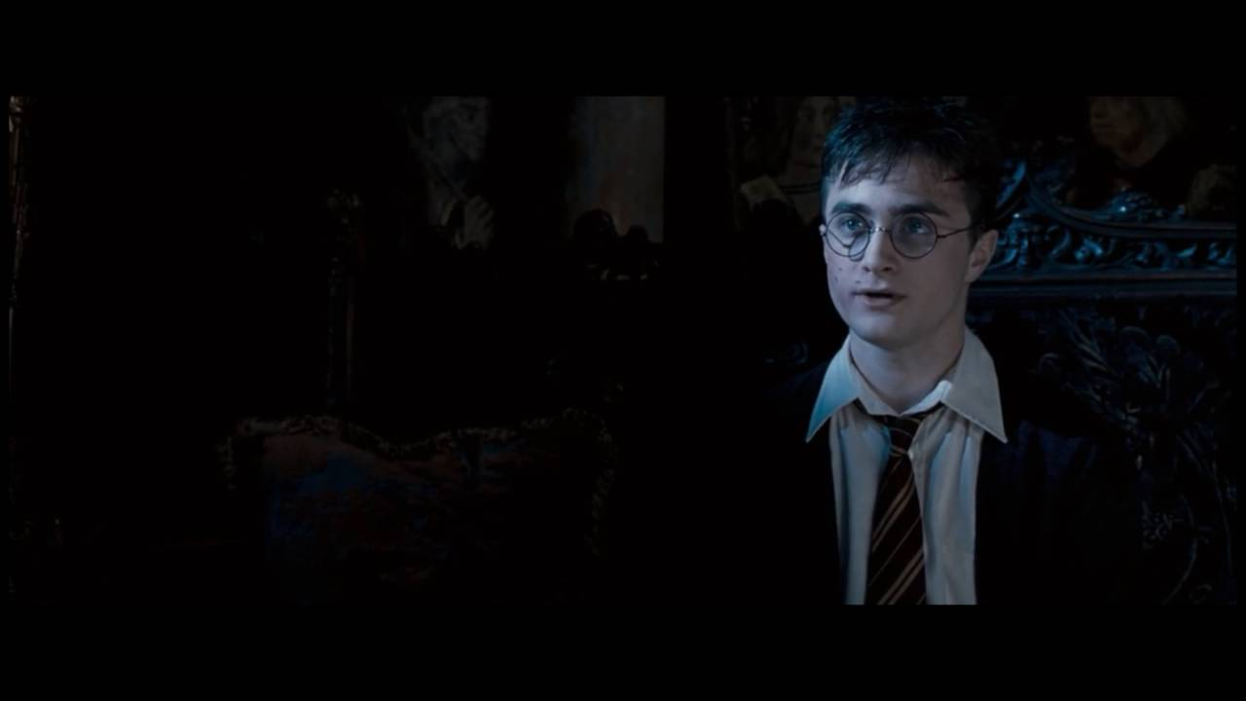

Dumbledore meets Harry in his office. Harry is visibly upset about Sirius’s death. Dumbledore tells Harry this pain is his greatest strength. Dumbledore admits it’s his own fault that Sirius is dead because he never told Harry the whole truth about his scar. Dumbledore explains. On the night Harry saw Mr. Weasley attacked, Voldemort figured out that Harry’s scar allowed Harry to be privy to Voldemort’s thoughts and actions. Assuming this connection must work both ways, Voldemort began forcing his way into Harry’s thoughts. Voldemort knew the only person Harry would go to great lengths to save was Sirius.

When Harry was an infant, Hagrid took him to the Dursleys instead of a Wizarding family because, in order to remain safe, Harry needed to be near his mother’s blood, which came in the form of Aunt Petunia. As long as Harry can still call the place where his mother’s blood dwells *home*, he is safe. Dumbledore sent the Howler to Petunia to remind her of this bond.

Questions

* Dumbledore says pain is Harry’s greatest strength. What does he mean by this?

### Chapter Thirty-Eight – The Second War Begins

Harry is in the hospital wing with Ron, Hermione, Ginny, Neville, and Luna. Dumbledore saved Umbridge from the Centaurs, and she is also in the hospital. Harry hasn’t told his friends about the prophecy. He tells his friends he is going to see Hagrid, but instead he sits at the edge of the lake and cries.

Professor McGonagall makes a full recovery and returns to Hogwarts. The day before the end of term, Umbridge leaves the school. Harry finds the wrapped package Sirius gave him at Christmas. He rips the paper off and finds a mirror with an inscription on the back, instructing Harry to use it to communicate with Sirius. Harry shouts into the mirror but receives no reply. Devastated, Harry throws the mirror down, and it shatters. Harry decides to seek advice from a Hogwarts ghost and finds Nearly Headless Nick. Nick explains that not all dead wizards are turned into ghosts. Harry, upset, runs into Luna, who asks about Sirius. Remembering that Luna can see the thestrals, he asks her if anyone she has known has died. Luna says her mother died when she was nine. She tells Harry that the voices behind the curtain at the Department of Mysteries are the voices of wizards who have died. Harry is not sure whether to believe her or not.

The next day, all Hogwarts students board the Hogwarts Express. Cho walks by, and Harry does not meet her eyes. He tells Ron that nothing is going on with Cho anymore. When the train pulls into Kings Cross, Harry sees several members of the Order waiting for him. Lupin spots the Dursleys, and Moody, Tonks, and Mr. Weasley insist that they treat Harry fairly while he is home for the summer. Ron and Hermione promise to see him soon, and Harry heads back to Four Privet Drive.

Questions

* Why is Harry no longer seeing Cho?
* What will Harry’s summer be like this time?

Homework

* ‘The character of Harry Potter teaches us how to be strong and deal with difficult situations and feelings’. Discuss this statement. To what extent do you agree or disagree?