**Harry Potter and the Order of the Phoenix**

Chapters Nine to Fifteen

**Opening Activity**

* In these chapters we are introduced to the character of Umbridge, who is one of the best (or worst) villains in the series. Think about any other books you’ve read or movies you’ve watched – who is the best villain you’ve ever seen?

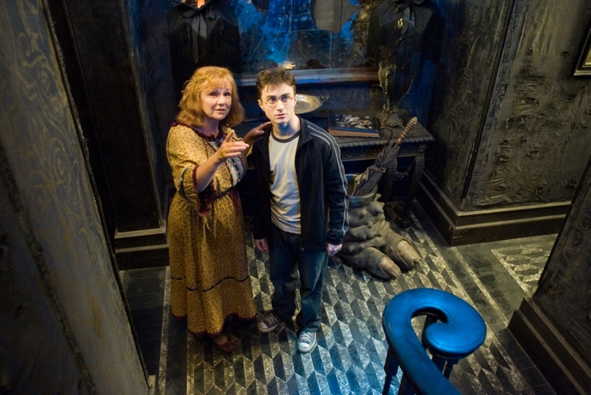

**Chapter Nine – The Woes of Mrs Weasley**

After the hearing, Mr. Weasley and Harry return to number twelve. Sirius does not seem happy that Harry will be returning to Hogwarts. Hermione suspects that Sirius secretly wanted Harry to live with him. Ron and Hermione have both been selected as Gryffindor prefects for the coming year. Mrs. Weasley is delighted with Ron’s achievement and buys him a new broom. Later, Harry becomes increasingly enraged that Dumbledore overlooked him for the prefect position, recounting the many times he has proven himself a better wizard than Ron.

Later, Moody pulls out a photograph of the old Order and shows Harry the former members. Harry sees Neville’s parents and eventually his own. Harry gets upset at the sight of his mother and father. He retreats upstairs, irritated with Moody for showing him the photograph.

**Questions**

* What is interesting about Harry’s mood and behaviour in this extract?
* Why do we think Dumbledore hasn’t made Harry a prefect?

**Chapter Ten – Luna Lovegood**

Harry has a troubling night’s sleep, dreaming of Mrs. Weasley crying and Ron and Hermione wearing crowns. He wakes up to Ron telling him they’re going to be late for the train to Hogwarts. A guard must accompany Harry. When no one can locate Sturgis Podmore, Sirius fills in, transforming himself into Padfoot, in direct defiance of Dumbledore’s orders. Ron and Hermione sit in the prefect cabin, and Ginny and Harry run into Neville. The three of them unhappily share a compartment with Luna “Loony” Lovegood, who is reading the wizard tabloid *The Quibbler*, which her father edits. Eventually, Ron and Hermione join them. Ron tells Harry that Draco Malfoy is now a Slytherin prefect. The train arrives at Hogwarts. Harry expects to see Hagrid directing the first-years but instead sees Professor Grubbly-Plank. As Harry approaches the usually horseless carriages that bring the students up the castle, he realizes that they are being pulled by emaciated, winged, horse-like creatures. Harry asks Ron about the horse creatures, but Ron doesn’t see them. Luna tells Harry that she can see them, too, and has been able to since her first year at Hogwarts.

**Questions**

* What do we think the significance of Harry’s dream is? Do we think dreams are important in the book?
* Why might Draco being a prefect present problems later in the book?

**Chapter Eleven – The Sorting Hat’s New Song**

As the first-years arrive, the Sorting Hat bursts into song, warning the students against becoming too internally divisive. Nearly Headless Nick explains that the Hat gives warnings only when it feels Hogwarts is in danger. After supper, Dumbledore announces that Professor Grubbly-Plank will be teaching Hagrid’s class, Care of Magical Creatures, and that Professor Umbridge, the toadlike woman from Harry’s trial, is the new Defense Against the Dark Arts teacher. Professor Umbridge interrupts Dumbledore to deliver a long, boring speech of introduction, and Harry confirms his dislike for her. Very few students actually listen to the speech, but Hermione infers that the Ministry will be interfering in Hogwarts business this year.

**Questions**

* How have things changed this year compared to other years?
* 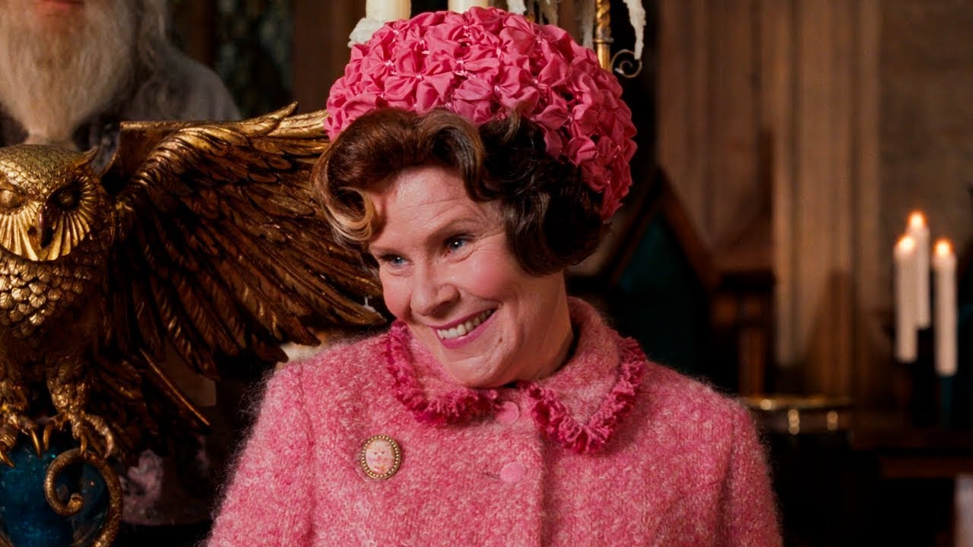What does it mean to be ‘internally divisive’?

**Chapter Twelve – Professor Umbridge**

All fifth-years at Hogwarts must take O.W.L.s, or Ordinary Wizard Level exams. Ron, Harry, and Hermione report to their first session of Professor Umbridge’s Defense Against the Dark Arts class. Professor Umbridge explains that the Ministry does not want underage wizards practicing defensive spells that are dangerous and unnecessary. Harry explodes, explaining that they must be prepared to fight Voldemort. Professor Umbridge insists that Voldemort has not returned and gives Harry detention every night for a week. Harry is sent to see Professor McGonagall, who tells Harry to be mindful of who Umbridge is and to whom she is reporting.

**Questions**

* Who is Umbridge reporting to? What is her agenda?
* 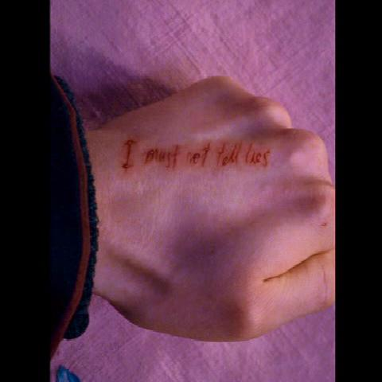Is Harry right to get angry in this chapter?

**Chapter Thirteen – Detention with Dolores**

Harry, Ron, and Hermione leave dinner early to escape whispering students. Before bed, Hermione sets out small knit hats for the House Elves, who are freed when they find clothing of their own. As usual, Hermione seems more concerned with freeing elves than with whether or not they want to be freed.

After dinner, Harry reports to Umbridge’s office, and Umbridge assigns him the task of writing “I must not tell lies” over and over again on a piece of parchment. She gives him a special quill to use, and the words appear on the parchment in blood. The phrase also appears on the back of Harry’s hand, cut into his skin. As Harry stares at the cut, the skin heals over again, slightly redder but still smooth. The process is extremely painful, but Harry does not want to show weakness and does not complain or ask questions. Umbridge finally lets Harry leave. It is past midnight.

On his way back to the dorms after his third night with Umbridge, Harry runs into Ron, who has been secretly practicing for Keeper tryouts. Harry is delighted. Ron sees the back of Harry’s hand, and Harry finally tells him about detention. Ron suggests that he tell Dumbledore, but Harry refuses. At his final detention on Friday, Harry strains to watch Ron’s Keeper tryout from the window. Umbridge grabs his hand to check his progress. As she touches him, Harry’s scar burns tremendously, and he experiences a peculiar sensation in his midriff. When Harry returns to the dorm, he learns that Ron made the Gryffindor Quidditch team. Harry tells Hermione about detention and the pain in his scar. Like Ron, she suggests he consult Dumbledore. Harry refuses but mentions that he may ask Sirius. Hermione reminds him of the Order’s warning about letters.

**Questions**

* Why do we think Harry is hesitant to go to Dumbledore about his worries? Do we think this is the right decision?

### Chapter Fourteen – Percy and Padfoot

Harry wakes up early on Saturday to write Sirius a letter, including subtle allusions to Umbridge, the pain in his scar, and Hagrid. At breakfast, Harry finds an article in the *Daily Prophet* stating that Sturgis Podmore was sentenced to six months in Azkaban for trying to break into the Ministry. Ron suggests that Sturgis was arrested because of his involvement with the Order. After breakfast, Ron and Harry leave to practice Quidditch, and Hermione studies.

The next night, Percy’s owl, Hermes, appears, carrying a letter from Percy. The letter congratulates Ron on becoming a prefect and warns him to stay away from Harry. Harry then spots Sirius’s head in the fire. Sirius tells Harry not to be worried about his scar, since it burns whenever Voldemort feels a powerful emotion. Sirius also agrees that Umbridge is quite unpleasant but does not believe that she is a Death Eater. Sirius does not know anything about Hagrid’s whereabouts but assures Harry he is probably safe. When Sirius suggests transforming into a dog again and accompanying Harry on his next trip to Hogsmeade, both Harry and Hermione protest loudly. Sirius tells Harry his father would have enjoyed the risk and disappears back into the fire.

**Questions**

* What is the significance of Sirius’ final comment in the fire?
* Why does Percy tell Ron to stay away from Harry?

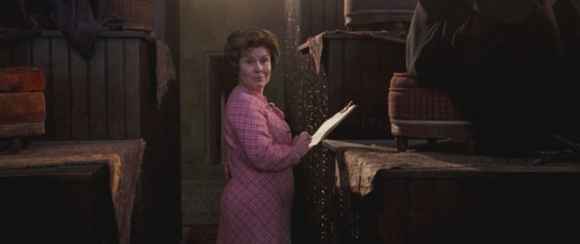**Chapter Fifteen – The Hogwarts High Inquisitor**

According to the Daily Prophet, Dolores Umbridge has been named High Inquisitor, granting the Ministry of Magic an unprecedented level of control at Hogwarts. Umbridge will be sitting in on all classes. At Divination, Umbridge and inspects Professor Trelawney and demands that she make predictions. Later, in Defense Against the Dark Arts, Harry loses his temper again, earning another week of detention. Umbridge appears again in Transfiguration, and Professor McGonagall expresses her obvious disdain. After classes, Harry retreats to Umbridge’s office for another detention. Later, Hermione suggests that the students form their own study group for Defense Against the Dark Arts, with Harry as their teacher. Harry agrees to consider her proposition.

**Questions**

* Why is it bad that the Ministry is interfering at Hogwarts?

**Homework**

* The Quibbler is a tabloid magazine, which mostly publishes gossip and speculation. Write a tabloid article about Professor Umbridge. What might you say about her?