Harry Potter and the Order of the Phoenix

Chapters One to Eight

Opening Activity

* Patronus Charms feature a lot in this novel. What is required to make a Patronus Charm?
* What animal form would your Patronus take, and why? What qualities do you share?

**Chapter One – Dudley Demented**

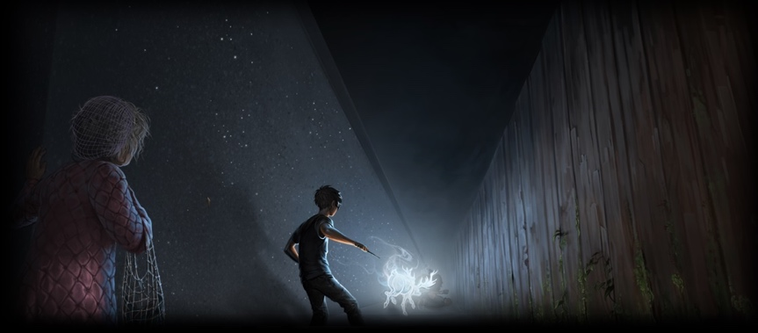

Harry Potter is hiding beneath the open living room window of Aunt Petunia and Uncle Vernon’s home, trying to overhear the evening news. Harry is relieved to hear no news that might indicate the work of Voldemort. Suddenly, a thunderous crack rips through the neighbourhood. Harry is sure that the crack was someone either Apparating or Disapparating. Harry leaves Privet Drive to investigate.

Harry is upset that he has heard little news from his friends. Harry takes a seat on the swings and watches Dudley, leading a gang of delinquents, slinks past. Harry gets up and follows Dudley home. Suddenly, the night becomes pitch black and very cold. Harry realizes that dementors are about to attack. Harry uses his wand to summon a Patronus stag. Mrs. Figg, Harry’s neighbour, comes running toward them, and Harry tries to hide his wand. Mrs. Figg begs him to keep his wand out, in case more dementors lurk nearby.

Questions

* How is this opening different from the first chapters we have had in other books?
* We have seen the Muggle world and the Wizarding world interact in the past, but what is different about this particular time?
* Who is Mrs. Figg and how do we feel about her presence in Little Whingin?

**Chapter Two – A Peck of Owls**

Mrs. Figg, a squib, tells Harry that someone named Mundungus Fletcher had been ordered to keep him safe, but that he must have left his watch. Harry hears another crack, and Mundungus appears. Mrs. Figg demands that Mundungus return to Hogwarts and explain to Dumbledore why Harry needed to use magic. Harry and Dudley return to Privet Drive where Harry receives a letter that expels him from Hogwarts for improper use of magic. Another letter arrives from Arthur Weasley. Telling Harry that Dumbledore is attempting to sort the issue out with the Ministry.

Harry tries to explain the dementor attack to his aunt and uncle. Another owl arrives, with a second letter from the Ministry stating that Harry is allowed to retain his wand until a disciplinary hearing on August 12. Another owl arrives, this time carrying a letter from Harry’s godfather. Sirius warns Harry not to leave the house. Aunt Petunia seems horrified by Harry’s announcement that Lord Voldemort has returned. Her concern is strange to Harry, since she has never expressed interest in the world of magic before. A fifth owl arrives, carrying a Howler. The owl deposits the letter on Petunia’s head. The letter howls: “Remember my last, Petunia.” Petunia demands that Harry stay, despite Vernon’s wishes.

Questions

* 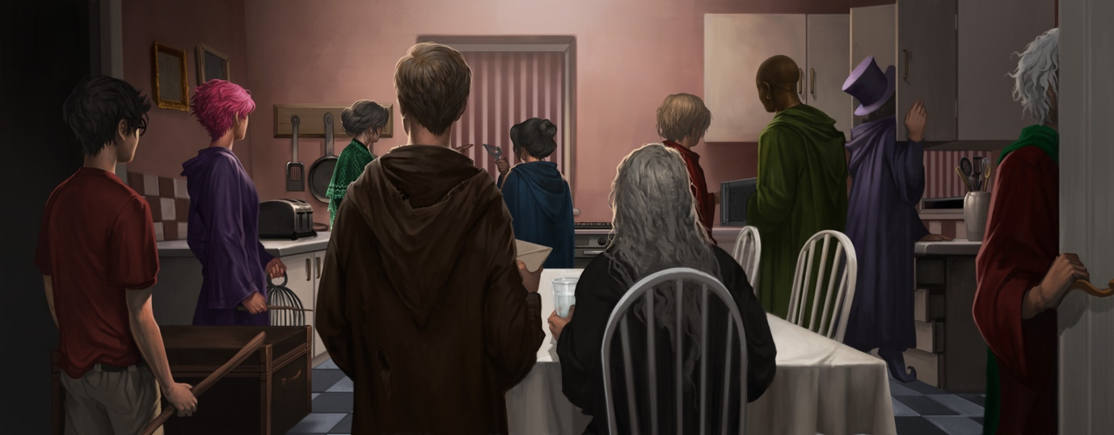What is interesting about Petunia’s behaviour in this chapter? Does it change the way that we think about her?

**Chapter Three – The Advance Guard**

Harry asks his owl, Hedwig, to deliver messages to Ron, Hermione, and Sirius. The Dursleys leave to attend an award ceremony for the All-England Best Kept Suburban Lawn Competition. They depart, and Harry hears a loud crash. Harry heads downstairs to investigate and is greeted by a group of nine wizards: Mad-Eye Moody, Professor Lupin, Nymphadora Tonks, Kingsley Shacklebolt, Elphias Doge, Dedalus Diggle, Emmeline Vance, Sturgis Podmore, and Hestia Jones. They have come to transport him somewhere safe. Harry learns that Tonks is a Metamorphmagus and can change her appearance at will. Harry and the others mount their flying broomsticks and take off into the cold night, finally landing in a run-down looking part of London. Moody hands Harry a piece of paper that reads, “The Headquarters of the Order of the Phoenix may be found at number twelve, Grimmauld Place, London,” and orders Harry to memorize it.

Questions

* Here we are introduced to the concept of the Metamorphmagus. Why do we think it might be useful or fun to be one? What would be good or bad about being one?
* Things are escalating now, and more and more wizards are introduced to the situation. What might this tell us about how severe the situation is?

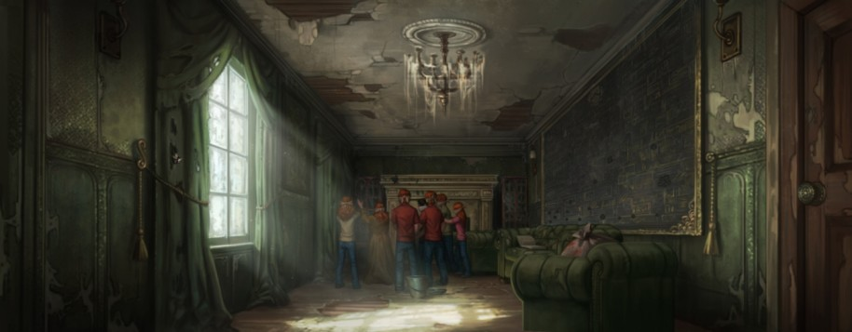**Chapter Four – Number Twelve, Grimmauld Place**

The wizards rush Harry into number twelve. Mrs. Weasley, emerges from a door and hugs Harry. Harry’s friends greet him excitedly, but Harry is still angry and screams at them for keeping him in the dark. Ron and Hermione explain that Dumbledore made them promise not to send Harry any messages with specific news and that the Order of the Phoenix is a secret society, comprised of people who wish to prevent Voldemort’s return. Harry also learns that Ron’s brother, Percy, has betrayed his family to support the corrupt Cornelius Fudge. Hermione tells Harry how the *Daily Prophet* has been building a case against Harry all summer, portraying him as an egotistical liar. Ron, Hermione, and Harry head downstairs to dinner, where Harry sees Sirius.

Questions

* In this chapter we are told that Harry is glad to see the cuts on Ron and Hermione’s hands from Hedwig’s persistent pecking. What does this tell us about Harry’s character? Is this a concerning detail?

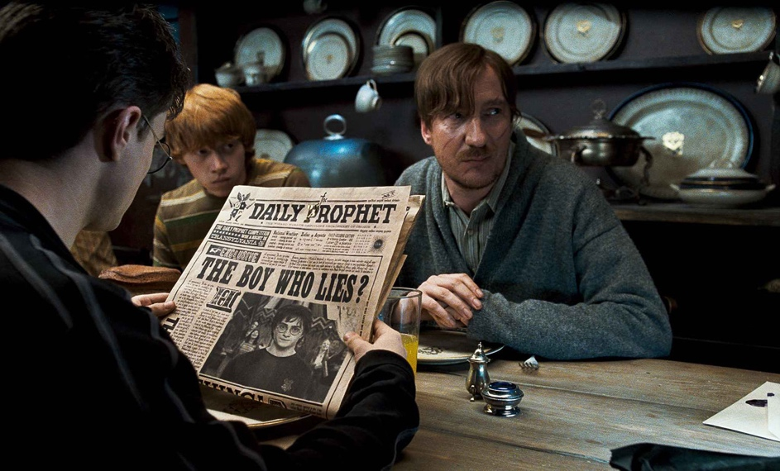

**Chapter Five – The Order of the Phoenix**

Sirius explains that number twelve was his parents’ house. During dinner, Sirius gets into a fight with Mrs. Weasley over how much information Harry should be made privy to. Mrs. Weasley would prefer that Harry not be told anything, but Sirius and Lupin convince her that there are certain things he needs to know. Sirius tells Harry that while Dumbledore thinks Voldemort is building his army back up, the Ministry of Magic refuses to accept that Voldemort is back. Fudge fears that Dumbledore is plotting to overthrow him. Harry also learns that Voldemort is attempting to gain access to a secret weapon, but Mrs. Weasley stops the conversation.

Questions

* Why might Mrs. Weasley not want to tell Harry everything about the situation? And why might Sirius and Remus want to fill him in? Debate.
* Why do we think the book is named after the Order?

Chapter Six – The Noble and Most Ancient House of Black

### Chapter 6: The Noble and Most Ancient House of Black – Harry Potter Thoughts and Theories

Members of the Order come and go, delivering news and checking in. Sirius shows Harry the Black family tapestry, which traces the Black family back to the Middle Ages. Sirius’s mother burned off her son’s name after he refused to subscribe to Voldemort’s philosophies. Harry also learns that Sirius is related to both Tonks and Lucius Malfoy. The Blacks are also related to the Lestrange family, a name that sounds familiar to Harry.

Meanwhile, Fred and George continue to plot the opening of their joke shop. Harry notes that this is the first time all summer he has had any fun. He enjoys it so much that he forgets about his hearing, until Sirius asks if it would be acceptable for him to accompany Harry to the Ministry. Dumbledore sends Mr. Weasley instead, and Sirius is again stuck inside number twelve. Harry puts on clean clothes, washes his hair, and tries to prepare himself for possible expulsion.

Questions

* Family is an important theme in the Harry Potter books. What do we learn about Sirius’ family in this chapter?
* Why is it frustrating for Sirius to be stuck inside number twelve?

### Chapter Seven – The Ministry of Magic

On the morning of his hearing, Harry wakes up early. Everyone wishes Harry luck, and he and Mr. Weasley leave for the Ministry. They enter the Ministry through a phone booth, and Mr. Weasley takes Harry to wait in his office. There, Mr. Weasley’s partner, Perkins, breathlessly informs them that the time and place of Harry’s hearing have changed. Mr. Weasley looks at his watch and realizes they’re already late. Dragging Harry behind him, he sprints toward the courtroom, where he leaves Harry.

Questions

* We’ve spoken in previous lessons about the idea of corruption (think back to Buckbeak’s trial, and even further back to Lucius Malfoy’s threatening of the school board). How does corruption influence events here?

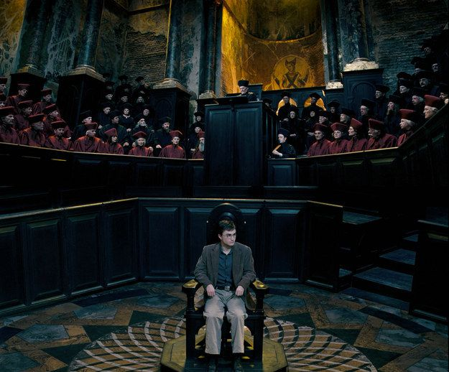**Chapter Eight –**

**The Hearing**

Harry enters the courtroom and Cornelius Fudge reprimands Harry for being late. The Wizengamot trying Harry is made up of about fifty wizards and witches, led by Cornelius Fudge, who is seated next a toadlike woman named Delores Umbridge. Percy Weasley is present to transcribe the proceedings. As the hearing begins, Dumbledore breezes into the room, declaring himself a witness for the defence. Dumbledore does not look at Harry. Members of the Wizengamot seem impressed that Harry was able to conjure a full Patronus but do not appear to believe Harry’s story about dementors appearing in Little Whinging. Dumbledore calls Mrs. Figg as a witness, and she nervously corroborates Harry’s story. Fudge still refuses to believe that dementors, who are under strict Ministry control, escaped Azkaban to terrorize a Muggle suburb. The Wizengamot votes, and Harry is cleared of all charges. Dumbledore dashes out of the dungeon.

Questions

* What is strange about Dumbledore’s behaviour in this chapter, and why do we think he is acting this way?
* Why do we think Cornelius Fudge refuses to admit that Voldemort might be back?

**Activity**

* Write a letter to Cornelius Fudge urging him to accept that Voldemort is back. What kind of evidence might you include from the previous books? What sort of tone might you need to adopt in order to convince him?

Homework

* Make a case for Harry Potter. Imagine that you are the lawyer in charge of defending Harry during his trial. What would you say to convince Cornelius Fudge and his court that Harry was innocent?