**Harry Potter and the Goblet of Fire**

Chapters Twenty-Nine to Thirty-Seven

|  |  |  |
| --- | --- | --- |
| Theme | Significance | Quote |
|  |  |  |
|  |  |  |
|  |  |  |
|  |  |  |
|  |  |  |

Debate

* I want each of you to pick a theme and take five minutes to tell me why you think it is the most important theme in the book. Be prepared to share your ideas with the class.

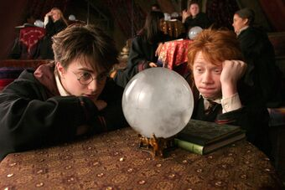

**Chapter Twenty-Nine – The Dream**

At daybreak the morning after Mr. Crouch attacked Krum, Harry, Ron, and Hermione are at the Owlery, sending an update to Sirius. Fred and George enter the Owlery discussing blackmail and preparing to send a letter, and the five students regard each other warily. Later that morning, Harry, Ron, and Hermione visit Professor Moody, who reports that Mr. Crouch did not show up on the Marauder's Map. Moody warns Harry to be especially careful; soon after, Harry receives a letter back from Sirius, also warning him to be especially careful. Sirius warns him further to prepare well for the third task.

Several days later, in Divination, Harry falls asleep and he dreams of flying on an owl into a house, inside of which Voldemort is reprimanding Wormtail for having made some mistake, noting that some unnamed "he" is dead, and foretelling that soon he would have Harry Potter dead and ready to be fed to his pet snake. Voldemort then applies the Cruciatus curse to Wormtail, causing Harry to wake up screaming and clutching his scar. Harry leaves the room and charges towards Dumbledore's office, where he can hear Cornelius Fudge and Moody arguing with Dumbledore.

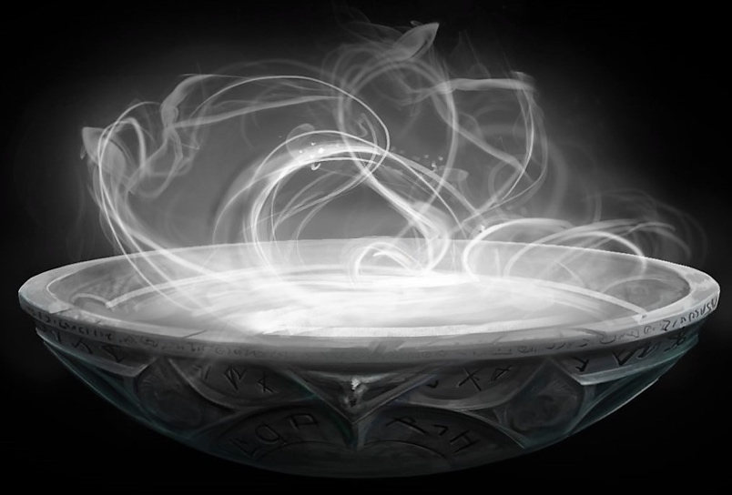**Chapter Thirty – The Pensieve**

Harry waits in Dumbledore's room while the three adults examine the grounds for clues; as he waits, he observes Fawkes, Dumbledore's pet phoenix, and he also notices in a half-open cupboard a basin containing something silvery and swirling. Harry studies it, pokes it with his wand and looks closer, ultimately touching his nose to it and falling in; he lands in a courtroom, where he is an unseen observer among a grave audience (including a slightly younger Dumbledore and Moody). Harry watches as Karkaroff is strapped into a chair at the room's center and questioned by Mr. Crouch, who has agreed to set him free from Azkaban in exchange for the names of other Death-Eaters. Karkaroff gives many names, including Snape-but Dumbledore stands up and vouches for Snape. Suddenly the room dissolves, and Ludo Bagman is sitting in the same chair, pleading that he didn't realize that he was working for Voldemort's supporters. The room dissolves a third time and reveals Mr. Crouch's son in the center of the room, pleading to be let go, while his strict father accuses him of many awful things, including subjecting the Longbottoms to the Cruciatus curse. Mr. Crouch sentences his only son to a lifetime in Azkaban.

Dumbledore pulls Harry out of the room and back into his office, where he explains that the basin is a Pensieve, a holder for excess thoughts and memories. Harry tells Dumbledore about his dream, and Dumbledore expresses his belief that the dream is probably true, that Voldemort is near and dangerous. Harry asks also whether Bagman or Snape has been convicted of any Dark activity since that time. Dumbledore answers, with conviction, that neither has, before bidding Harry goodbye.

**Chapter Thirty-One – The Third Task** 

Harry tells Ron and Hermione everything he has seen in the Pensieve. On the morning of the third task, Rita Skeeter writes an article describing how Harry fainted in class and is possibly disturbed and dangerous, and the students read it over breakfast. Hermione jumps up and runs to the library, saying that she has figured something out. After breakfast, the families of the champions arrive at Hogwarts to watch the final task, and Bill and Mrs. Weasley come to watch Harry; at dusk, the champions are placed at the entrances to a giant hedge maze, at the center of which the winner would find the trophy.

Harry and Cedric are currently tied for first place, so they go first, followed by Krum and Fleur. Harry hears Krum mutter, "Crucio", and hears Cedric scream. Harry burns a hole in the hedge and saves Cedric by stupefying Krum. The two continue through the maze. Harry passes a sphinx, answers her riddle, and sees the Triwizard Cup ahead. He and Cedric both run for it. They are barred by a giant spider, which together they defeat. Harry breaks his leg in the process. Unable to decide who should have the trophy, they decide to touch it at the same time, both winning. They do, and the Cup, it turns out, is a portkey.

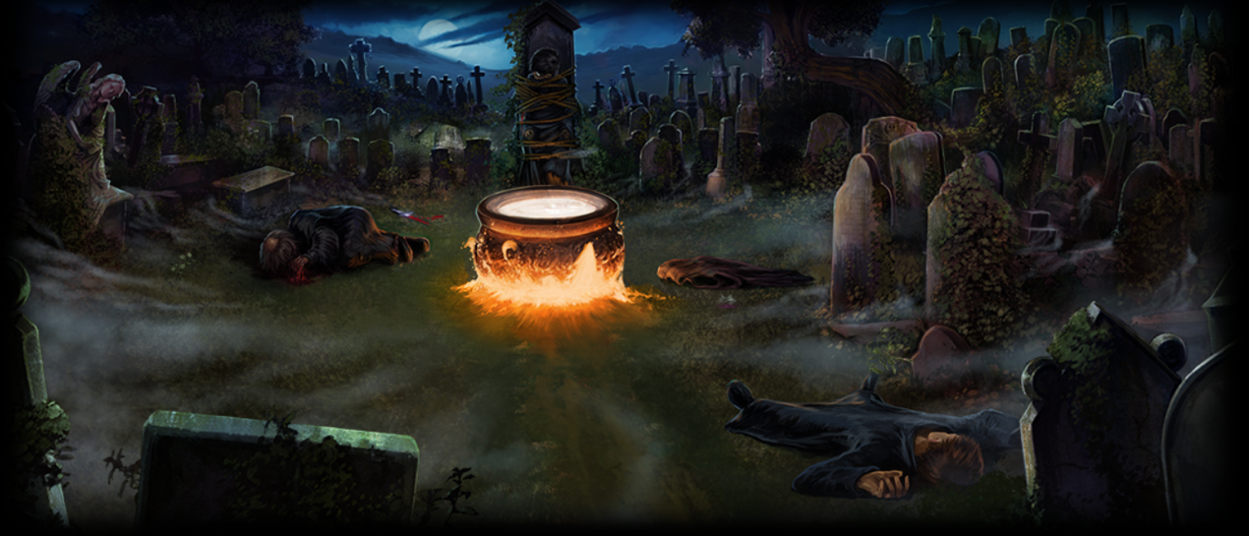**Chapter Thirty-Two – Flesh, Blood and Bone**

Harry and Cedric land in a graveyard far away from Hogwarts. Coming towards them, they see a hooded man carrying what looks like a baby. Suddenly, Harry's scar sears with pain, as he hears a cold voice say, "Kill the spare." The voice is followed by a second, which says, "Avada Kedavra." Cedric is killed instantly. As Harry stares at Cedric, horrified, the hooded man ties Harry tightly to a tombstone of a man named Tom Riddle. Harry recognizes the man in the hood as Wormtail. Harry watches as Wormtail boils water in a giant cauldron, unwraps the bundled object and drops it into the cauldron.

Wormtail summons dust from Tom Riddle's grave to renew his son. Wormtail says "Flesh of the servant," and slices off his right hand, dropping it into the cauldron. Finally, he draws blood from Harry's upper arm, adding "Blood of the enemy" to the cauldron. From the cauldron's simmering depths, a tall, thin man rises. Lord Voldemort has risen again.

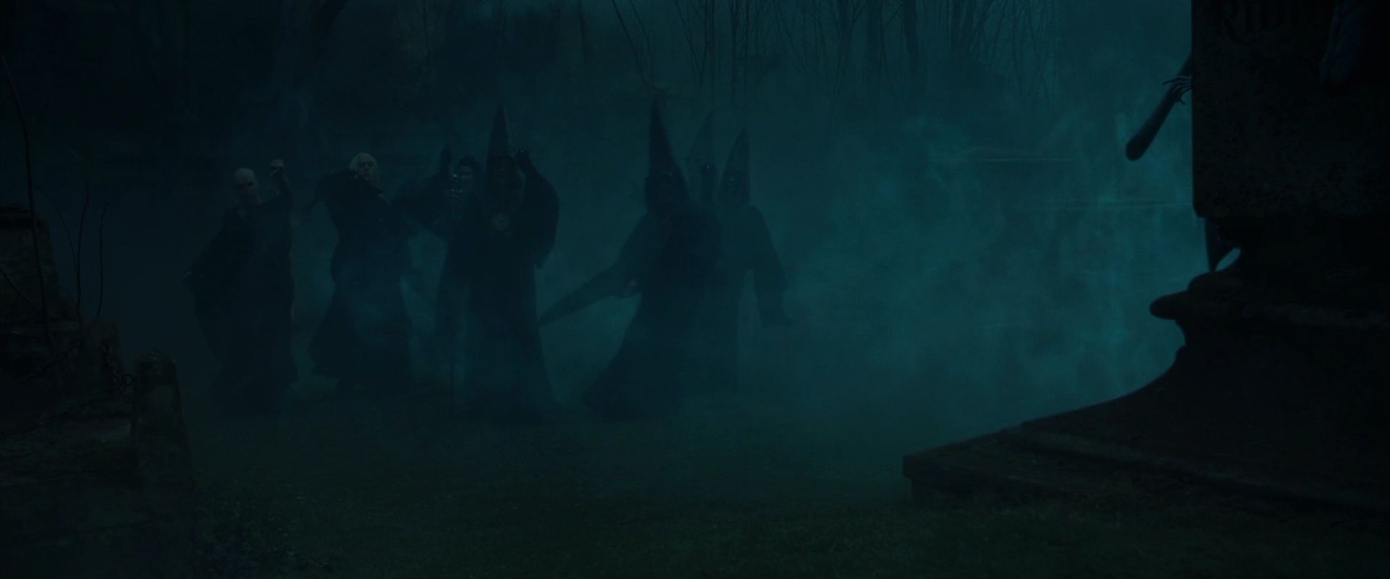**Chapter Thirty-Three – The Death Eaters**

Harry watches as Voldemort examines his new body, and presses a red tattoo-the Dark Mark-on the weeping Wormtail's upper arm. Voldemort paces the graveyard. As he speaks, wizards begin Apparating in a circle around him. Voldemort welcomes his Death Eaters and notes that they seem, as a group, guilty for having betrayed him when he needed them. One of the men throws himself at Voldemort's feet, begging forgiveness, and Voldemort laughs mirthlessly and performs the Cruciatus curse on him. Voldemort then publicly rewards Wormtail for returning by giving him a new right hand. One of the Death Eaters, Harry notes, is Lucius Malfoy, Draco's father. Voldemort notes that many Death Eaters are missing, either dead, imprisoned, or having fled. He says that one of the missing people, his most faithful servant, is at Hogwarts, and through that servant's efforts, Harry Potter has been brought here tonight.

Voldemort then discloses his history since he last encountered his Death Eaters. He attempted to kill Harry which ripped Voldemort from his body, and forced him to flee to a faraway forest where he inhabited the bodies of snakes. Then, four years ago a foolish future Hogwarts teacher (Quirrell) wandered across his path.Voldemort was alone and weak when his servant Wormtail returned to him, bringing with him Bertha Jorkins, who informed him of a Death Eater who would be able to help. He adds that Harry's blood was more potent than any blood, since Harry's mother's protection could now reside in Voldemort's veins. He turns to Harry and says "Crucio!" placing Harry in more pain than he has ever felt before. Then he commands Wormtail to untie Harry and give him back his wand.

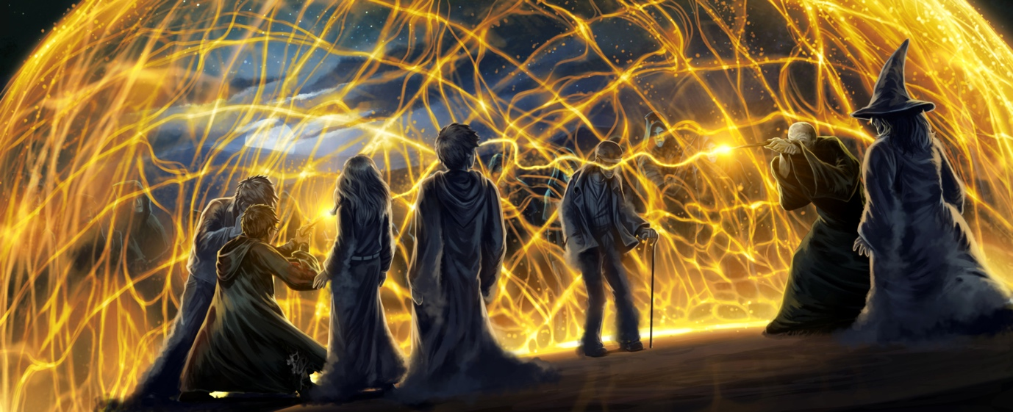

**Chapter Thirty-Four – Priori Incantatem**

Harry feels his injured leg crumple under him as he stands up, wand in hand. Voldemort challenges Harry to a duel, and Harry thinks fretfully that the only dueling spell he knows how to do is "Expelliarmus,". Voldemort places Harry under the Imperius curse, and commands Harry to say no. Harry has learned to fight this curse, and still refuses. Voldemort is furious. Harry, after ducking behind a gravestone to dodge the Cruciatus curse again, stands up straight and tall to die fighting, like his parents and Cedric did. As Voldemort cries "Avada Kedavra," Harry cries "Expelliarmus," and the light from the two wands meet in midair, lifting both Harry and Voldemort into a golden, dome-shaped web of light. He watches a bead of light traveling across the thread connecting him to Voldemort. He concentrates to force the bead toward Voldemort's wand and away from his.

A shadow of a hand blossoms out of the tip of Voldemort’s wand, followed by a shade of Cedric, then an old Muggle (Frank Bryce), then Bertha Jorkins, then Harry's parents. They crowd around him, each of them telling him to hold on, and finally his mother tells him quietly that once he lets go, they will linger long enough to give him time to touch the portkey and return to Hogwarts. Cedric asks that Harry take his body back to his parents, and Harry nods. The shadows of the victims remain and close in upon Voldemort while Harry runs to grab Cedric. Just as Voldemort is approaching him ready to strike, Harry summons the Triwizard Cup to him. He grips Cedric's body and feels himself spinning away, and in the distance he can hear Voldemort's cry of fury.

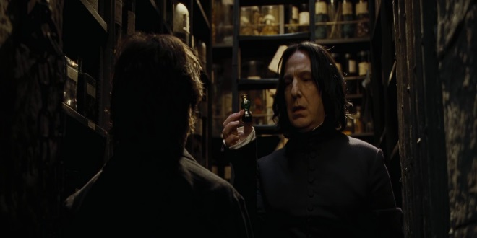**Chapter Thirty-Five – Veritaserum**

Harry falls into the grass at Hogwarts, still clutching Cedric. Around them, cries of "Diggory's dead!" sound in the air, and Dumbledore leaves to talk with Cedric's parents, after instructing Harry to remain where he is. Harry is grabbed by a pair of hands and dragged toward the castle, and only once he is there does he recognize his carrier as Moody. As Harry explains in panic that Voldemort is back, Moody seems interested in knowing whether Voldemort forgave the Death Eaters who left him. Harry explodes with the information that there is a Death Eater at Hogwarts, and Moody assures him that he himself is the supporter. Moody then raises his wand to finish off Harry, saying madly that he will be cherished as a son by Voldemort. The door bursts open. Dumbledore, Snape, and McGonagall enter, stupefying Moody.

Harry has never seen Dumbledore look so angry and so powerful, and he understands in an instant why he is the only wizard that Voldemort ever feared. Dumbledore takes a key-ring from the stupefied Moody, and begins opening the seven locks on the trunk in the room. He and Harry see a sleeping, disheveled man-the real Alastor Moody. Dumbledore explains that the impostor Moody had been making Polyjuice potion from the real Moody's hair. Time passes, and the sleeping figure changes from Moody into a pale young man whom Harry recognizes from the Pensieve as Mr. Crouch's son.

Dumbledore drops some of the Veritaserum into the man's mouth and wakes him. Young Barty Crouch explains that as he was in Azkaban, his dying mother persuaded his father to switch bodies with her son. The mother, appearing to be young Barty, died soon after, while Barty himself lived under an invisibility cloak under the watch of Winky.

Barty kidnapped Moody the morning Hogwarts term began and he has been here ever since, keeping Moody alive to use his hairs for the potion. Meanwhile, Wormtail and Voldemort had moved into Mr. Crouch's house, where they kept Mr. Crouch under the Imperius Curse and instructed him to go about business as usual. Somehow, Mr. Crouch escaped and ran to Hogwarts to find Dumbledore. In the forest, Barty, disguised as Moody, found Mr. Crouch on the Marauder's Map, stunned Krum while Harry was gone, killed his father, transfigured him into a bone and buried him. While Winky sobs inconsolably, Barty grins insanely after finishing his story, he and says that now that his master has returned, he himself will be honored beyond all dreams.

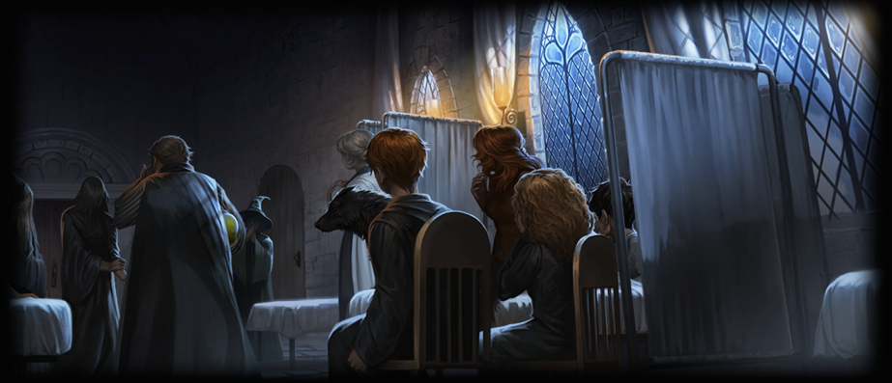

**Chapter Thirty-Six – The Parting of the Ways**

A disgusted Dumbledore ties up Barty Crouch, sends Alastor Moody to the hospital wing, and takes Harry into his office, where Sirius awaits them. Dumbledore explains the connection of the wands with the words "Priori Incantatem," meaning that the wands were not able to properly battle against each other because they were made from identical feathers from the same phoenix. Once the twin wands connect, one forces the other to regurgitate its spells in the reverse order in which they were performed. At the end, Dumbledore commends Harry's bravery in reliving the events, and he sends him to the hospital wing to sleep, accompanied by Sirius, disguised as a dog.

The Weasleys are waiting in the hospital wing. Madame Pomfrey gives Harry a potion for dreamless sleep, and he sleeps, only to be awakened in the night by an argument between Cornelius Fudge and Professor McGonagall. She is furious with him for having allowed a dementor to accompany him to see Barty Crouch, and to administer the fatal dementor's kiss. Dumbledore enters and joins in the reprimands, as now Barty will not be able to testify for what he did. Fudge doesn't seem to believe that Voldemort has risen again, and he accuses Barty Crouch of being a lunatic, and Harry of hallucinating in his visions of Voldemort. Dumbledore then advises Fudge to take necessary precautions against Voldemort's return to power. Fudge refuses to do any of this, and Dumbledore accuses him of being blind to what is going on.

Fudge is disbelieving, even after Snape shows him his own Dark Mark and explains that it burned that night, signifying Voldemort's return. Fudge leaves the room in a huff, after depositing Harry's Triwizard winnings, a thousand galleons, on his hospital bed. Dumbledore then asks Sirius to round up old friends, including Lupin. He says gravely to Snape to do what he knows he must. Everybody leaves except for Harry and the Weasleys. Harry doesn't want the money he has won, and he tries to give it to the Weasleys, who refuse to take it. Mrs. Weasley hugs him, and Harry feels on the verge of crying before he finishes his sleep potion and leaves the night behind him.

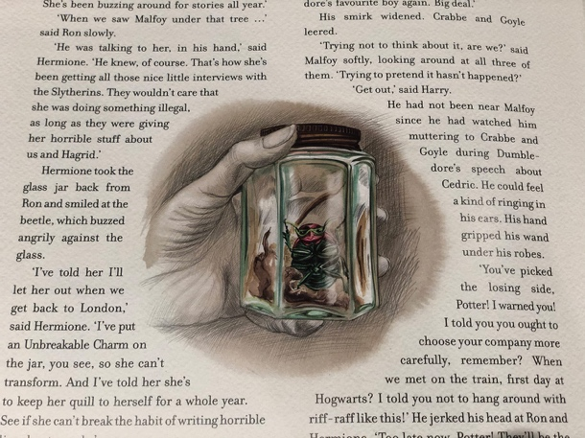**Chapter Thirty-Seven – The Beginning**

Several days later, Harry, Ron, and Hermione visit Hagrid, who had made up with Madame Maxime and is planning to spend the summer with her. Hagrid says wisely that what will come, will come, and that all anyone can do is rise to meet it. On the night before leaving Hogwarts, the Great Hall is decorated in black to mourn Cedric, and during the dinner Dumbledore announces to everybody that Cedric was, in fact, murdered by Voldemort, and that Harry Potter risked his life to bring back Cedric's body. He says further that the time has come for everybody to understand the true merit of the Triwizard Tournament, which is to promote magical ties and understanding.

On the train, Hermione shows Ron and Harry a beetle in a jar. She has caught Rita Skeeter, an unregistered animagus, who had been buzzing around Hogwarts collecting information. Malfoy and his cronies enter the train compartment at this point, and he says that Harry has picked the losing side, because Voldemort will triumph. At the same time, Harry, Hermione, Ron, and Fred and George strike them with various minor curses, knocking them out entirely. At the end of the train ride, Harry pulls the twins aside and gives them his gold, telling them to use it for Weasleys' Wizard Wheezes, and also to buy Ron a new set of dress robes. They accept the gift gratefully, and Harry returns to live with the Dursleys for the summer.

**Homework**

* Pick your favourite quote from Harry Potter and the Goblet of Fire and write an argument for why it is your favourite quote. Think about how it might tie into the themes that we’ve been looking at throughout the book.