**Harry Potter and the Goblet of Fire**

Chapters Twenty-Two to Twenty-Eight

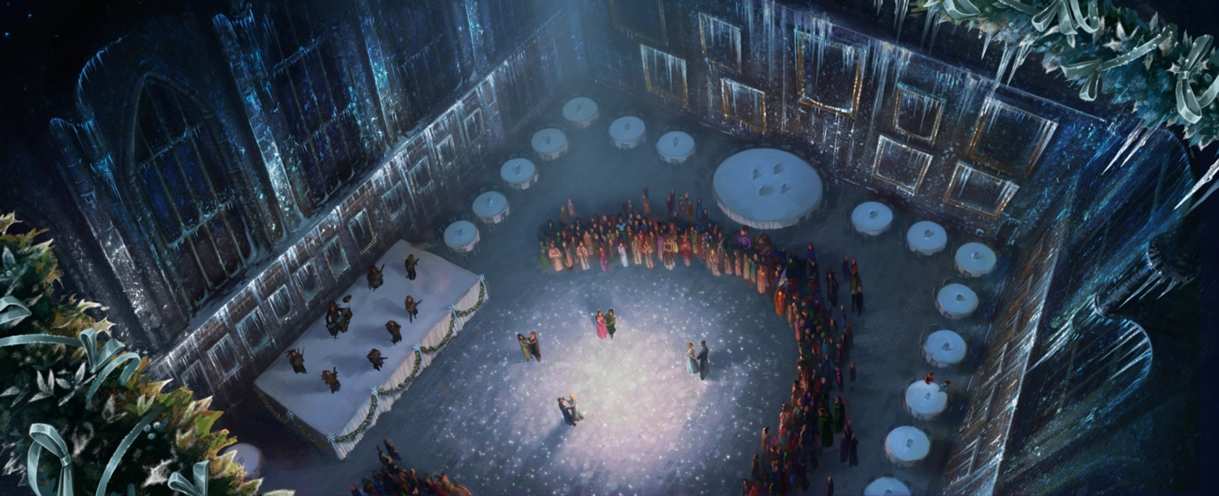

**Chapter Twenty-Two – The Unexpected Task**

After a Transfiguration class, McGonagall tells her students about the [Yule Ball](https://harrypotter.fandom.com/wiki/Yule_Ball), a formal event that is scheduled for [25 December](https://harrypotter.fandom.com/wiki/25_December) and is open to fourth years and above (though a younger student can still attend if invited by an older student as their date). They gather in a spare classroom to practise for the ball and Ron is forced to practise dancing with McGonagall. She tells Harry privately that he and his dance partner will start off the event alongside the other champions and their dates as a traditional part of the Triwizard Tournament.

Over the next few weeks, both Ron and Harry unsuccessfully attempt to find dates as they get through the final classes of the term. Fred and George are also acting suspiciously again; they want to borrow Pigwidgeon to deliver a letter to someone, but Pigwidgeon is not back yet (from delivering Sirius' letter). Harry later works up his courage and asks Cho to go to the dance with him, but learns that she had already agreed to go with Cedric. This information sours Harry's relationship with Cedric.

After Harry returns to the Gryffindor common room, he sees Ginny comforting Ron and learns that Ron foolishly tried to ask Fleur out. Ron then tactlessly asks Hermione out, but she is going with someone else. Harry can't ask Ginny out either, since she is going with Neville. Finally, Harry manages to secure dates for both himself and Ron.

**Questions**

1. Why did Harry need a dance partner for the Yule Ball?
2. Who did Harry first ask to the ball?
3. Who is she going to go with?

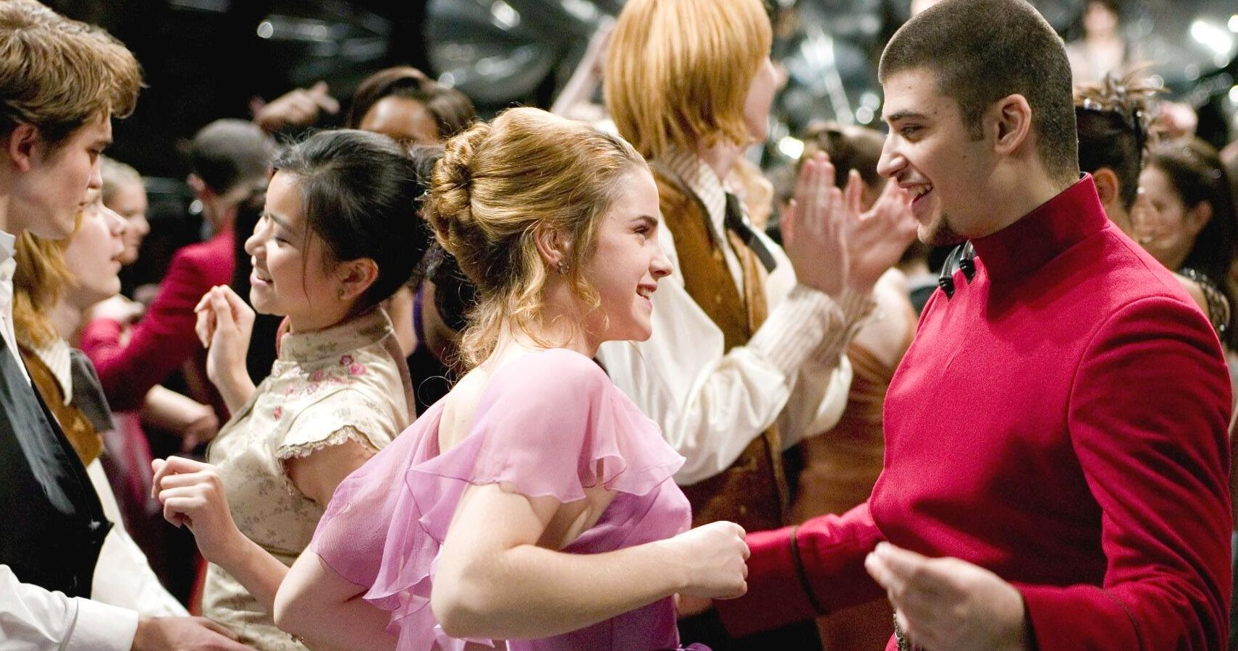

**Chapter Twenty-Three – The Yule Ball**

As the holidays begin, Hermione refuses to tell Ron who her date for the Yule Ball is, stating he'll make fun of her. She also reveals that after Malfoy put the curse on her that made her already large front teeth grow to a huge size, she let [Madam Pomfrey](https://harrypotter.fandom.com/wiki/Poppy_Pomfrey) shrink them to a more normal size when she healed her. Draco Malfoy tries to taunt Hermione, saying no one in their right mind would take her to the ball, but the mere mention of Mad-Eye Moody is enough to drive him back. Pigwidgeon returns with Sirius' reply. Sirius congratulates Harry for completing the first task and reminds him to stay on guard.

On [Christmas Day](https://harrypotter.fandom.com/wiki/Christmas_holidays), Dobby wakes Harry up and gives Harry his present: a pair of mismatched socks he made himself from wool he purchased with his wages. [Harry](https://harrypotter.fandom.com/wiki/Harry_Potter) then opens the presents he got from his other friends for Christmas, which include a hand-knit sweater with the image of a dragon from Mrs Weasley and a [magical penknife](https://harrypotter.fandom.com/wiki/Sirius_Black%27s_penknife) from [Sirius](https://harrypotter.fandom.com/wiki/Sirius_Black). After spending the day relaxing, Harry and his dorm mates get ready for the ball, then head to the [Great Hall](https://harrypotter.fandom.com/wiki/Great_Hall), where the event is to take place. At the start of the ball, it is revealed that Hermione is going with none other than [Viktor Krum](https://harrypotter.fandom.com/wiki/Viktor_Krum).

When the champions reach the judges table, [Crouch](https://harrypotter.fandom.com/wiki/Bartemius_Crouch_Senior) is nowhere to be seen. [Percy Weasley](https://harrypotter.fandom.com/wiki/Percy_Weasley), who was promoted to Crouch's assistant, says Crouch is ill. After the entire room has their meal, the [Weird Sisters](https://harrypotter.fandom.com/wiki/Weird_Sisters) start their performance for the dance. Neither Harry nor Ron have any interest in dancing (though Harry does participate in the opening dance) and their dates, the [Patil sisters](https://harrypotter.fandom.com/wiki/Padma_and_Parvati_Patil), soon abandon them, Ron also gets into an embarrassing argument with Hermione; he claims that Viktor Krum is the enemy and that going to the ball with him is treason.

Percy sees Fred and George bothering [Ludo Bagman](https://harrypotter.fandom.com/wiki/Ludovic_Bagman) and tries to intervene, and Mr Bagman comes over to have a chat with Harry. Harry and Ron then decide to go for a walk on the grounds to get away from the ruckus. They encounter Karkaroff having a worried discussion with Snape, and Hagrid and Maxime enjoying a tender moment. The moment is ruined when Hagrid insinuates Maxime is a [Half-giant](https://harrypotter.fandom.com/wiki/Half-giant), like him. Ron naturally has to inform Harry about how serious this information is, given the nasty reputation giants have in the wizarding world. Shortly after the ball, Cedric gives Harry a hint about the egg: take a bath with it. He gives Harry the password to enter the [Prefects' bathroom](https://harrypotter.fandom.com/wiki/Prefects%27_bathroom) and thanks him for warning him about the dragons.

**Questions**

1. Why didn’t Hermione want to tell Harry and Ron who she was going to the ball with?
2. Why was Ron upset when Hermione went to the ball with Krum?
3. Why was Madam Maxime upset when Hagrid assumed she was a giant?
4. What was the clue Cedric gave to Harry about the golden egg?

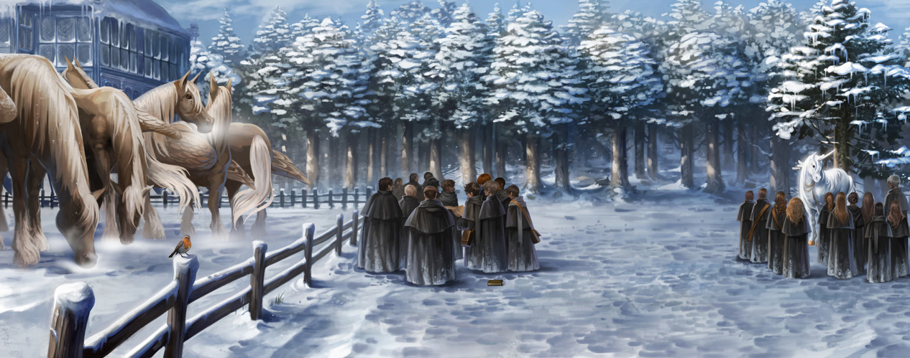**Chapter Twenty-Four – Rita Skeeter’s Scoop**

Ron and Hermione decide to put last night's argument behind them. Hermione isn't too surprised when she learns that Hagrid is a half-giant, as she suspected this all along. Meanwhile, Harry is reluctant to take Cedric's advice due to his jealousy about Cho.

A substitute teacher, [Professor Grubbly-Plank](https://harrypotter.fandom.com/wiki/Wilhelmina_Grubbly-Plank), teaches the first Care of Magical Creatures of the year. Draco Malfoy shows Harry that Rita Skeeter had published a nasty story about Hagrid and his giant heritage (which also used a quote from Draco); this has apparently driven Hagrid into hiding. This raises some questions between the trio, as nobody else heard Hagrid talking privately with Madam Maxime that night and Rita is supposed to be banned from Hogwarts.

Several weeks pass and during another [Hogsmeade visit](https://harrypotter.fandom.com/wiki/Hogsmeade_weekend_trips), while hoping to find Hagrid at the [Three Broomsticks Inn](https://harrypotter.fandom.com/wiki/Three_Broomsticks_Inn), the trio instead finds Ludo Bagman meeting with some goblins. During a private conversation with Mr Bagman, Harry learns that Barty Crouch has stopped coming to work and is sending Percy instructions by owl. Also, after a search, they still haven't found Bertha Jorkins. Bagman then again offers his help for the tournament, which Harry immediately declines. Fred and George's sudden appearance forces Mr Bagman to leave. Hermione then questions why Mr Bagman is trying to help Harry cheat, along with why he was meeting with goblins. Rita Skeeter, who also encountered Bagman and the goblins, then shows up to investigate. Harry and Hermione start an argument with her about her article on Hagrid.

The trio go to Hagrid's cabin and, along with Dumbledore, try to persuade him to return. They point out that not everyone has abandoned Hagrid, and that everyone has secrets in their pasts. After Dumbledore leaves, Hagrid remembers his late father telling him never to be ashamed of what he is and gets over his depression. He gives his support to Harry in the Tournament, believing that if Harry wins, he could show everyone they do not have to be ashamed of what they are. This is enough to convince Harry to put aside his pride and take Cedric's advice.

**Questions**

1. Why is Hagrid in hiding?
2. Predict how Rita Skeeter learned of Hagrid’s history.
3. Why did Ron think Hermione was going to get a news article published about her?
4. 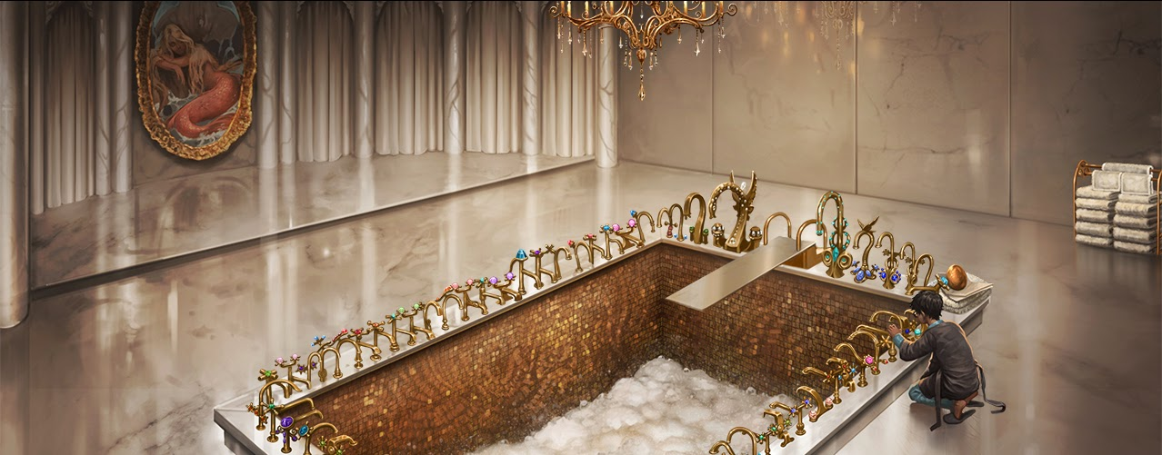What helped Hagrid realize he shouldn’t hide anymore?

**Chapter Twenty-Five – The Egg and the Eye**

Harry sneaks into the Prefect's bathroom at night so he could have all the time he will need to figure out the clue, taking only the golden egg, his [Invisibility Cloak](https://harrypotter.fandom.com/wiki/Cloak_of_Invisibility), and the [Marauder's Map](https://harrypotter.fandom.com/wiki/Marauder%27s_Map) with him. Harry initially has trouble figuring out how to open the egg properly, but with a little help from Moaning [Myrtle](https://harrypotter.fandom.com/wiki/Myrtle_Warren), who had been spying on him, Harry opens the egg under water. This time, Harry hears voices singing and can understand them when he puts his head underwater. Harry realises that he must save something he cares about from [merpeople](https://harrypotter.fandom.com/wiki/Merpeople) who live in the depths of the [Black Lake](https://harrypotter.fandom.com/wiki/Great_Lake).

On the way back to Gryffindor tower, Harry sees Barty Crouch in Snape's office on the Marauder's Map and goes to investigate. When he falls through a trick stair and traps his leg, he accidentally drops the egg and map, attracting the attention of [Filch](https://harrypotter.fandom.com/wiki/Argus_Filch). Filch finds the egg, and Snape soon arrives and demands Filch's help in catching someone who broke into his office. Moody then shows up, angering Snape by suggesting Snape had something to hide in his office. Snape points out that Moody searched his office after his arrival at Hogwarts. Moody then saves Harry from detection by claiming that the Marauder's Map is his own (after an invisible Harry warns him not to give it to Snape). However, Snape suspects Harry's involvement because he recognises the Marauder's Map before Moody confiscates the egg from Filch and forces the pair away.

As Moody frees Harry's leg, Harry tells Moody about how the map works and that he saw Mr Crouch on it. After Moody spends time looking over the Marauder's Map, Harry asks what Crouch was doing in Snape's office, and Moody suggests that Crouch was trying to find evidence of Snape being a [Dark Wizard](https://harrypotter.fandom.com/wiki/Dark_Wizard). Moody then asks to borrow the map, and after learning what Harry was up to that night, says that Harry might consider becoming an [Auror](https://harrypotter.fandom.com/wiki/Auror" \o "Auror) for a career.

**Questions**

1. How did Moaning Myrtle help Harry figure out the mystery to the egg?
2. Why was Moaning Myrtle sensitive about being dead?
3. How did Moody stop Snape from finding Harry?
4. Why do you think Moody wants to borrow the Marauder’s Map?

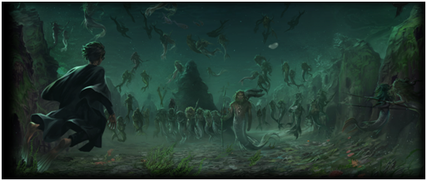

**Chapter Twenty-Six – The Second Task**

Harry explains what happened the previous night to Ron and Hermione. Even though Harry and Ron suspect Snape might have put Harry's name in the Goblet of Fire, Hermione doubts this. Harry also sends a school owl to Sirius to update him on what happened.

Over the coming weeks, even with help from Hermione and Ron as well as the library's resources (including getting McGonagall's permission for the [Restricted Section](https://harrypotter.fandom.com/wiki/Restricted_Section)), Harry struggles to think of a way to breathe underwater for an hour. Two days before the second task is to start, Sirius's response comes in. Sirius wants to know when their next trip to Hogsmeade is.

On the last night before the task, the trio are continuing their research in the school library when Fred and George appear to inform them that Professor McGonagall has summoned Ron and Hermione. Harry later sneaks back into the library after hours with his Invisibility Cloak, but can't find anything else.

The next morning, with a little help from Dobby, Harry discovers [gillyweed](https://harrypotter.fandom.com/wiki/Gillyweed), a plant that, when eaten, gives him fish-like qualities such as gills and fins. He quickly makes his way to the lake just as the task is about start and finds that, once again, Percy is taking Mr Crouch's place. While swimming through the lake and fighting off a swarm of [Grindylows](https://harrypotter.fandom.com/wiki/Grindylow" \o "Grindylow), Moaning Myrtle points Harry in the right direction and Harry discovers a town of [Merpeople](https://harrypotter.fandom.com/wiki/Merpeople" \o "Merpeople), where Ron (the thing Harry would miss the most) is being held, along with Hermione (for Krum), Cho (for Cedric), and Fleur's sister.

Harry frees Ron, but refuses to leave the others, despite the insistence of the Merpeople. Cedric and Krum appear and rescue their loved ones, but Fleur never arrives. With little other choice, Harry drags her sister to the surface as well, narrowly avoiding drowning as the gillyweed wears off. Although he was wrong to think the other hostages would be left to die (they would have simply returned to the surface unharmed), his bravery and valour earn him extra points from the judges, who state that he showed great "moral fibre." This puts both Harry and Cedric in first place in the overall points. Ludo Bagman then reveals the third and final task is on [24 June](https://harrypotter.fandom.com/wiki/24_June) and the champions will learn more about it a month beforehand.

**Questions**

1. Why was Harry so worried about the second task?
2. How did Dobby know what Harry could use for the task?
3. Why was Harry late and out of breath for the second task?
4. Summarize what happened during the task.

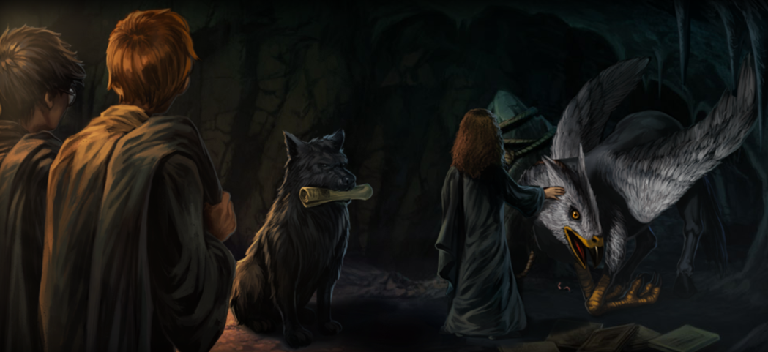

**Chapter Twenty-Seven – Padfoot Returns**

In [March](https://harrypotter.fandom.com/wiki/March), Sirius' reply states that the trio is to meet up with him during their next Hogsmeade trip and asks them to bring food. Before Potions, Slytherin [Pansy Parkinson](https://harrypotter.fandom.com/wiki/Pansy_Parkinson) gleefully gives Hermione a copy of [Witch Weekly](https://harrypotter.fandom.com/wiki/Witch_Weekly_Magazine); Rita had published an article on Hermione Granger saying that she is toying with both Harry and Krum's feelings. Pansy who is quoted in the article, suggested Hermione was making illegal [Love Potions](https://harrypotter.fandom.com/wiki/Love_Potion). Hermione realises that Skeeter must have eavesdropped on her and Krum's conversation on the shores of the lake, and begins wondering how Rita is getting her information. After Snape gets a hold of the article, he reads it aloud, creating further laughter from the Slytherins. He then breaks the trio up and sends them to different tables. Snape also confronts Harry over the recent theft of [boomslang skin](https://harrypotter.fandom.com/wiki/Boomslang_skin) and [gillyweed](https://harrypotter.fandom.com/wiki/Gillyweed" \o "Gillyweed) from his office, who has no idea what he's talking about. He threatens Harry with [Veritaserum](https://harrypotter.fandom.com/wiki/Veritaserum" \o "Veritaserum), a potion that will cause Harry to tell the truth when consumed. Karkaroff then shows up to talk to Snape and sticks around until after class. Snape blows him off, but not before Harry, who purposely stayed behind, noticed that Karkaroff had tried to show Snape something on his arm.

Sirius meets Harry, Ron, and Hermione secretly in Hogsmeade and directs them to a mountain cave where Buckbeak and some old [Daily Prophet](https://harrypotter.fandom.com/wiki/Daily_Prophet) articles are waiting (Sirius had been stealing discarded newspapers to keep up on current events). They first discuss Winky and what happened at the World Cup. Sirius suggests that whoever stole Harry's wand must have done so while they were watching the game in the Top Box and is suspicious that [Barty Crouch](https://harrypotter.fandom.com/wiki/Bartemius_Crouch_Senior" \o "Bartemius Crouch Senior) was looking around for something before he sacked Winky. He then finds it odd that not only did Crouch not show up during the game, but also that he is suddenly indisposed.

Sirius explains that Crouch was the one who sent him to Azkaban without a trial, as Crouch used to be the Head of the [Department of Magical Law Enforcement](https://harrypotter.fandom.com/wiki/Department_of_Magical_Law_Enforcement) and was once poised to become the next [Minister for Magic](https://harrypotter.fandom.com/wiki/Minister_for_Magic). During Voldemort's previous reign, Crouch took extreme measures against the Death Eaters, including allowing the Aurors to use the [Unforgivable Curses](https://harrypotter.fandom.com/wiki/Unforgivable_Curses) against them. While this greatly boosted Crouch's popularity and ensured that Crouch would become the next Minister, Crouch's [son](https://harrypotter.fandom.com/wiki/Bartemius_Crouch_Junior) had been caught with a group of Death Eaters just after Voldemort's downfall. The Death Eaters in question were trying to find Voldemort and help him get his strength back. The youth was given a show trial by his father before being locked up in [Azkaban](https://harrypotter.fandom.com/wiki/Azkaban); he died a year later. Shortly after Barty Crouch Jnr died, Crouch's [wife](https://harrypotter.fandom.com/wiki/Bartemius_Crouch_Jnr%27s_mother) died as well. Crouch's popularity dropped heavily after that, as people suspected that Crouch was a bad father. As a result, with Crouch's reputation outside of the Ministry destroyed, The Minister of Magic's post went instead to [Cornelius Fudge](https://harrypotter.fandom.com/wiki/Cornelius_Fudge) who immediately reassigned Barty Crouch Snr to the Department of International Magical Cooperation.

Ron brings up Crouch's appearance in Snape's office. Sirius states that doesn't make sense since Crouch would have kept an eye on Snape as a tournament judge. When Ron and Hermione bicker about whether Snape can be trusted, Sirius partly agrees with Ron, as it is questionable why Dumbledore would trust Snape. Snape was interested in the Dark Arts as a child and hung out with some Slytherin students that became Death Eaters, though he also knows Snape is smart enough to not get caught by the Ministry. Harry then remembers Karkaroff's sudden appearance in their class, though Sirius can't figure out what that was about.

Sirius then brings all the questions of these mysterious circumstances together, including why Moody was also searching Snape's office. He asks Ron to send a letter to Percy to find out if there is any news about Crouch. Before they leave, Sirius reminds them not to wander outside of Hogwarts at all for safety reasons. On the way back, the trio conclude that the scandal involving his son is the reason Crouch overreacted to seeing Winky being accused of conjuring the Dark Mark. Ron voices how he and Percy are similar. Hermione states Percy would never do what his boss did but Ron is unconvinced.

**Questions**

1. Infer what is on Karkaroff’s arm?
2. Why did the friends purchase socks for Dobby?
3. Where did Sirius take the friends to talk?
4. Why does Sirius want the friends to call him Snuffles?

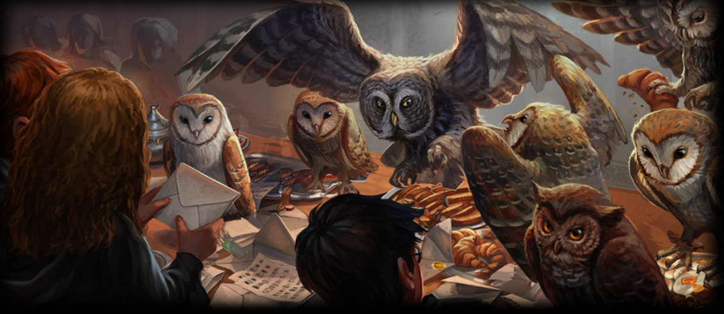

**Chapter Twenty-Eight – The Madness of Mr Crouch**

After sending Hedwig with the letter to Percy, the trio heads to the kitchen to give Dobby the socks Harry bought for him. They find that Winky has become intoxicated from consuming a large amount of butterbeer (which works like alcohol on house-elves). It doesn't help when Harry mentions that Mr Crouch has disappeared.

Hate mail soon starts popping up for Hermione in regards to Rita Skeeter's article. She has to go to the Hospital Wing due to a curse and doesn't turn up until a Care of Magical Creatures lesson, where Hagrid is having them use [Nifflers](https://harrypotter.fandom.com/wiki/Niffler" \o "Niffler) to find gold coins (which is actually [Leprechaun gold](https://harrypotter.fandom.com/wiki/Leprechaun_gold)) he buried. Hagrid encourages Hermione to ignore the hate mail, citing the hate mail he received after Skeeter released the article about him. Hermione decides to discover how Skeeter has been getting her information when she is already banned from school grounds.

It is around Easter that Percy's response comes, along with Easter eggs from Mrs Weasley (Hermione's is smaller than Harry and Ron's because Mrs Weasley read Skeeter's article). His irradiated response doesn't help. On the night of [24 May](https://harrypotter.fandom.com/wiki/24_May), Harry and the other champions are called to the [Quidditch pitch](https://harrypotter.fandom.com/wiki/Quidditch_pitch) by Ludo Bagman and informed that a magical maze will be grown there and filled with magical obstacles. Their job is to head to the centre of the maze and touch the Triwizard Cup. Before Mr Bagman can offer Harry advice again, Krum takes Harry aside to the [Forbidden Forest](https://harrypotter.fandom.com/wiki/Forbidden_Forest) and questions him about his relationship with Hermione. Harry assures Krum that he and Hermione are just friends.

Moments later, a rather crazy-looking [Barty Crouch](https://harrypotter.fandom.com/wiki/Bartemius_Crouch_Senior" \o "Bartemius Crouch Senior) emerges from the forest asking for [Dumbledore](https://harrypotter.fandom.com/wiki/Albus_Dumbledore). He mentions that Voldemort is getting stronger and that he himself was responsible for something bad. He also mentions his son, as well as Bertha Jorkins, who is now dead. Harry goes to retrieve Dumbledore, but when he returns, they find that Krum has been [stunned](https://harrypotter.fandom.com/wiki/Stunning_Spell) and Crouch has disappeared. Karkaroff accuses Mr Crouch's apparent attack on his student as a secret conspiracy by Dumbledore. Hagrid angrily demands that he apologise but Dumbledore restrains him. Dumbledore has Hagrid take Harry back to Gryffindor Tower to rest. He hints in his message not to contact Sirius until the next morning. On the way back, Hagrid scolds Harry for being out alone with Viktor Krum.

**Questions**

1. Describe Harry’s watch.
2. Why was Ron mad at Harry when he learned what happens to leprechaun gold?
3. Why did Ron’s mom send a smaller Easter egg to Hermione?
4. Why was Hagrid upset when he found out Harry had spoken to Krum alone?

**Themes**

Friendship

**Questions About Friendship**

1. What's the stated purpose of the Triwizard Tournament? Does the Tournament achieve its official goals? Why or why not?
2. What pressures on the friendship between Harry, Hermione, and Ron does J.K. Rowling introduce in Goblet of Fire? What do these new tensions add to the plot of the novel? Why might Rowling choose to introduce these particular tensions in Goblet of Fire?
3. Do you think that it's possible for Death Eaters to be friends with one another? Could a Death Eater friendship be the same as Harry's friendship with Ron or Hermione, for example? If so, why? If not, why not?

**Homework**

**Why is friendship important in the Harry Potter novels? Write a short report on why you think friendship is or is not important in the novels.**