Harry Potter and the Goblet of Fire

Chapters Fifteen to Twenty-One

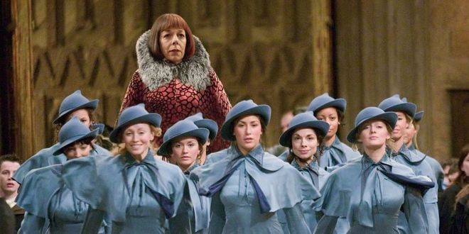

**Chapter Fifteen – Beauxbatons and Durmstrang**

The morning after hearing from Sirius, Harry wakes early and tiptoes to the Owlry, where he sends a letter to Sirius, disclaiming his scar pain and telling him to stay where he is. Days pass with no response, and in defense against the dark arts, Professor Moody places the Imperius Curse on the students in order to teach them to ward it off.

Classes get busier. Near the end of October, a poster informs the students that the delegations from Beauxbatons and Durmstrang will be arriving on October 30 in the evening. Hermione continues with S.P.E.W., which most people think is a great joke, and Harry receives word from Sirius that he is indeed coming and will stay well hidden.

On the 30th, the Hogwarts students line up to welcome the guests. Beauxbatons arrives in a great flying carriage, and from the carriage emerges the Headmistress, Madame Maxime, an oversized and attractive woman who greets Dumbledore and then leads her underdressed, shivering students into the castle to warm up. Soon from the lake emerges a great ghostly ship, from which the Durmstrang students, led by the shifty, shrewd-looking Karkaroff, file onto dry land. One of these students, Ron gasps in amazement, is the Bulgarian Seeker, Viktor Krum.

**Questions**

* Why does Harry not want Sirius to come to Hogwarts?
* What are the implications of Professor Moody using the Imperius Curse on the students?

**Chapter Sixteen – The Goblet of Fire** 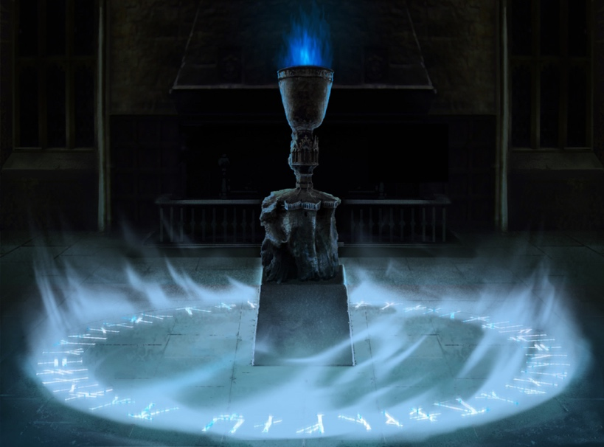

As the guest schools file into the Great Hall, the Hogwarts girls are in a great fluster to get Viktor Krum's autograph, just as the boys are fighting to have him sit near them. He winds up sitting at the Slytherin table, but throughout dinner Ron considers offering him a space to sleep in his and Harry's room. Ron becomes fixated on one of the Beauxbatons girls, whom he thinks looks like a Veela. At the head table, Ludo Bagman and Barty Crouch have arrived to help judge.

Dumbledore introduces the Goblet of Fire to the students and explains that those who wish to enter the Tournament should place their name on a slip of paper inside the goblet; he adds that he has drawn an age line around its perimeter, meaning that no one under the age of seventeen can approach. The next day, Fred and George use a potion to age themselves, but still the Age Line throws them away. That afternoon, Harry, Ron, and Hermione slip over to visit Hagrid, and they are shocked to find that he has dressed in a hairy brown suit, slicked back his hair, and put on some sort of awful-smelling cologne. They all discuss the Tournament and the Skrewts, and as they all begin to move back toward the castle, Hagrid is distracted by Madame Maxime.

**Questions**

* What are the differences between Durmstrang and Beauxbatons students? How does this broaden our idea of the Wizarding world?
* 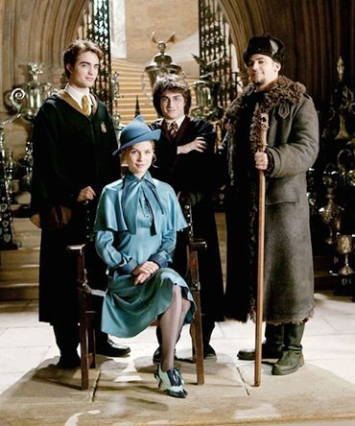Why is there an age limit on entering the Triwizrd Tournament?

**Chapter Seventeen – The Four Champions**

Upon hearing Dumbledore announce his name, Harry is stunned; he moves slowly to the room with the other champions, feeling shocked and confused. Ludo Bagman seems delighted about Harry's being one of the champions. Madame Maxime and Karkaroff angrily suspect that the contest has been rigged; Dumbledore is stern, but believes Harry when he says that he didn't put his name in the Goblet. Moody enters in the middle of all the chaos, and reminds everyone what being chosen by the Goblet represents an unbreakable contract; he says that someone put Harry's name in the Goblet knowing that he would have to compete, perhaps in the hope that Harry would die doing so. Karkaroff takes this moment to accuse Moody of having done it, since he seems to know exactly how to do it; Moody responds belligerently by saying that he needed to think as Dark wizards do, as Karkaroff ought to remember.

Mr. Crouch explains briefly that the contest will consist of three surprise tasks beginning in late November. Harry and Cedric return to their respective houses, and Cedric, though he acts diplomatically, clearly doesn't believe Harry when he claims not to have submitted his name to the Goblet. In the Gryffindor common room, everybody is celebrating Harry as the Hogwarts champion; when he finally returns to his dorm room, he finds Ron, who is sullen that Harry found a secret way to enter and didn't invite Ron to join him.

**Questions**

* Why is Ron upset that Harry has been chosen as a competitor?
* What is the point of the Triwizard Tournament?

**Chapter Eighteen – The Weighing of the Wands**

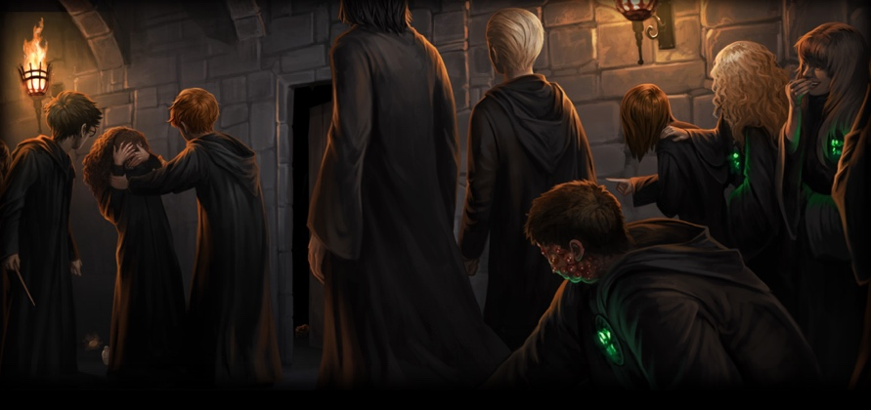

The next morning, Harry is met by Hermione. She believes that he didn't put his name in the goblet, and she explains that Ron would believe it too, but that he is jealous of all the attention Harry always gets. Harry then writes a letter, updating Sirius on the previous night's events. Classes resume. Although Hagrid believes Harry, most people do not; students from all houses except Gryffindor scowl at Harry in the corridors, believing that he entered in hope of attracting even more attention.

In Potions class, all the Slytherins wear light-up badges that say, "Support Cedric Diggory-the REAL Hogwarts Champion!" When pressed, the badges chirp, "Potter Stinks!" Malfoy, after tiring of insulting Harry, decides to turn on Hermione, and Harry explodes, casting a mild disfiguring curse on Malfoy, just as Malfoy does the same to Harry; the curses miss and hit Goyle and Hermione instead, and instantly Hermione's already-large teeth begin to grow down past her chin. Snape sends Goyle to the hospital wing but dismisses Hermione's wound, saying that she looks the same. She flees in tears, and Ron and Harry both turn angrily on Snape, receiving detentions in the process. Potions class is interrupted by Colin Creevey, who takes Harry out of class and to the weighing of the champions' wands.

Before the weighing begins, Rita Skeeter pulls Harry into a broom closet and begins firing questions at him. He doesn't answer them, and still her Quick-Quotes Quill manages to sketch out a tragic portrait of him before Dumbledore enters the closet and rescues Harry. The weighing is done by Mr. Ollivander, who sold Harry his wand. Fleur's wand contains a hair of her grandmother, a Veela; Cedric's contains a unicorn tail- hair. Krum's contains a dragon heartstring, and Harry's contains, although Mr. Ollivander tactfully refrains from mentioning it aloud, a feather from the phoenix whose other feather resides in Voldemort's wand. Finally, that evening, Harry receives a request to be in the Gryffindor Common room alone at one in the morning on November 22, just two days before the first task.

**Questions**

* How do we feel about Snape’s behaviour towards Hermione?
* Why is Harry upset in this chapter, and why is Ron jealous?

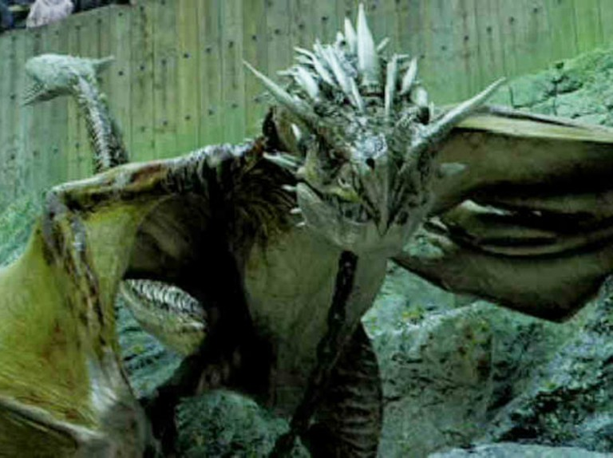**Chapter Nineteen – The Hungarian Horntail**

Life is moving along slowly for Harry these days: his first task is nearing, Ron refuses to speak to him, and to top it off, Rita Skeeter published an article about the Triwizard Champions in which she left out Cedric entirely and spent four pages expounding on Harry's tragic past. During a Hogsmeade visit, Harry wears his Invisibility Cloak in hope of attaining some anonymity, but Mad-Eye Moody spies him through it and points him out to Hagrid, who tells him to come to his cabin that night at midnight. Invisibly, he follows Hagrid, who escorts Madame Maxime deep into the Forbidden Forest, where several dozen men, including Charlie Weasley, are trying to subdue four dragons. Harry overhears Charlie tell Hagrid that each dragon is a nesting mother, and that the four champions are to get past the dragons as their first task-he notes that one of them, a Hungarian Horntail, is significantly more dangerous than the rest.

Harry dashes off to meet Sirius in the common room at one. Right on time, Sirius's head is sitting in the Gryffindor fireplace. Harry tells him everything, and in return Sirius warns Harry that Karkaroff had been a Death-Eater who ultimately was caught by Moody. Sirius says that Moody was the best Auror in history, and is now at Hogwarts for a reason. Furthermore, he suggests that the fiasco with the dustbins may actually have been legitimate; someone may have tried to stop Moody from coming to Hogwarts. Lastly, Sirius notes that Bertha Jorkins was last seen in Albania, oddly enough, where Voldemort was last sighted; he may have used her for information and disposed of her. Before Sirius can advise Harry on how to get past a dragon, Ron walks into the common room, and Sirius disappears in the flames. Harry is furious at this interruption and throws a "Potter Stinks" badge at Ron's face.

**Questions**

* How have our impressions of Moody changed and shifted over the course of the book?
* 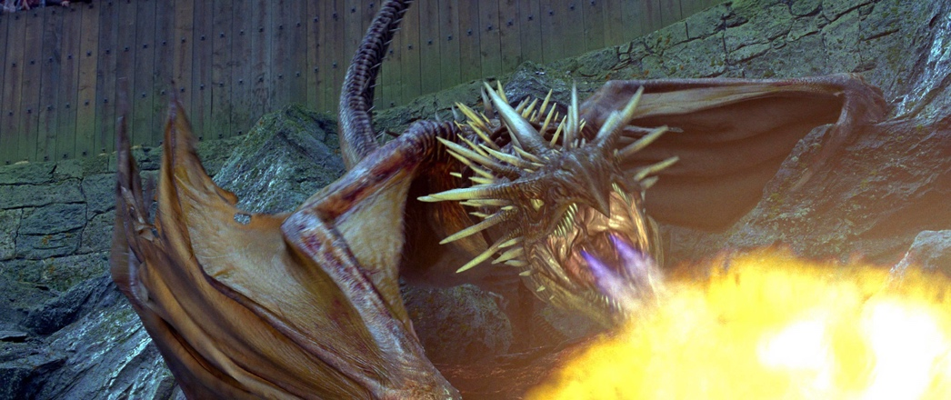What are some elements of foreshadowing in this chapter?

**Chapter Twenty – The First Task**

As the first task nears, Harry and Hermione research ways to subdue dragons; Harry is terrified and considers leaving Hogwarts. The day before the task, Harry warns Cedric about the dragons, since the other champions must have heard from their school-heads by now. Cedric is suspicious, and Moody pulls Harry aside and advises Harry to play to his strengths, nodding when Harry says "Quidditch." Harry realizes through this conversation that he must fly past the dragon, and therefore he must have his Firebolt broomstick. He and Hermione spend the rest of the day and night practicing the summoning charm, "Accio!"

The morning of the task, the four nervous champions are led into a tent in the forest and told that their goal is to get the golden egg. Harry is to go fourth and fight the Hungarian Horntail. He listens as the crowd reacts to the work of the other three champions, and when his turn comes, he walks into the enclosure, summons his broomstick, and flies around the dragon, feeling at ease for the first time in the whole tournament, and getting the egg in what Ron afterwards tells him was the best and fastest of the four methods. Ron and Harry are reunited afterwards, as Ron was terrified for Harry's life and realized that Harry would never put himself in that position just for attention. The champions are told that their golden eggs will clue them in on the second task, which will take place in three months.

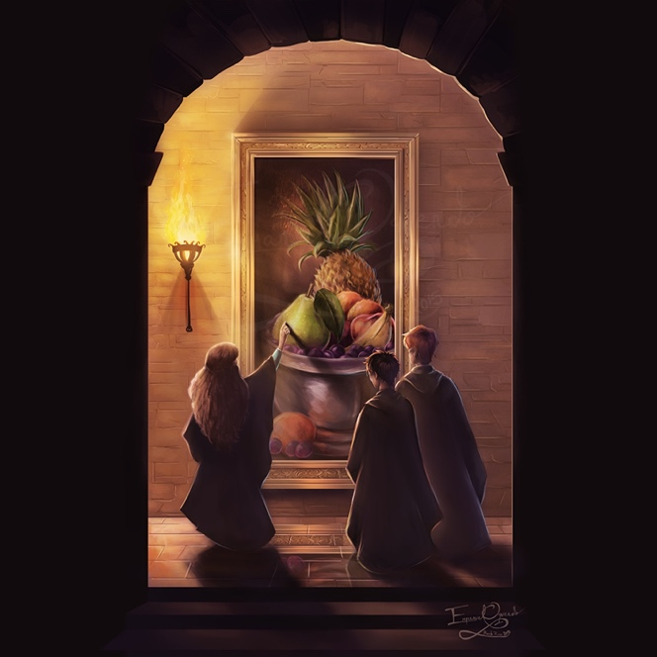**Chapter Twenty-One – The House-Elf Liberation Front**

Harry sends a letter to Sirius describing the triumph over the dragon. He goes into the Gryffindor common room, where a great celebration ensues. At one point, Harry is persuaded to open his golden egg, but only a garbled shrieking comes from it. Everyone is merry, especially Fred and George, whose Canary Creams turn Neville temporarily into a giant yellow canary.

Days later, while Harry is helping Hagrid tie up ten angry Skrewts, Rita Skeeter drops in and asks to interview Hagrid. After class, Hermione drags the boys down to the kitchens, where, amid a hundreds of house-elves offering food and tea, Dobby appears and greets Harry. He and Winky now work at Hogwarts, and although Dobby is delighted by his freedom and his ability to earn money for his work, Winky is not; she misses Mr. Crouch and feels disgraced. Dobby, now that he is free from the Malfoys, confides in Harry that the Malfoys are dark wizards; Winky weeps sloppily and refuses to speak ill of Mr. Crouch, although she does mention that Ludo Bagman is a bad wizard. As the students leave the kitchens, Dobby promises to visit Harry, and Hermione feels confident that the other house-elves will soon envy Dobby's freedom and demand better standards for themselves.

**Questions**

* What do we think about Hermione’s efforts at liberation now, do we think that it’s a good idea?
* What elements of foreshadowing do we see here?

**Themes**

**The Importance of Friendship**

* Without Ron, Harry is shown to be entirely miserable. How do Harry’s friends help him in these chapters, and why is friendship important?

**Activism and Diversity**

* Hermione realises that what she has been told about House Elves isn’t true, and jumps into action. Why is this an important part of her growth?

**Homework**

* Write a news report about the Triwizard Tournament covering the first task. Think about including description, context, and interviews with some of the contestants.