Harry Potter and the Goblet of Fire

Chapters 8-14

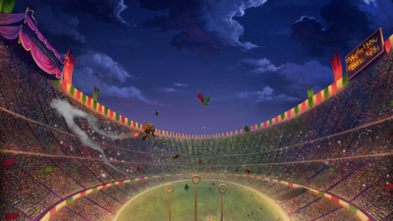

Chapter 8 – The Quidditch World Cup

The Weasleys go to their seats in the top box. As they sit down, Harry notices a small bat-eared creature sitting alone. It is house-elf Winky who is saving the seat for her master, and informs Harry that she knows Dobby, who is currently trying to liberate the house-elves. Soon Cornelius Fudge, the Minister of Magic, joins them in the top box, as do the Malfoys.

Ludo Bagman is commentating on the game, and as he begins to speak, the teams send out their mascots. First, Bulgarian Veela, beautiful dancing Sirens enchant the audience. Then, Irish Leprechauns form shapes in the sky and drop gold pieces onto the bleachers, which Ron collects and uses to repay Harry for the omnioculars. The players enter the field and the game begins. Harry has never seen such a fast game of Quidditch. The players dash madly through the sky, and Ireland is quickly in the lead. The mascots are growing more involved, to the point that the Veela, angry at the Bulgarian's lagging behind, burst out of their beautiful skins and reveal their true, demonic bird- heads. Krum wows the audience by performing a "Wronksi Feint," a spectacular dive for the Snitch that fools the other team's Seeker into following him and crashing into the ground. Once his team is one hundred and sixty points behind Ireland, he catches the Snitch, ending the game, but in Ireland's favor. The crowds go wild, and Fred and George go to collect their winnings from Ludo Bagman.

Questions

* What do the different teams’ mascots say about the teams?
* What do we think about Dobby’s endeavour – do we think it’ll work?

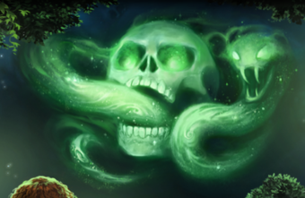Chapter 9 – The Dark Mark

After several hours of discussing the game, the two Weasley tents quiet down and sleep. Mr. Weasley awakens Harry and tells him to get outside the tent. He does so, and he see a crowd of masked, hooded wizards marching through camp. He sees Mr. Roberts, his wife, and his kids levitating above them. Harry, Ron, and Hermione run to the woods; there, they find Draco Malfoy leaning against a tree and looking pleased. He explains to them that the crowd is rampaging against Muggles and Mudbloods. Harry realizes that he cannot find his wand. In this midst of this chaos, they spy Winky the house-elf limping along, squeaking fearfully to herself. Ludo Bagman then appears near them, looks alarmed, and disappears. Moments later, they hear a spell mumbled and see a green smoky skull with a snake in its mouth, arising high in the sky. The woods around them erupt in screams. Suddenly many wands are aimed at Harry, Ron, and Hermione, who duck in time to escape being stupefied.

Mr. Weasley comes to rescue them, but not before Mr. Crouch storms over and asks which of them conjured the Dark Mark. The three explain that they heard a voice summoning it, but Mr. Crouch suspects them. At this point, Mr. Diggory goes into the trees and emerges holding an unconscious Winky in his arms, as well as a wand he found in her hand. Mr. Crouch is horrified and defensive, and Mr. Diggory brings Winky back to consciousness to ask what happened. She says that she did not do it, and Harry notices that the wand she was holding is his. This causes a new wave of suspicion, especially when Mr. Diggory reveals that this wand did in fact summon the Dark Mark. It seems highly unlikely that either Harry Potter or Mr. Crouch's house-elf could or would have conjured the spell, so the frightened group disbands. As the group returns to their tents, Mr. Weasley reassures the masses that everything is okay, and then he explains to his kids and Harry that Voldemort's followers, the Death Eaters, always made the Dark Mark after killing someone, and as they were the ones levitating the Muggles, they would have been frightened by the Dark Mark into thinking that Voldemort had returned to find that that they had betrayed him. Harry is shaken by this knowledge, and he wonders whether it pertains to the pain in his scar three nights before.

Questions

* How has the tone shifted in this chapter?
* Who do we think cast the dark mark and why?
* Why do you think there is so much hatred against Muggles and Mudbloods?

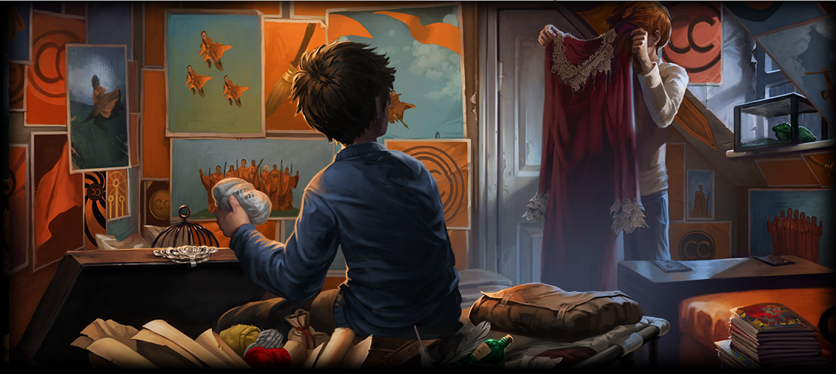

Chapter 10 – Mayhem at the Ministry

The Weasley party goes home early the next morning. Mr. Weasley heads to the Ministry to clear up rumours written by the reporter Rita Skeeter, and Harry confides to Ron and Hermione about his scar hurting; they react just as he predicted they would. For the following week, Percy and Mr. Weasley spend all of their time at the Ministry of Magic, while Harry, Hermione, and the Weasley kids prepare their school things to return to Hogwarts. They learn from Bill about Rita Skeeter's reputation for ruining wizard reputations. The night before they leave for school, Mrs. Weasley brings to the kids an armful of laundered dress robes, and Ron throws a fit at the fact that his are second-hand and lacy. Harry feels deeply sorry for Ron about financial matters, because Harry's parents left him a small fortune, and the Weasleys are always struggling to make ends meet.

Questions

* Do you think money is an obstacle between Harry and Ron?
* 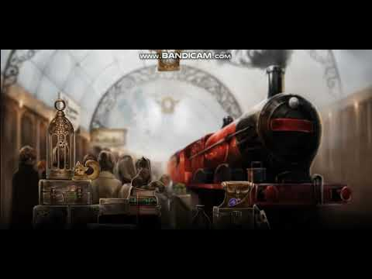Why is Rita Skita a potential danger in this story?

Chapter 11 – Aboard the Hogwarts Express

It is raining hard the following morning, and the Weasleys, Harry, and Hermione wake up to find Amos Diggory's head in the fireplace. Amos reports that Mad-Eye Moody set his dustbins to attack what he thought was an intruder, and has been caught by Muggle policemen. Mad-Eye Moody once was a great Auror (dark wizard catcher), but now he has grown old and suspicious. Mr. Weasley speeds off to the Ministry to sort this out, while everyone else loads into the three Muggle taxicabs that will take them to King's Cross Station. The Hogwarts students enter platform nine and three-quarters and board the Hogwarts Express. Charlie hints that he may be seeing them sooner than they think.

On the train, Harry, Ron and Hermione overhear Draco Malfoy boasting to his friends that his father wanted to send him to Durmstrang, a wizard school in Northern Europe that teaches the Dark Arts. The three friends reunite with other students, such as Dean Thomas, Seamus Finnigan, and Neville Longbottom. Ron has draped his new dress robe over Pig's owl cage, and Malfoy saunters by, spies it, picks on Ron for a bit, and mentions something mysterious that is soon to happen at Hogwarts. Finally, they arrive at Hogwarts and are taken to the castle in a row of horseless carriages.

Questions

* What do we think about our first impression of Mad-Eye Moody, including the name he is presented with?
* Why do we think Charlie hints that he might be seeing them soon?

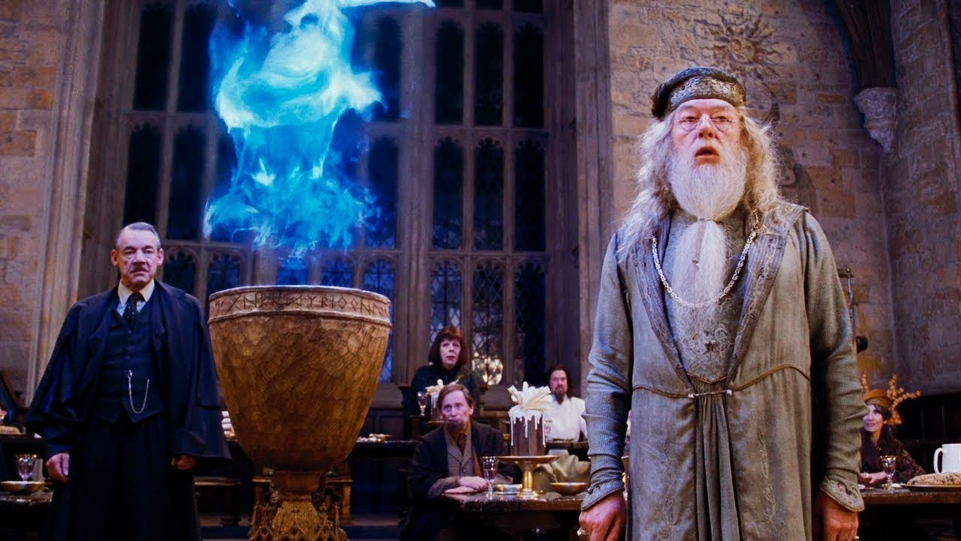Chapter 12 – The Triwizard Tournament

Once the students enter the castle, they are bombarded with water-balloons by Peeves. Drenched, they all file into the Great Hall for dinner. Harry is greeted by Nearly-Headless Nick, the friendly Gryffindor House ghost, while he waits for the Sorting to begin and wonders who the new Defence Against the Dark Arts teacher will be. Dennis Creevey, the younger brother of Colin Creevey, a third-year who idolizes Harry, is Sorted into Gryffindor, and he gawks at the scar on Harry's forehead.

Dinner appears on the tables, and as the students eat, Nearly Headless Nick mentions that Peeves has caused problems with the house-elves in the kitchen. Hermione stares at him, proclaims that Hogwarts is engaging in slave-labour, and refuses to finish her dinner. Soon the headmaster, Dumbledore, rises to address the school. He tells them that the annual Quidditch Cup will not take place this year; before he can tell them what will take its place, he is interrupted by the entrance of a gnarled, grumpy looking man with one large swiveling eye: Mad-Eye Moody, who is the school's new Defence Against the Dark Arts teacher. The students stare silently as Dumbledore introduces him, and they listen in anticipation as Dumbledore proceeds to explain that the Triwizard Tournament, a competition between representatives from each of the three largest European schools of wizardry (Hogwarts, Beauxbatons, and Durmstrang), will take place this year at Hogwarts. It had been discontinued hundreds of years ago because of high death tolls, but the Ministry of Magic has now taken enough precautions for it to continue. He adds that the winner will receive a thousand galleons, and that nobody younger than seventeen years old can enter. The Weasley twins scoff, and that night as Harry falls asleep in his dorm room, he imagines himself entering and winning the Triwizard Tournament. He imagines Cho Chang, a Ravenclaw girl on whom he has a crush, cheering for him.

Questions

* Why was the Tournament originally discontinued?
* Why does Hermione refuse to eat her dinner?

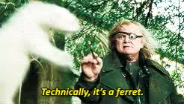

Chapter 13 – Mad-Eye Moody

The students begin classes. First is Herbology, during which Professor Sprout teaches them how to collect Bubotuber pus. In Care of Magical Creatures with Hagrid, they are introduced to newly hatched Blast-Ended Skrewts. Nobody can tell where their mouths are or how to feed them, or what purpose there is in keeping them alive. After lunch, which Hermione is eating once again, she dashes away to the library. Harry and Ron trek to Divination class, where the airy, cryptic Professor Trelawney predicts that whatever Harry fears will happen soon. She shows the class how to read the planets by using Harry as an example, whom she says must have been born in midwinter, because of his colouring and tragic past. He informs her that his birthday is in July. She grows annoyed that nobody takes her class seriously and assigns them a month's worth of personal predictions on the planetary alignments.

As the students enter the Great Hall for dinner, Malfoy reads aloud from an article written by Rita Skeeter, ridiculing Mr. Weasley for helping Mad-Eye Moody out of his tangle with the policemen several days before. Harry defends Ron by noting that Malfoy's mother had a perpetually unpleasant expression on her face. Harry turns around to leave, and Malfoy attacks him, the sparks of his wand just missing Harry. At this moment, Mad-Eye Moody enters the scene, swiftly turning Malfoy into a ferret and causing him to bounce in the hallway, as punishment for attacking when his opponent's back was turned. Professor McGonagall transforms Malfoy into his original form and warns Moody not to transfigure students. At dinner, the Weasley twins speak in awe of Moody's teaching abilities in Defence Against the Dark Arts.

Questions

* Describe a Blast-Ended Skrewt.
* What do we think about our further impressions of Mad-Eye, particularly his teaching style?

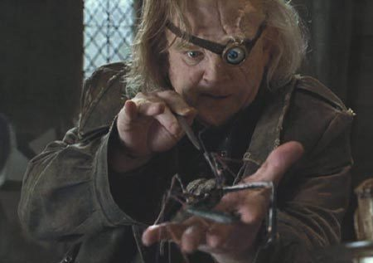Chapter 14 – The Unforgivable Curses

Over the next few days, Harry notices that Professor Snape seems especially timid around Professor Moody. The Gryffindors excitedly await Moody's class, and finally Thursday comes. He hobbles in, grizzled and gruff, and tells the students to put away their books; he says that the class has studied dark creatures but that they were behind in curses, and that he has one year to cover the subject. He adds that instead of teaching just the counter-curses, he and Dumbledore agreed that it would be best to teach the curses themselves, in order to show the students what they are up against. He uses three spiders to demonstrate the three unforgivable curses, each of which would land the curser a lifetime in Azkaban. He first demonstrates the Imperius Curse, which allows the curser to control the cursed. This is the curse that Voldemort used to put wizards under his control. He then shows the Cruciatus Curse, which causes terrible writing pain to the cursed, and which upsets Neville tremendously when he sees it done to the spider. Finally, he shows Avada Kedavra, the killing curse, which only Harry Potter has ever survived. Harry is upset to see the final curse, which killed his parents. Moody warns them all to keep "constant vigilance!". After class, Neville is still shaky from watching the second curse. Moody pulls him aside and gives him a book on Mediterranean water plants, saying kindly that Professor Sprout has mentioned that Neville was good at Herbology.

That night, Harry and Ron sit in the common room doing their Divination homework. The Weasley twins are sitting quietly in a corner poring over a mysterious piece of parchment. Hermione enters the common room with a box of badges, each bearing the letters S.P.E.W. The acronym stands for the Society for the Protection of Elfish Welfare, an organization she has just begun. Hedwig enters the common room with a letter for Harry from Sirius, which says that he has heard of many odd signs and wants Harry to go to Dumbledore if the scar hurts again. He says that he is returning and will be in touch. Harry finishes reading and feels like a hypochondriac. He thinks that he has placed Sirius in danger by telling him about the scar. He unhappily goes to his dormitory, not noticing that Neville is also awake and restless.

Questions

* What do we think about Moody’s class? Do we think it’s an acceptable thing to do?
* 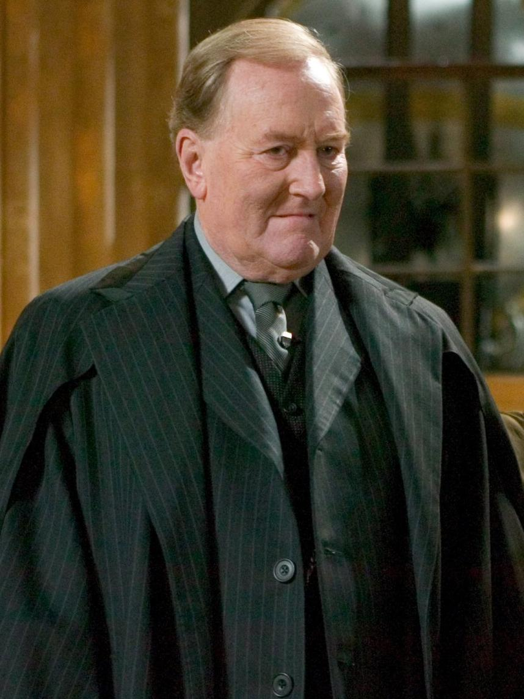What do we think about Hermione’s S.P.E.W? Is this a noble thing to do, or do we think it’s silly?

Themes

Politics

* As Harry grows up and matures, he begins to tune in to the politics of the Wizarding World and how it works. What are some examples of this?

Danger and Fear

* As in the rest of the novels, things begin to darken as the story progresses. What are some of the ways in which danger, fear and uncertainty are introduced in this book?

Homework

* Imagine that you are the Wizarding Reporter Rita Skeeter. Write an article on Mr Weasley’s intervention with Mad-Eye Moody regarding his bins. Think in particular about how Rita Skeeter might write.