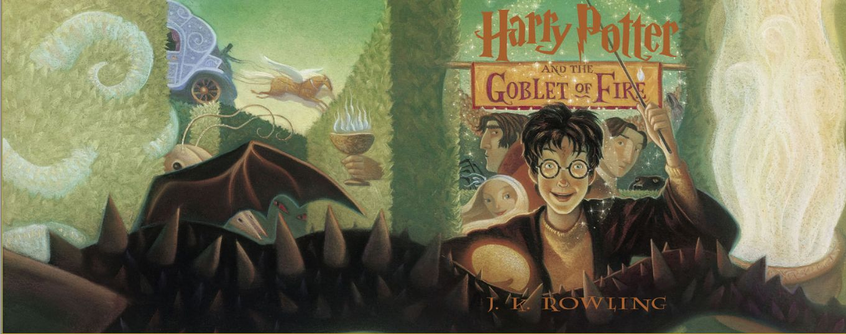**Harry Potter and the Goblet of Fire**

Chapters One – Seven

Chapter One – The Riddle House

The Riddle House stands on a hilltop in Little Hangleton. Much mystery has arisen around it. Fifty years ago, its inhabitants, the Riddle family, were killed in a most mysterious manner as if they had been frightened to death. The villagers instantly suspected Frank Bryce, the Riddles' gardener, and even after he was questioned and found innocent, the villagers still mistrusted him.

One night, fifty years later, the elderly Frank sees a bright light inside the Riddle House, and he thinks the village boys have set a fire. He limps over to the house and overhears a conversation between two voices, one high pitched controlling one, another nervous submissive one. Frank overhears the controlling one, who reveals his name to be Lord Voldemort, telling the other one, whom he calls Wormtail, that he must wait for the Quidditch World Cup to end before capturing Harry Potter. Wormtail suggests using a different boy, but Lord Voldemort refuses. Wormtail pleads his loyalty by reminding his master that he brought him Bertha Jorkins, whose information proved quite useful before they had to kill her. A thick, twelve-foot long snake slithers past Frank. Lord Voldemort calls Frank into the room and kills him in a single flash of green light; at that moment, miles away, Harry Potter awoke in the night.

Questions

* The previous volumes have all opened at the Dursley home, but this book starts somewhere else. How did that change the tone of the story for you? Why do you think Rowling departed from the way she had started the other books?
* In what ways is this novel darker than the previous books we have looked at in the series?
* In the first few books, a lot of the humour and authenticity of the novels comes from the juxtaposition between the muggle world and the wizarding world. How can some of these juxtapositions be chilling as well?

Chapter Two – The Scar

Harry Potter wakes to feel the scar on this forehead throbbing. He looks around his dark room in alarm, remembering that the last time his scar hurt him was when Lord Voldemort was nearby..

Harry paces the room, debating what to do. He cannot tell the Dursleys, because they detest his presence as well as magic. He cannot tell his best friend Hermione, because she would find it alarming and want him to inform Dumbledore. He cannot tell his other best friend, Ron, because Ron would think it was a false alarm. Finally, Harry decides to write to Sirius Black, his godfather whose escape Harry assisted in *Harry Potter and the Prisoner of Azkaban.* Black has been wrongly imprisoned for killing thirteen people in addition to turning Harry's parents over to Voldemort. Harry and his friends discovered that this work had actually been done by Peter Pettigrew who is also known as Wormtail. Black was innocent. Harry writes him a short letter and walks down to breakfast.

Questions

* Harry begins the novel, as usual, by having a miserable time at the Dursley’s. But what is different this year?
* What is the effect of the exposition here?

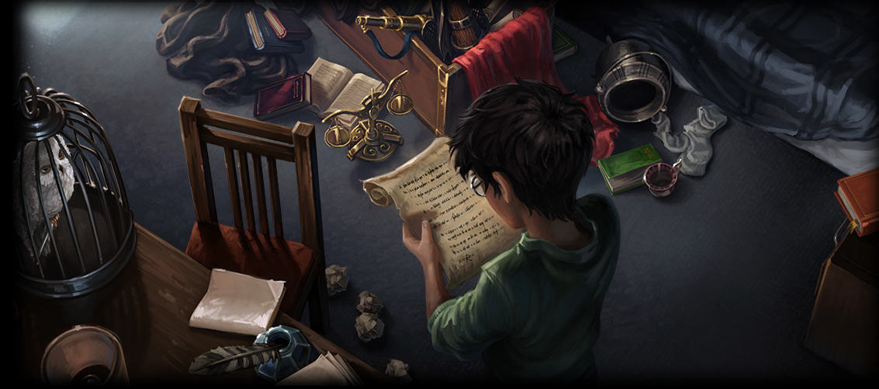Chapter Three – The Invitation

When Harry arrives downstairs for breakfast, nobody blinks an eye. Uncle Vernon is buried behind the morning paper, and his son Dudley is sulking furiously about the grapefruit that Aunt Petunia is slicing into quarters. Dudley's school has written to the Dursleys, saying that they have no knickerbockers to accommodate his gigantic behind. Dursely has gone on a diet. Aunt Petunia has placed the whole family under Dudley's diet, which Harry has survived by asking his friends to send him food by owl.

Breakfast is interrupted by the arrival of the postman with a letter, and Uncle Vernon calls Harry into a side room. The letter is from Ron's mother, Molly Weasley, who is inviting Harry to attend the Quidditch World Cup and stay with her family for the rest of the summer. What most infuriates Uncle Vernon is that the letter is in an envelope covered in dozens of stamps. Harry mentions casually that he must finish a letter to Sirius Black, and Uncle Vernon looks terrified and grumpily tells Harry to go, not wanting a convicted murderer to show up.

Harry bounces upstairs delightedly to find that his snowy owl, Hedwig, has returned from a night flight, and that another, smaller owl is zooming around the room. The smaller owl, Pig, is Ron Weasley's new owl, and it delivered a note from Ron saying for Harry to be ready to leave for the Quidditch Cup the following night at five. Harry writes back to Ron and sends his letter out to Sirius, feeling most optimistic about the end of the summer.

Questions

* Why is Harry ‘optimistic’ about the summer?
* Why is Vernon angry about the letter, besides the copious use of stamps?

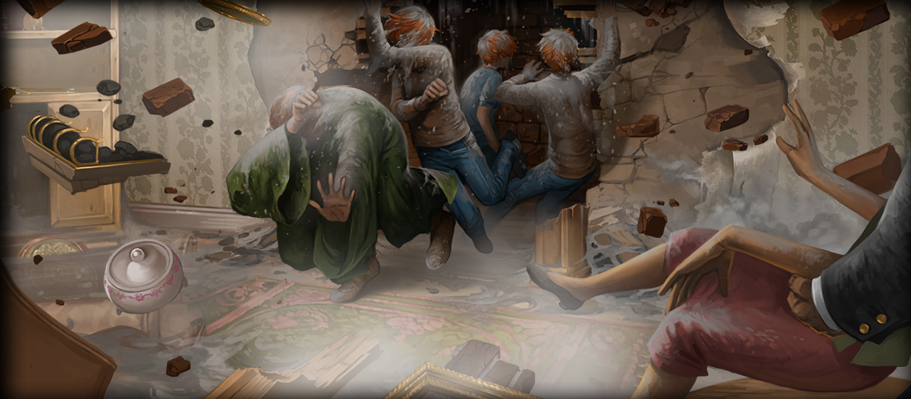

Chapter Four – Back to the Burrow

Harry packs his trunks and is ready to leave by noon the next day. Uncle Vernon makes several snide comments about how he hopes that the Weasleys will think to dress properly. Finally, at a quarter past five, loud banging sounds come from inside the Dursleys' boarded-up fireplace, and Harry knows instantly that the Weasleys have tried to travel by Floo Powder through the fireplace network. Arthur Weasley's voice warns Harry to stand back, before the fireplace explodes, revealing the red-haired figures of Ron, the twins Fred and George, and their father, Arthur. They greet the Dursleys politely, but the Dursleys simply stare, while Dudley disappears, clutching his bottom, which spouted a pig's tail during his last encounter with a grown wizard.

Fred and George head upstairs to retrieve Harry's trunk from his room, while Mr. Weasley bravely attempts conversation with the Dursleys. When the twins return with Harry's trunk, one of them drops a pocketful of sweets on his way back to the fireplace. They find that Dudley has devoured one of the sweets, thus enlarging his tongue. Aunt Petunia shrieks and tries to pull his tongue out of his mouth, while Uncle Vernon throws ornaments at Mr. Weasley. Mr. Weasley tries to restore the tongue.

Questions

* What is comedic about this scene, and what is different about this and the last time the wizarding and muggle world collided in this book?
* What is the difference between the Weasleys and the Dursleys as families?

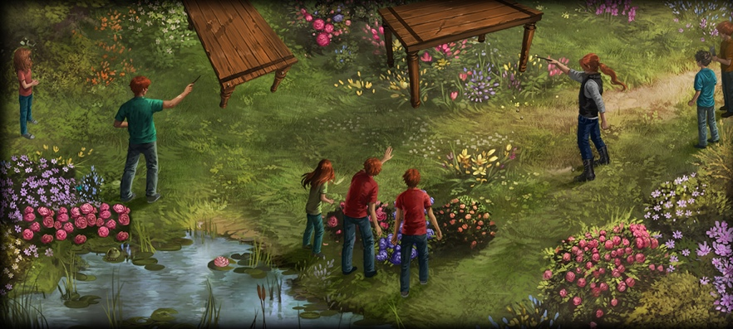

Chapter Five – Weasleys’ Wizard Wheezes

Harry arrives at The Burrow and instantly notices two older Weasleys sitting at the kitchen table. He is introduced to the eldest members of the family: Charlie, who works with dragons in Romania, and Bill, who works at Gringotts bank in Egypt. Suddenly Mr. Weasley arrives in the fireplace, furious with the twins for giving Ton-Tongue Toffee to Dudley. Harry, Ron, Ginny, and Hermione, who also is visiting, all troop upstairs away from Molly Weasley's rage. On their way up, they encounter the smug and hardworking Percy, another Weasley brother who has just graduated from Hogwarts and now is working for the Ministry of Magic. Ron admires the eldest two brothers and the twins, but is scornful of Percy.

They all remain in Ron's room for a bit, discussing Percy's job and Weasleys' Wizard Wheezes, a line of magical jokes that Fred and George have been perfecting. Their mother disapproves. Harry, Ron, Hermione, and Ginny go downstairs to find Mrs. Weasley cooking dinner and complaining about the twins. They dart outside to find that Bill and Charlie have levitated a pair of tables and are using magic to make them crash into each other. Eventually they all sit down for a twilight meal. A cosy evening ensues, filled with simple family arguments. Percy complains about how Ludo Bagman, a friend of Mr. Weasley and the head of Magical Games and Sports within the Ministry of Magic, has managed to lose one of his workers, a woman named Bertha Jorkins. Harry feels at peace to be with the Weasleys, and is excited to be going to the World Cup.

Questions

* Why do we think Harry feels ‘at peace’ at the Weasleys’?
* What hints of foreshadowing can we begin to see in this chapter?

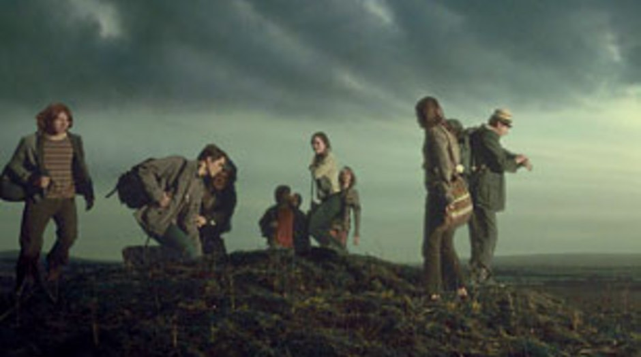Chapter Six – The Portkey

Early the following morning, Harry is awakened by Mr. Weasley, who is dressed in Muggle clothes. He, Ron, Ginny, Hermione, Harry, Fred, and George must leave early in the morning to get to the Cup. The eldest three Weasleys are able to Apparate. Everybody is grumpy and tired. The early morning tension escalates when Mrs. Weasley calls out "Accio!", casting a spell that extracts dozens of Ton-Tongue- Toffees from the twins' pockets. Everybody except for Mrs. Weasley leaves the house and walks through the cold morning air to Stoatshead Hill. Mr. Weasley explains that because it would be impossible to fit thousands of wizards at once onto Hogwarts Express, or Diagon Alley, alternate means for transportation are used for events such as the World Cup. In this case, they were to use a Portkey.

At the top of the hill, they encounter Cedric Diggory, a handsome Hogwarts student and the Seeker for the Hufflepuff Quidditch team, and his father, Amos Diggory. The Diggorys have found the Portkey, a dilapidated boot, and at five a.m. they all touch it. It jerks them from the bellybutton and spins them all blindly through the air. When they arrive shakily at the campground, only Mr. Diggory, Mr. Weasley, and Cedric are able to land on their feet.

Questions

* Why do you think Amos Diggory brags about his son’s Quidditch performance in this chapter?
* What do we think about the introduction of a new form of magical transport?

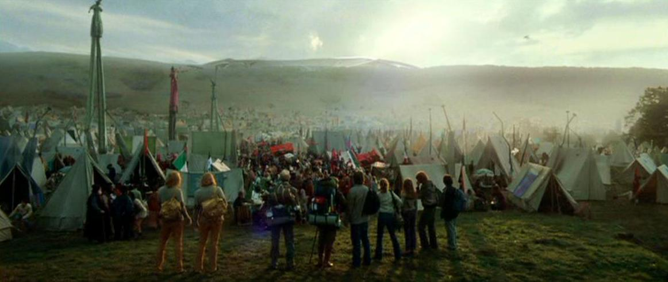

Chapter Seven – Bagman and Crouch

At the site of the Quidditch World Cup, Harry, Hermione, and the Weasleys are directed to their campgrounds. The task of creating a place where a hundred thousand wizards can congregate undiscovered is no easy feat, as the frantic Ministry wizards remind Mr. Weasley many times throughout this chapter - they are constantly having to erase Mr. Roberts' memory, so that he will not recall all of the strangeness he is observing. All of the wizards have pitched tents in attempts to act like Muggles. Many of the tents have chimneys. With Wizards present from all over the world, Harry realizes how expansive the wizard world really is.

Upon returning to the tent, they find Mr. Weasley trying to start a fire with matches. Percy, Bill, and Charlie Apparate in. The group is visited by Ludo Bagman, the Head of Magical Games and Sports, and a retired Quidditch Beater. Ludo wagers with Fred and George on the outcome of the game. The twins bet all their money that Ireland will win, but that Krum will catch the Snitch. Barty Crouch, Percy's stiff and humorless boss Apparates. Percy bows low and offers him tea, and the startled Crouch accepts the tea, but mistakes Percy for Weatherby, much to the twins' delight. They allude to a mysterious upcoming event at Hogwarts, and then they leave. Harry buys himself, Ron, and Hermione each a pair of expensive omnioculars from a wizard vender, and they troop to the field to watch the match.

Themes

Family

* Throughout the books Harry finds himself increasingly taken in by the Weasley family. Now, with the addition of his Godfather, Sirius, he is beginning to develop a firm and reliable family circle. How do you think this makes him feel? And how do you think it increases the stakes of the novels?

The Muggle and Wizarding World

* In what ways do the Muggle and Wizarding worlds seem to collide in this novel, and how does it differ from previous novels?

Homework

Imagine that you are a muggle reporter. Write an article covering the mysterious activity currently taking place on Roberts’ field. Think particularly about how you might interpret the events on the field as a non-magical individual.