**Class Schedule**

1. Test on last lesson’s vocabulary (15 mins)
2. Opening Activity (20 mins)
3. Read extract (10 mins)

Break (10 mins)

1. Comprehension questions (15 mins)
2. Read through new vocab, guess blank words (15 mins)
3. Describe the picture (15 mins)

**Refresh Test**

* Spot check on definitions, antonyms and synonyms of last week’s words (use the words in sentences)

**Opening Activity**

1. *Match the word to the definition!*
2. Ample
3. Commit

1. Punctual
2. Suspect
3. Wretched
4. Betray
5. Grieve
6. Leisure
7. Meticulous
8. Volatile
9. More than enough, plentiful
10. To have an idea of impression of something without certainty
11. To feel intense sorrow for the loss of something
12. To carry out an action (mistake, crime)
13. Likely to change rapidly and unpredictably
14. In a very unhappy or unfortunate state
15. Happening at an agreed time
16. To break a promise or be disloyal to someone
17. Showing great attention to detail; careful and precise
18. Free time for enjoyment
19. *Now work together to make up a story using these ten words!*

A Tale of Two Cities by Charles Dickens – City of London School: Specimen Entrance Examination (English, 2018)

*In this  passage,  the  writer  describes  England  in  1775  –  a  lawless  time  of  thieves  and  highwaymen  (robbers who stole  from travellers). The Dover Mail was the equivalent of the  Royal Mail – a horse‐drawn coach delivering the post.*

In England, there was **scarcely** an amount of order and protection to **justify** much national **boasting**. Daring **burglaries** by armed men, and highway robberies, took place in the capital itself every night; families were publicly **cautioned** not to go out of town without removing their furniture to **upholsterers’** warehouses for security; the highwayman in the dark was a City tradesman in the light, and, being recognised and challenged by his fellow-tradesman whom he stopped in his character of “the Captain,” **gallantly** shot him through the head and rode away; the **mall** was **waylaid** by seven robbers, and the guard shot three dead, and then got shot dead himself by the other four, “in **consequence** of the failure of his **ammunition**:” after which the mall was robbed in peace; that **magnificent** **potentate**, the Lord Mayor of London, was made to stand and deliver on Turnham Green, by one highwayman, who **despoiled** the **illustrious** creature in sight of all his **retinue**; and nobody thought any of these **occurrences** much out of the common way.

It was the Dover road that lay, on a Friday night late in November, before the first of the persons with whom this history has business. The Dover road lay, as to him, beyond the Dover mail, as it **lumbered** up Shooter’s Hill. He walked up hill in the **mire** by the side of the mail, as the rest of the passengers did; not because they had the least **relish** for walking exercise, under the circumstances, but because the hill, and the harness, and the mud, and the mail, were all so heavy, that the horses had three times already come to a stop, besides once drawing the coach across the road, with the **mutinous** intent of taking it back to Blackheath. Reins and whip and coachman and guard, however, in **combination**, had read that article of war which **forbade** a purpose **otherwise** strongly in favour of the argument, that some **brute** animals are **endued** with Reason; and the team had **capitulated** and returned to their duty. With **drooping** heads and **tremulous** tails, they **mashed** their way through the thick mud, **floundering** and stumbling between whiles, as if they were falling to pieces at the larger joints.

There was a steaming mist in all the **hollows**, and it had roamed in its **forlornness** up the hill, like an evil spirit, seeking rest and finding none. A **clammy** and intensely cold mist, it made its slow way through the air in ripples that visibly followed and overspread one another, as the waves of an **unwholesome** sea might do. It was dense enough to shut out everything from the light of the coach-lamps but these its own workings, and a few yards of road; and the reek of the **labouring** horses steamed into it, as if they had made it all.

**Comprehension Questions**

1. Which statement best describes the picture of England given in the first paragraph?
   1. People boasted of how they were not afraid of the violent robberies
   2. Violent robberies were frequent and people were afraid.
   3. People wore disguises so their bravery was not recognised
   4. People boasted of how good their disguises were
2. What is the effect of the author’s use of semi-colons in this extract?
3. What do you understand by the phrase ‘nobody thought any of these occurrences  much out of the common way’?
4. What is the purpose of the first sentence of the second paragraph?
5. Which words in the second or third paragraphs describe the state of the road?
6. What does the word ‘capitulated’ mean in this context?
   1. Gave in
   2. Returned to the capital city
   3. Agreed
   4. Considered their options
7. ‘There was a steaming mist in all the hollows, and it had roamed in its forlornness  up the hill, like an evil spirit, seeking rest and finding none’ – what two techniques  are used in this sentence?

**Vocabulary**

* *Define each word, put it into one of four categories (noun, adjective, verb or adverb) and, where applicable, note down a synonym or antonym.*

1. Scarcely – adv. Only just, almost not
2. Justify – v. to give reason for doing something
3. Boast – v. to talk proudly of your achievements
4. Burglary – n. theft
5. Cautioned –
6. Upholsterer – v. cover the walls or furniture with fabric
7. Gallantly – adv. In a brave or heroic manner
8. Mall – n. a walkway bordered by trees
9. Waylay – v. to stop por interrupt something
10. Consequence – n. a result or effect of an action; importance or relevance
11. Ammunition – n. a supply or bullets
12. Magnificent – adj. extremely beautiful or elaborate
13. Potentate –
14. Despoiled – v. stole or violently removed a valuable possession
15. Illustrious – adj. well known or respected
16. Retinue – n. a group of adviser or assistants that accompany an important person
17. Occurrence – n. an incident or event
18. Lumbered – v. to move in a slow or heavy way
19. Mire – n. boggy or swampy ground
20. Relish –
21. Mutinous – adj. refusing to obey orders; disobedient
22. Combination – n. a joining or merging of different things
23. Forbade/forbid – v. refuse to allow something
24. Otherwise – adv. Or else
25. Brute – n. a savagely violent person or animal
26. Endued – v. endowed or provided with a quality or ability
27. Capitulate – v. stop resisting an opponent or a demand; yield
28. Drooping – v. bending or hanging down limply
29. Tremulous – adj. shaking or quivering
30. Mashed – adj. reduced to a pulpy mass
31. Flounder – v. struggle or stagger in mud or water; show great confusion
32. Hollow –
33. Forlorn – adj. pitifully sad and lonely
34. Clammy –
35. Unwholesome – adj. not healthy, or causing bad health
36. Labour –

**Describe the Scene**

*Look at this drawing of mid-18th Century London. Come up with as many words as you can think of to describe the scene, paying particular attention to the people within it.*

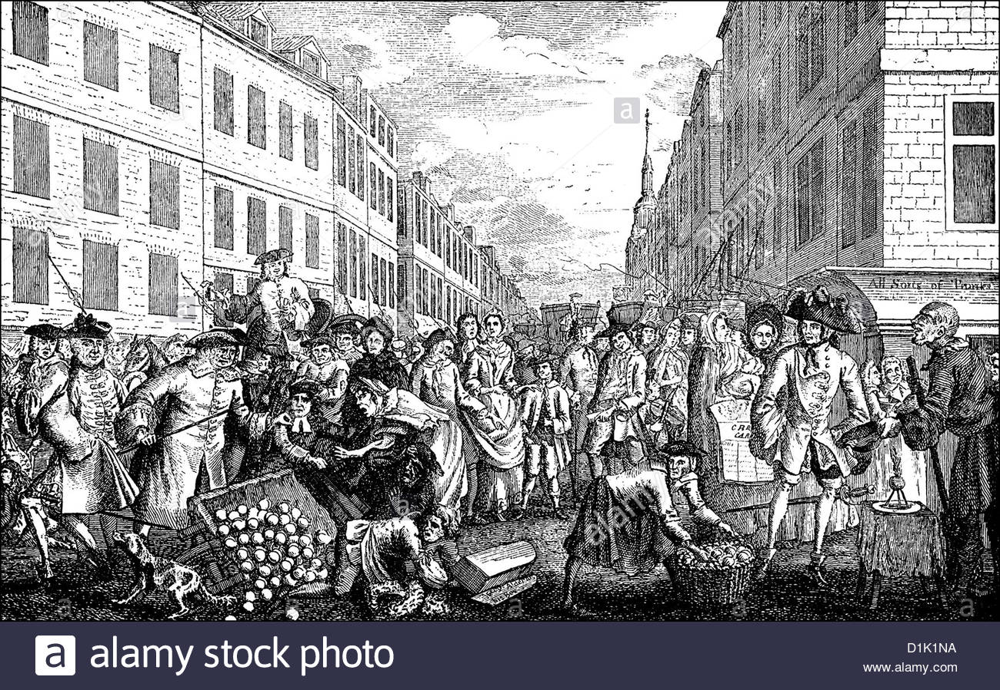

**Homework**

* Revise the vocabulary we have learned today.
* Write a story about a modern-day robbery. Use five words from the list above, and five synonyms or antonyms. You can use the image above for inspiration.