**Class Schedule**

1. Vocab Bingo! (15 mins)
2. Opening Activity (10 mins)
3. Read extract (10 mins)
4. Comprehension questions (15 mins)
5. Read through new vocab (10 mins)

**Vocab Bingo!**

* Follow the link in the chat to access your bingo card! First person to fill in a line wins!

**Opening Activity**

*Look at the picture of a cave. Using the five senses, come up with as many adjectives as you can think of to describe being in the cave, or what might live in the cave!*

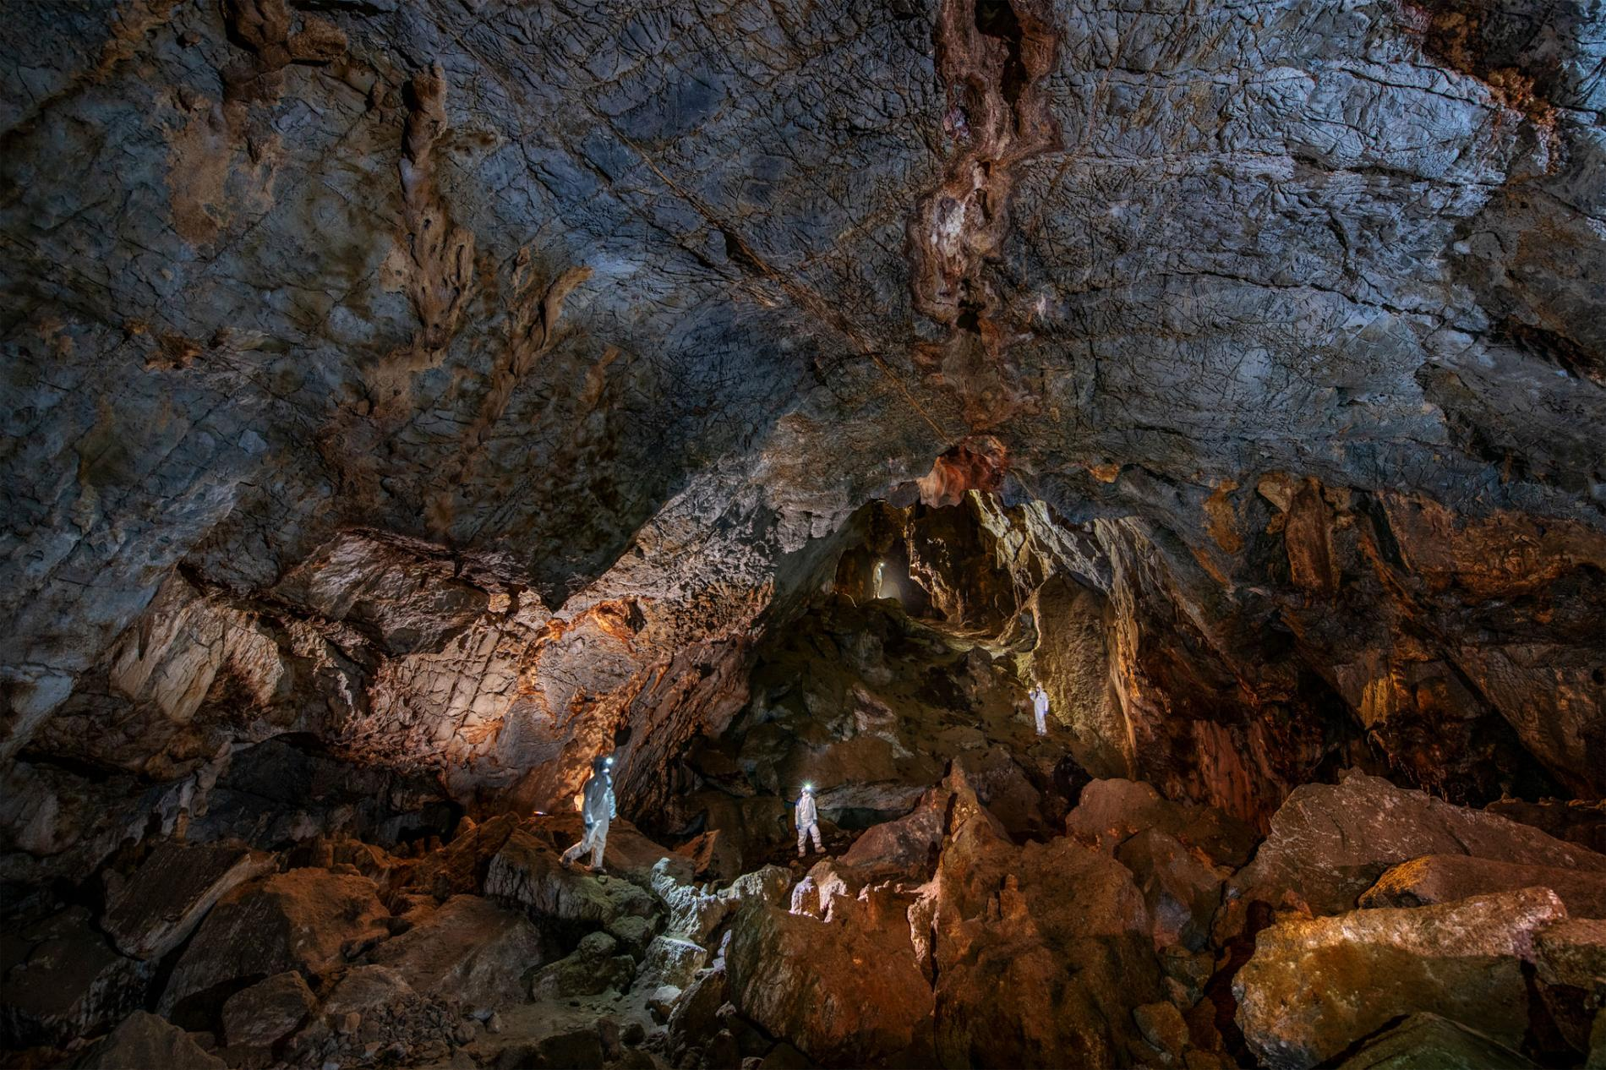

**The Adventures of Tom Sawyer by Mark Twain – North London Collegiate School**

Now to return to Tom and Becky’s share in the picnic. They tripped along the **murky** **aisles** with the rest of the company, visiting the familiar wonders of the cave – wonders **endowed** with rather over-descriptive names, such as ‘The Drawing Room,’ ‘The Cathedral,’ ‘Aladdin’s Palace,’ and so on.

**Presently** the hide-and-seek **frolicking** began, and Tom and Becky engaged in it with **zeal** until the **exertion** began to grow a little **wearisome**; then they wondered down a **sinuous** avenue, holding their candles **aloft** and reading the tangled webwork of names, dates, postoffice addresses, and **mottoes** with which the rocky walls had been **frescoed** (in chalk perhaps or elsewhere scratched into the stonework). Still drifting along and talking, they **scarcely** noticed that they were now in a part of the cave whose walls were not frescoed. They **scored** their own names into the rock under an overhanging shelf with a jagged piece of stone and moved on.

Presently they came to a place where a little stream of water, trickling over a ledge and carrying a limestone **sediment** with it, had, in the slow-dragging ages, formed a laced and **ruffled** Niagara* in gleaming and **imperishable** stone. Tom squeezed his small body behind it in order to **illuminate** it for Becky’s **gratification**. But Tom found that it **curtained** a sort of steep natural stairway which was enclosed between narrow walls, and at once the **ambition** to be a discoverer seized him.

Becky responded to his call, and they made a wax mark for future guidance, and started upon their quest. They wound this way and that, far down into the secret depths of the cave, made another mark, and branched off in search of **novelties** to tell the upper world about.

In one place they found a **spacious** cavern, from whose ceiling depended a **multitude** of shining **stalactites** of the length and **circumference** of a man’s leg; they walked all about it, wondering and admiring, and presently left it by one of the numerous passages that opened into it. This shortly brought them to a **bewitching** spring, whose **basin** was **encrusted** with a **frostwork** of glittering crystals; it was in the midst of a cavern whose walls had been formed by the joining of great stalactites and **stalagmites** together, the result of the **ceaseless** water-drip of centuries.

Under the roof vast knots of bats had packed themselves together, thousands in a bunch; the lights disturbed the creatures, and they came **flocking** down by the hundreds, squeaking and darting furiously at the candles. Tom knew their ways, and the danger of this sort of **conduct**. He seized Becky’s hand and hurried her into the first corridor that offered; and none too soon, for a bat struck Becky’s light out with its wing while she was passing out of the cavern. The bats chased the children a good distance; but the **fugitives** **plunged** into every new passage that offered itself, and at last got rid of the **perilous** things. Tom found a **subterranean** lake, shortly, which stretched its dim length away until its shape was lost in the shadows. He wanted to explore its borders, but concluded that it would be best to sit down and rest a while first. Now for the first time the deep stillness of the place laid a clammy hand upon the spirits of the children. Becky said:

‘Why, I didn’t notice, but it seems ever so long since I heard any of the others.’

‘Come to think, Becky, we are down below them, and I don’t know how far away north, or south, or east, or whichever it is. We couldn’t hear them here.’

Becky grew apprehensive.

**Comprehension Questions**

1. Summarise the passage in two or three sentences
2. Considering the passage as a whole, why do you think that certain areas of the caves have been given names such as ‘The Drawing Room,’ ‘The Cathedral’ and ‘Aladdin’s Palace’?
3. Why do you think the narrator refers to these names as being ‘overdescriptive’?
4. In the second paragraph, we are told that Tom and Becky wander off from the others. How does the writer communicate their separation from the rest of the party?
5. Looking again at the descriptions of the caves in the 3rd and 5th paragraphs, what do you find interesting about the language and sentence structures in these passages?
6. In the description of the bats at the start of the 6th paragraph, what aspects of the creatures’ character and behaviour does the writer try to capture?
7. Why do you think Becky and Tom are referred to as ‘fugitives’ in the 6th paragraph?
8. At the end of the passage, we are told that ‘the deep stillness of the place laid a clammy hand upon the spirits of the children’. What are the implications of this phrase and what do you find interesting about the writer’s use of language?

**Vocabulary**

* *Define each word, put it into one of four categories (noun, adjective, verb or adverb) and, where applicable, note down a synonym or antonym.*

1. Murky
2. Aisles – a passage between rows of seats or shelves
3. Endow – give an income or property to someone
4. Presently – at the present time; now
5. Frolicking – play or move about in a cheerful and lively way
6. Zeal – great energy or enthusiasm
7. Exertion -
8. Wearisome -
9. Sinuous – having many curves and turns
10. Aloft
11. Motto – a short sentence or phrase chosen to sum up beliefs of an individual or institution
12. Frescoed – done in the style of a fresco, which is a rapidly done painting on wet plaster or a ceiling
13. Scarcely
14. Scored – gain a point in a game; cut or scratch a line in something
15. Sediment – particles that settle to the bottom of a liquid
16. Ruffled – disordered or disarranged by running hands through it
17. Imperishable
18. Illuminate
19. Gratification – pleasure from the satisfaction of a desire
20. Curtained – provided with a curtain
21. Ambition
22. Novelty – the quality of being new or original
23. Spacious
24. Multitude
25. Stalactites – an icicle-like structure that hangs from the roof of a cave
26. Circumference
27. Bewitching – enchanting or delightful
28. Basin – a bowl for washing
29. Encrusted
30. Frostwork – attractive patterns made by frost on a window or other surface
31. Stalagmites – like stalactite, but rising from the floor
32. Ceaseless
33. Flocking – congregate or join in a big group
34. Conduct – the manner in which a person behaves
35. Fugitives
36. Plunged – jump or dive quickly and energetically
37. Perilous – full of danger or risk
38. Subterranean – under the surface of the earth

**Homework**

* Revise the vocabulary we have learned today.
* Imagine you are on an expedition, travelling deep underground into dark and dangerous caves. Suddenly, you realise you are lost. Describe your situation using ten of the words in the vocabulary list above.