**Harry Potter and the Prisoner of Azkaban**

Chapters Eighteen to Twenty-Two

**Chapter Eighteen: Moony, Wormtail, Padfoot, and Prongs**

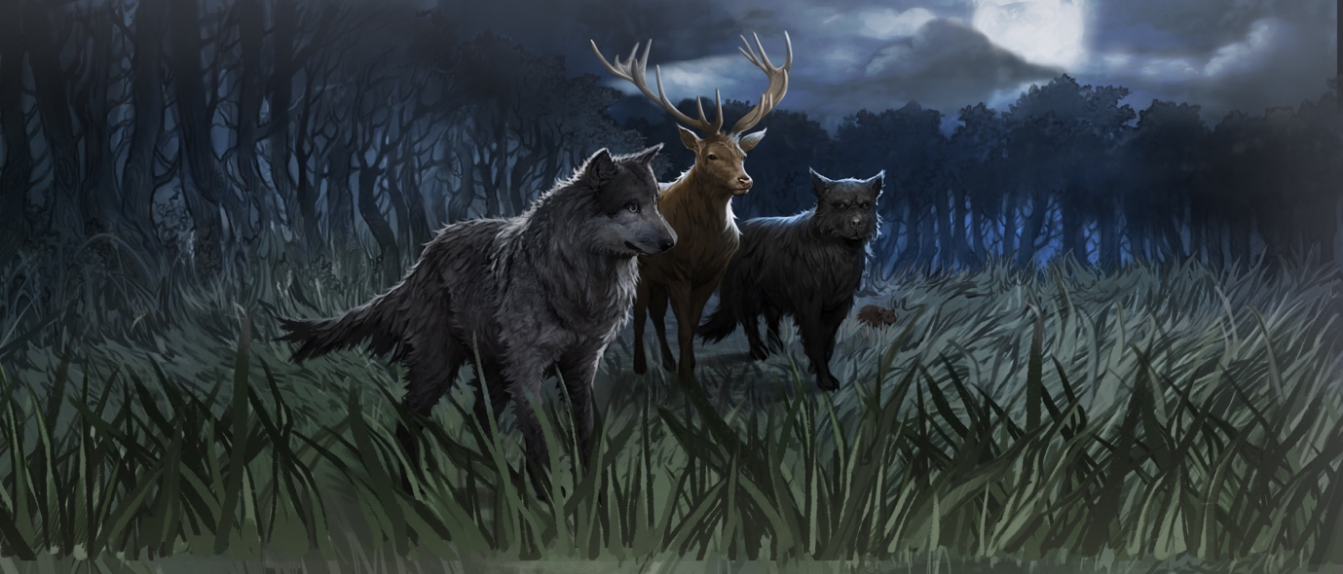

Ron is unwilling to believe that his faithful pet rat is really an animagus, a transformed version of a man named Peter Pettigrew. Black is furious and expresses his desire to kill Peter. Lupin stops him and demands that he explain everything first. Lupin begins saying that when he came to Hogwarts, a young werewolf, Dumbledore devised a way for him to leave Hogwarts secretly and safely through the Whomping Willow and remain, during the full moon, in the Shrieking Shack. Lupin's good friends, James Potter, Sirius Black, and Peter Pettigrew, noticed his monthly absence and figured out his true identity. They then worked toward becoming animagi so they could assume animal form and keep Lupin company without placing themselves in danger. The four friends roamed everywhere and learned every part of Hogwarts and Hogsmeade, and they ultimately used this information to create the Marauder's Map.

Hermione points out that there have been only seven registered animagi over the century, and Lupin admits ruefully that they were unregistered. Lupin then explains that Snape, who now makes the revolutionary potion Wolfsbane that allows Lupin to keep his mind, thus remaining harmless during his transformation, as a student was always curious about the monthly disappearance. Once evening, Black played a prank by encouraging Snape to follow Lupin down the Whomping Willow, and James Potter ran after him and rescued him before he encountered the fully-grown werewolf at the other end of the tunnel. This trick is one of the reasons for Snape's grudge against Lupin, Black, James Potter and his son Harry. As Lupin finishes explaining this, Snape suddenly appears in the corner of the room, shedding Harry's invisibility cloak.

**Questions**

* This chapter is full of revelations and realisations. What are some of the things we find out in this chapter, and are there any moments of foreshadowing earlier in the book?
* What is significant for Harry about Lupin’s connection to his father?

#### Chapter Nineteen: The Servant of Lord Voldemort

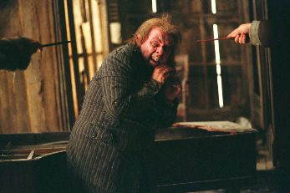

Snape sneers and says that he found the invisibility cloak where Harry had dropped it. He proceeds to tie up Lupin and point his wand at Black, threatening to kill him. Snape refuses to hear the full story because he is set on vengeance. Finally Harry, Ron and Hermione all disarm him at once, knocking him out. Black then explains that he recognized Scabbers as Peter Pettigrew in a photo in the newspaper Cornelius Fudge gave him during a visit, and he set out to Hogwarts after him. He explains Scabbers' missing toe by saying that Peter must have cut off his own finger before blowing up the street and disappearing into the gutter. Black adds that Hermione's cat Crookshanks had collaborated with him in pursuit of Peter.

Even with these explanations, Harry is frightened and sceptical, and so, to clarify things once and for all, Lupin reverses Scabbes' form into that of a short, balding man—Peter Pettigrew. Peter is squirmy and nervous and pleads with each of the people in the room to believe his innocence and let him go, and only after many more facts are clarified does Harry believe that Sirius Black is innocent, and that Peter Pettigrew did in fact support Voldemort and turn Harry's parents over to him. Peter finally admits, after much evasion, that he is and was the servant of Lord Voldemort. Lupin and Black prepare to kill Peter, when Harry stops them by saying that his dad wouldn't have wanted his two best friends to become murderers. They all tie up Peter and secure him between Lupin and Ron, and they bring with them the unconscious Snape as together they troop back to Hogwarts.

Questions

* What is the significance of revenge or vengeance in this chapter? Do we think it is ever right to take revenge?
* Everyone seems to know more about Harry’s life than Harry – how do we think Harry might feel about this? And how does it support the idea of Harry as hero or protagonist?

#### Chapter Twenty: The Dementor's Kiss

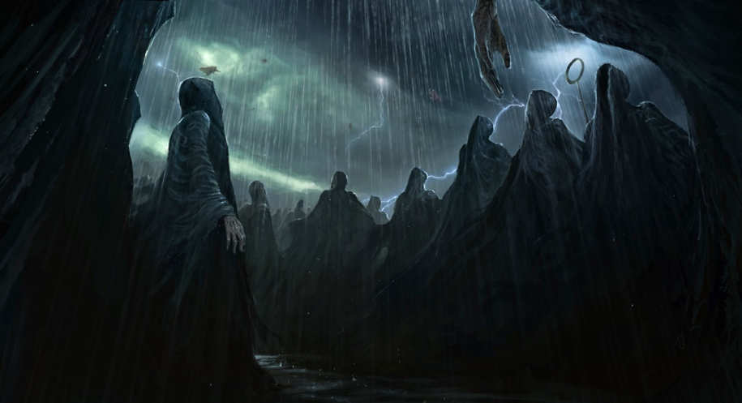

As the group returns through the tunnels, Black informs Harry of his role as his godfather. He invites Harry to live with him, once his name is cleared. They emerge from the ground into the forest, the clouds above them shift, revealing a full moon. Lupin turns into a werewolf, wrangling out of the chain binding him to Peter, and Black transforms into a dog and fights the werewolf away, into the woods. During the commotion, Peter grabs Lupin's wand, casts some stupefying spell on Ron, and turns himself back into a rat. He escapes, and Black then tears back into the woods after Scabbers.

Harry and Hermione examine the unconscious Ron, declaring him alive; they are interrupted by the yowl of a dog, and they turn to see Black in human form, cowering at the approach of over a hundred Dementors. Harry and Hermione run to help, but none of Harry's Patroni are strong enough to hold back the throng. Hermione drops next to him, and Harry feels himself weakening. Suddenly one of the Dementors lowers its hood, revealing gray skin and empty eye sockets and a shapeless sucking hole of a mouth, and the Dementor grasps Harry's head and prepares to administer the soul-sucking kiss to him. Harry feels himself drowning in cold and misery, when all of a sudden a bright shape begins to drive the Dementors away. As they retreat, Harry looks across the lake to see a large shimmering animal galloping away to a man who looks oddly familiar, like Harry's father. Exhaustion then overtakes Harry, and he faints.

**Questions**

* Why is Sirius’ revelation about being Harry’s godfather significant? What do we think Harry is feeling in this moment?

**Chapter Twenty-one: Hermione's Secret**

Harry awakens in the hospital ward to hear Snape boasting about his heroic act of saving the three students from both a werewolf and Sirius Black. Cornelius Fudge's voice sounds, promising Snape an award for his courage. Ron is still unconscious, but Harry and Hermione leap out of bed and begin explaining what they saw and heard, and about Pettigrew's appearance and Black's innocence. Snape waves this away, saying that Black must have confounded their minds. Harry and Hermione are still heatedly defending Black when Dumbledore enters the room and says that he must speak with the two of them alone. Once the others have left, Dumbledore tells Harry and Hermione that he has heard Black's story and that he believes it, but that not one shred of evidence exists to back it up. He says meaningfully that they need more time to save two lives that night, and Hermione nods. When Dumbledore leaves, Hermione turns an hourglass on a chain backwards three times, taking Harry and her into the Forbidden Forest, where they hear themselves and Ron visiting Hagrid. Hermione explains in a whisper how she was given this time- turning device so that she could take more than once class at the same time, and how it is of utmost importance that nobody sees them while they are in the form of their future selves.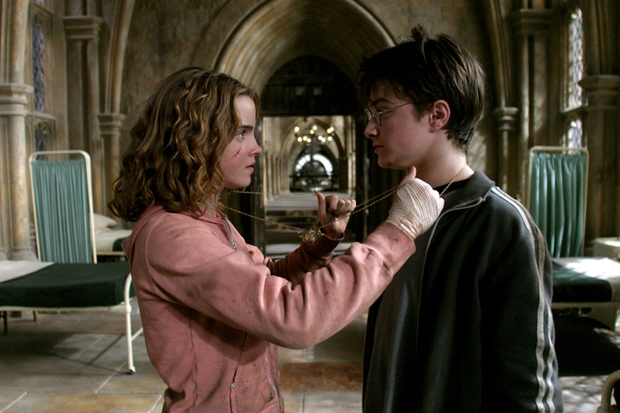

The second life to which Dumbledore refers, Harry determines, is Buckbeak's; so Harry and Hermione wait quietly by Hagrid's cabin, untying the hippogriff once the executioners have gone inside the cabin. Harry, Hermione, and Buckbeak hide in the forest as they hear the thud of an axe swung, as well as Hagrid's howl of joy. They wait in the woods, watching themselves go down the Whomping Willow and back up, and while Hermione and Buckbeak hide in Hagrid's empty cabin from the werewolf, Harry slips out to see who conjured the Patronus. He watches the Dementors approach and attempt to kiss him, and nothing happens. At this moment, Harry realizes that it was he who had conjured it, not his father, as he had suspected, and so he conjures it again, saving his, Hermione's, and Black's life, and finally understanding that the form of his Patronus is a stag, Prongs, his father's animagi form. Father and son regard each other, then the shape disappears. Harry rejoins Hermione, and together they fly on Buckbeak's back up to the tower room where Black is being held, and they send Black and Buckbeak flying away together to their freedom.

**Questions**

* What is important about Harry’s revelation of responsibility in this chapter?
* What new things do we learn in this chapter, and how does it help us revaluate the story so far?

**Chapter Twenty-Two: Owl Post Again**

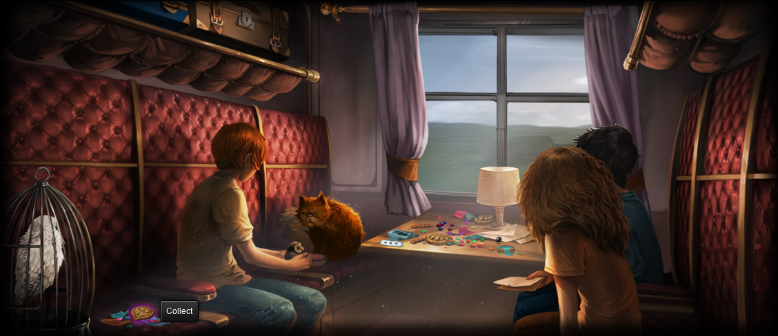

Harry and Hermione make it back into the hospital ward only minutes before Dumbledore leaves, exactly when they turned the time back. They confide their feat to Dumbledore, who naturally is very pleased. Snape however, is most displeased when word gets out that Black escaped. Fudge retracts the award that he had promised to Snape. That night, Fudge removes all of the Dementors from the school.

The next day is calm, until Hagrid informs Harry, Ron, and Hermione that Buckbeak escaped, and then that Lupin has resigned from the school. Harry runs to visit him as he is leaving the castle, and he listens as Lupin explains in his usual good-natured manner that after the events of last night, he shouldn't be allowed near students during his transformations. Dumbledore catches Harry leaving Lupin's office and talks with him for a bit, explaining that it is no coincidence that his Patronus takes his father's Animagus shape, and that Harry has done a wise thing by setting Pettigrew free.

On the train, Hermione announces that she will drop down to a normal course load for the next semester, and Ron begins planning for Harry to stay with him for the summer. All of a sudden, a small, fluffy owl bumps against Harry's window, and he discovers in its beak a note from Sirius Black, saying that he is safe, that he did in fact send the Firebolt, and that Ron is to keep the owl as a replacement for his lost rat. In addition, Black has enclosed a note giving Harry permission to visit Hogsmeade the following year. Harry returns to the Dursleys anticipating a better summer than the last one.

**Questions**

* Why do we think that Dumbledore says that Harry did a wise thing by setting Pettigrew free?
* How do we predict Harry’s summer turning out?
* How is this book summed up, and are we beginning to notice a pattern?

**Themes**

Bildungsroman

* Harry does a lot of maturing and growing up throughout the books, but he does so in this book in particular.
* A Bildungsroman is a novel that deals with one person’s formative years or spiritual education. It often covers someone growing up.
* What are some of the things that shape Harry in these books, and how do we see his character develop?

Justice

* It is clear within these chapters that the justice system doesn’t work, in that it doesn’t always deliver justice.
* Why is this an important revelation for Harry?

Fear

* Fear and conquering fear have always been a big theme in these books, but particularly here.
* What can figures like the Boggart and the Dementor teach us about fear and sadness?

**Homework**

Imagine that you are one of the original Marauders – James, Sirius, Remus or Peter – and write a diary entry describing their discovery of Remus’ lycanthropy and their attempt to become Animagi.