**Harry Potter and the Prisoner of Azkaban**

Chapters Thirteen to Seventeen

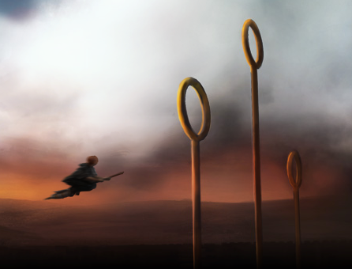

**Chapter Thirteen: Gryffindor versus Ravenclaw**

Animosity between Ron and Hermione has reached an all-time high, after the apparent death of Scabbers at the claws of Crookshanks. To cheer Ron up, Harry offers him a ride on the new Firebolt after Quidditch practice, and Ron happily accepts. The Gryffindor team is busily preparing for the game against Ravenclaw. As Harry's confidence on the new broomstick soars, the rest of the team's confidence rises as well, and the game prospects seem grand. When the players mount their broomsticks and begin the game, the announcer, Lee Jordan, is so focused on Harry's new broomstick that he forgets to comment on many of the basic plays between the teams. Harry is playing seeker against Cho Chang, a pretty and athletic Ravenclaw fourth-year girl on whom Harry seems to be developing of a crush.

Finally, Harry spies the Snitch, but as he speeds to catch it, his attention is drawn down toward three Dementors walking alongside the field. Without thinking, Harry casts a Patronus in their direction, and he catches the Snitch easily, winning the game. Only afterwards does he discover that the Dementors were, in fact, several Slytherins, including Malfoy, dressed in cloaks with the intention of unseating Harry. They are punished severely by McGonagall, much to everyone's delight, and Harry and his friends head to the Gryffindor common room to celebrate for the rest of the day and into the night. When Harry finally returns to his dormitory to sleep, he is woken before dawn to a scream from Ron, who claims that Sirius Black had slashed open the curtain around his bed. Everybody panics, and when McGonagall asks Sir Cadogan if he let anyone into Gryffindor Tower, the knight answers yes, that the intruder had all of the passwords written on a slip of paper, which Neville Longbottom, it is soon discovered, had accidentally left in one of the corridors.

**Questions**

* How can we tell that Harry is developing a crush on Cho Chang?
* How does this relate to the idea of Harry growing up?

**Chapter Fourteen: Snape's Grudge**

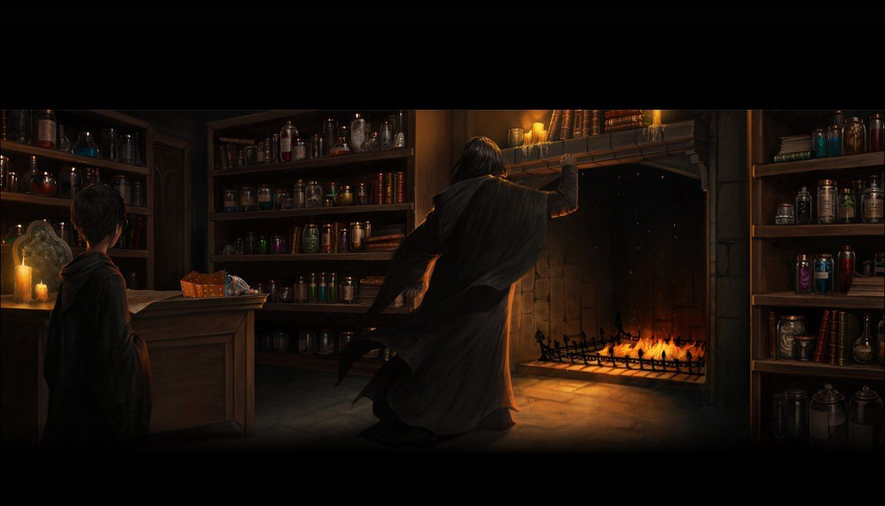

After the second Black break-in, Hogwarts tightens its security measures. Doors are taught to recognize Black's face, and the Fat Lady's portrait is returned and guarded by several trolls. Neville is not given Gryffindor's password. One afternoon Harry and Ron receive an invitation to visit Hagrid for tea, and when they do, Hagrid lectures them on shunning Hermione, who he says has been heartsick at the loss of their friendship. "I thought you two'd value yer friend more'n broomsticks or rats," he finally says.

Another Hogsmeade visit comes around, and this time Harry goes through the tunnels with his invisibility cloak. In Hogsmeade, he and Ron visit the Shrieking Shack, the most severely haunted house in Britain, and when they are taunted by Malfoy and Crabbe and Goyle, Harry throws mud at them from under his cloak, providing both Ron and himself great amusement until the cloak slips off and reveals his head. Harry runs back to Hogwarts, but not before Malfoy has reported to Snape what had happened. Harry hides his cloak in the tunnel just in time, because Snape greets him in the hallway soon after he has emerged and summons him into his office, where Snape insults Harry's troublemaking tendencies and compares his arrogance to that of his father. Harry is furious and yells at Snape to shut up. Snape is furious, and demands that Harry empty his pockets. He finds the map, which insults Snape rather than revealing its secrets. Snape summons Lupin through his fireplace, and Lupin arrives, looks at the map and excuses it as a trick from Zonko's joke-shop. At that moment, Ron arrives and assures them all that he had bought it for Harry months ago. Snape is forced to let the boys go, but Lupin calls them into his office and scolds them gravely for having the map in their possession when Black was on the loose. “Your parents gave their lives to keep you alive, Harry," he tells them. "A poor way to repay them—gambling their sacrifice for a bag of magic tricks." As Harry and Ron walk away, they are accosted by Hermione, who informs them that Buckbeak lost the case and is going to be executed.

**Questions**

* This chapter features as one of the few in which Harry’s own character is called into question, and he must realise the responsibility of his own actions. What are some of Harry’s flaws and how does he deal with them? What are his priorities?
* Imagine you are a teacher trying to keep Harry safe – how would you feel about what he is doing?

**Chapter Fifteen: The Quidditch Final**

Harry, Ron, and Hermione stare at Hagrid's note explaining Buckbeak's verdict, and Hermione takes the opportunity to apologize for Scabbers's death. Things return to normal between Ron and her. During the next care of magical creatures lesson, Hagrid speaks sadly about Buckbeak. When Malfoy taunts his tears, Hermione slaps him. Soon after, Hermione misses charms class, and Harry and Ron find her asleep in the Gryffindor common room. She looks exhausted and stressed, and she arrives at Divination late, entering while the class is gazing into crystal balls. Professor Trelawney makes a few misty comments about her predictions for their final exam and then finds yet another Grim in Harry's crystal ball, to which Hermione responds, "Not that ridiculous Grim again!" Hermione leaves the class, much to Harry's astonishment.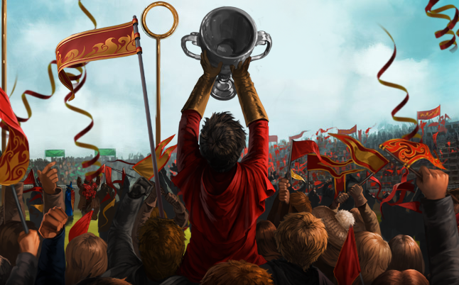

Tension escalates as exams and the final Quidditch match approach; Gryffindor and Slytherin are competing for the Cup. In order to win, Gryffindor must defeat Slytherin by at least two hundred points. The game day arrives, and the Slytherins play a game ridden with fouls, as usual, but they are still no match for Harry on his Firebolt, as he zooms around, parting crowds, protecting his teammates, and searching for the Snitch. He and Malfoy, the Slytherin Seeker, spy it near the ground and race for it; Harry catches it, winning both the game and the Quidditch Cup. As the chapter closes, Harry thinks to himself that with all the happiness he is currently feeling, he could conjure up a very impressive Patronus.

**Questions**

* What changes happen to Hermione’s character in this chapter?
* How does the Quidditch match demonstrate fundamental differences between the two houses and their attitude to success?

**Chapter Sixteen: Professor Trelawney's Prediction**

After the Quidditch victory, final exams come around. Everybody is hard at work preparing. The Care of Magical Creatures exam is easy, as Hagrid has become fearful of another injury and so will teach the class only boring, harmless creatures, like Flobberworms. Harry receives full marks on the Defense Against the Dark Arts exam, which requires that he combat several of the creatures studied over the term. In Divination, Professor Trelawney asks Harry to find signs of the future inside a crystal ball, an assignment that he fictionalizes dutifully. Suddenly, Professor Trelawney's voice changes, her eyes look hypnotized, and she predicts that the Dark Lord's servant will rejoin him tonight before midnight. She snaps out of the trance and has no recollection of the prediction. Harry dashes out to tell Ron, but before he can say anything, Ron and Hermione inform him that Buckbeak lost the appeal and will be executed at sunset.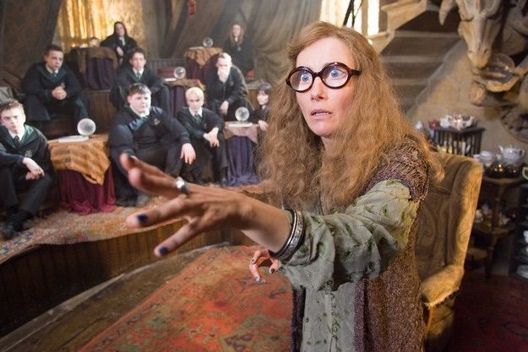

The three friends set out to comfort Hagrid, but only after Hermione has slipped downstairs to retrieve Harry's invisibility cloak from the secret tunnel. At Hagrid's cabin, they find Hagrid shaky as he explains that Lucius Malfoy must have threatened the Committee for Disposal of Dangerous Creatures. Hagrid accidentally drops a milk jug while attempting to serve them tea, and when Hermione begins to fill a replacement jug, she discovers Scabbers inside it, and Ron grabs it. Around this time, the executioners arrive and Hagrid shoos Harry, Ron, and Hermione back under the invisibility cloak and out of his cabin. As they walk away, they hear the thud of an axe.

**Questions**

* How does this chapter alter our perception of Professor Trelawney?
* What does Lucius Malfoy’s interference in Buckbeak’s trial tell us about the justice system?

**

As Harry, Ron, and Hermione walk sadly away from Hagrid's cabin, they have difficulties staying hidden under Harry's cloak because Scabbers will not stay still. Harry sees the reason for Scabbers' uneasiness once he spies Crookshanks slinking out of the Forbidden Forest, followed closely by the large black dog, who first tackles Harry and then Ron, ultimately dragging Ron away into the forest. Harry and Hermione dart after them and watch as the dog pulls Ron down inside the Whomping Willow, breaking his leg in the process. They follow him, but only after Crookshanks surprises them by pressing a hidden knot on the tree, causing it to quiet its branches. The path beneath the tree leads them into a boarded-up house that they instantly recognize as Hogsmeade's Shrieking Shack. In an upstairs room they find Ron, seated by Crookshanks, and guarded by Sirius Black, who the black dog has transformed into. Black disarms Harry and Hermione through the Expelliarmus spell, and Harry, insane with fury, leaps onto Black, reclaiming his wand with the help of Ron and Hermione, and ultimately forcing the unarmed Black into a corner.

Before Harry can gather his courage to kill Black, Professor Lupin bursts through the door, disarming Harry. Lupin quietly asks, "Where is he?" and Black points to Ron. The two men embrace. Hermione shrieks at Lupin that he is a traitor, and that she should have exposed him as a werewolf long ago. She says that she deduced his nature as a werewolf from seeing his Boggart turn into the moon, and from noting that he was out sick during each month's full moon. Lupin commends her cleverness, and begins to speak, only to be interrupted again and again by the accusations of Harry, Ron and Hermione. An exasperated Lupin gives each one of them back their wands, and explains that he was examining the Marauder's Map, watching Ron, Harry and Hermione exit Hagrid's cabin, when he saw the name Peter Pettigrew alongside Ron's. At that point, he realized that Peter must alive and disguised as Scabbers.

**Questions**

* How is the idea of revenge dealt with in this chapter, and what do we think about it?
* Harry must rely on his instincts here, but what might cloud his judgement?

**Themes**

**Duality and First Impressions**

* What are some of the ways in which characters have surprised us over the last few chapters?
* What does this show us about the importance of perspective, as well as the idea of trust and loyalty?

**Foreshadowing**

* How are events in these chapters hinted at or foreshadowed earlier in the novel, or in previous novels?

**Homework**

Go back through the book and find at least one example in which the events of these chapters are foreshadowed, and explain how they have been hinted at.