**Harry Potter and the Prisoner of Azkaban**

Chapters Five to Eight

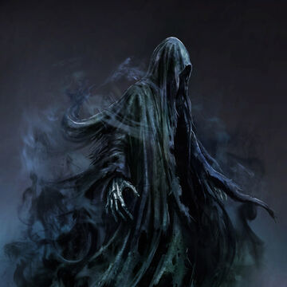

**Chapter Five – The Dementor**

In the midst of the rush to get ready for the Hogwarts Express, Harry has no chance to tell Ron or Hermione about the conversation he had overheard the previous night between Mr and Mrs Weasley. The Weasleys, as well as Harry and Hermione, are boarded on to the train and bid goodbye by Mr and Mrs Weasley. Once on the train, Harry takes Hermione and Ron aside to tell them what he knows. The two are horrified by the news, but shortly begin to talk about Hogsmeade. Harry informs the two that he hasn’t managed to get permission to go. Soon after, the train begins to slow down unexpectedly. Darkness descends and mysterious figures board the train. One of the figures, ghostly and clad all in black, enters the compartment. An icy cold descends and Harry soon faints.

When he awakes he is surrounded by concerned faces, and Professor Lupin, now awake, gives Harry a large piece of chocolate and tells him to eat. Harry begins to feel shameful that he was the only one that fainted. The train now soon arrives at the station, and carriages take the students to Hogwarts. Once they arrive, Professor McGonagall calls Hermione and Harry into her office, getting Madam Pomfrey to make sure Harry is okay. The two then return to the feast, drawing attention as they enter the Great Hall.

Dumbledore begins his speech, informing the students that Dementors will be stationed around the school’s perimeter. He also informs the students of two new staff members: Professor Lupin, Defense Against the Dark Arts teacher; and Hagrid, who will be taking Care of Magical Creatures. After the feast, the three congratulate Hagrid, and then, gratefully, head to bed.

**Questions**

* First impressions – what is our first impression of Professor Lupin in this chapter? Look back at his description, what does it tell us about him? How might he be mis-perceived?
* What do we think of the Dementors? How do we think they have come into being, and why are they particularly effective at what they do?
* How is this year different for Harry than the previous two?

**Vocabulary**

* Furrowed
* Billowing
* Pallid
* Apprehensive
* Malicious
* Insolent
* Befuddled
* Ravenous

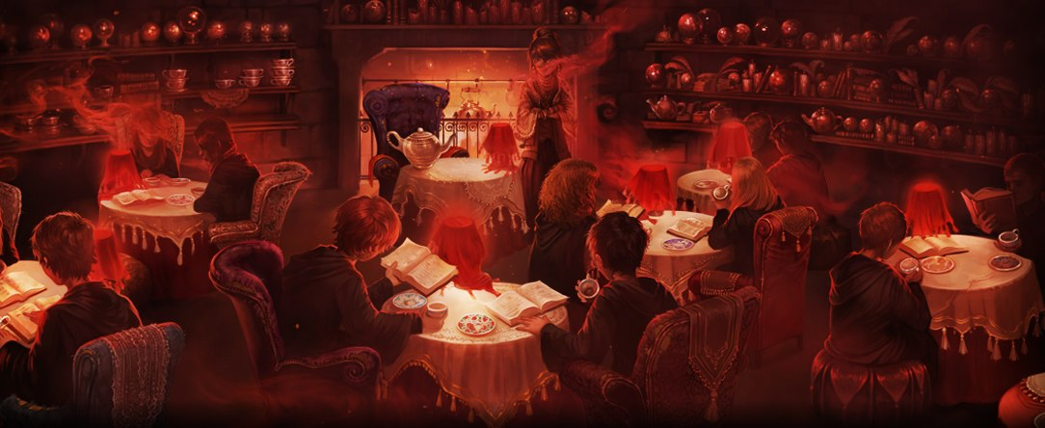

**Chapter Six – Talons and Tea Leaves**

The next morning Harry enters the Great Hall to the sound of mockery from the Slytherin table. It seems news of Harry’s fainting episode is now common knowledge. At breakfast, the students receive their new schedules. The three get lost on their way to their first class, Divination, and ask a portrait of a clumsy Knight for directions to the North Tower. Once there, the class is led up a ladder into a Tower Room filled with armchairs and cushions.

Professor Trelawney enters, making a strong impression on the group, delivering prediction after prediction. The class begins with learning how to read tea leaves. When Ron struggles to read Harry’s leaves, Trelawney steps in. She immediately gasps, stating that Harry has the Grim, a black spectral dog, which is a certain omen of death. Despite Professor McGonagall’s assertion of Professor Trelawney’s annual habit of predicting a student’s death (none of whom had died yet), Harry is still worried.

After lunch, the three head to their next class, Care of Magical Creatures with Hagrid. Hagrid introduces the class to Hippogriffs, odd creatures that seem to be a mix of horse and eagle. When the rest of the class backs away, Harry volunteers to be the first to be introduced to one of the animals. The introduction goes smoothly, and Harry is allowed to take Buckbeak for a ride. Malfoy, becoming cocky, insults Buckbeak and is attacked by the creature. Hagrid quickly takes Malfoy to the Hospital Wing, while Ron, Hermione and Harry worry that Hagrid might be fired as a consequence.

**Questions**

* What is our first impression of Professor Trelawney? What does her appearance tell us about her character?
* Discuss whether you think Hagrid is a good or a bad teacher, and why? Think about bias and perspective when discussing the question.
* Do we think Care of Magical Creatures is an important lesson?

**Vocabulary**

* Contemptuous
* Pronouncement
* Dregs
* Furtive

**Chapter Seven – The Boggart in the Wardrobe**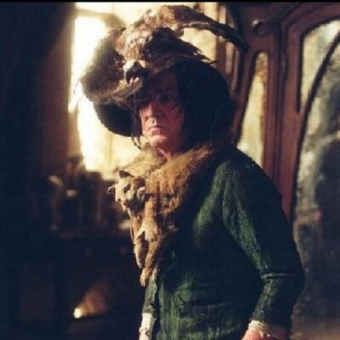

On Thursday morning Malfoy reappears in Snape’s Potion Class with a sling round his arm, enjoying the attention his injury is getting him. During the lesson, Seamus informs Harry that Sirius has been sighted not far from Hogwarts. Malfoy says it’s a wonder Harry wouldn’t want revenge on Sirius. Harry asks him what he means, but Malfoy declines to answer. That afternoon, the three attend their first Defence Against the Dark Arts class with Professor Lupin. Lupin introduces the class to a boggart, a creature that takes the form of whatever you are most afraid of. Lupin informs the class that a boggart can be defeated by laughter, as well as the spell ‘riddikulus’. One by one the class approaches the boggart and transforms it. When it comes to Harry’s turn, however, Lupin steps in and stops him facing it. Shortly after, the class is dismissed.

**Questions**

* What form would your boggart take? And what lessons can we learn from a boggart, with particular attention to how it can be defeated? And how does this tie in with the dementors?
* What do we think Hermione’s boggart would have been?

**Vocabulary**

* Malevolent

**Chapter Eight – Flight of the Fat Lady**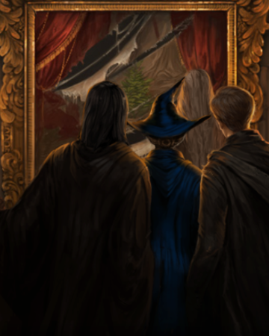

In the following weeks, DADA continues to be exciting, Potions excruciating, and Care of Magical Creatures becomes very dull after Hagrid’s mistake in the fir

st lesson. Harry becomes engrossed in Quidditch as the season approaches, but a notice for the first trip to Hogsmeade puts a dampener on his spirits. Tensions begin to rise between Ron’s rat, Scabbers, and Hermione’s cat, Crookshanks.

Harry, unable to secure permission to go to Hogsmeade, must remain in school while the others leave for the day. While wondering about the halls dejectedly, Harry encounters Professor Lupin. The two have a brief conversation, during which Snape enters to deliver a goblet of smoking liquid, which Lupin drinks.

After the Halloween feast that evening, the students return to the Gryffindor Common Room to find the Fat Lady missing. Dumbledore arrives and Peeves the poltergeist informs him that the Fat Lady had fled her painting because of Sirius Black.

**Questions**

* What is a grindylow?
* Why does Harry mistrust the goblet Snape delivers Lupin? How does this reflect on Harry as a biased narrator?

**Vocabulary**

* Vindictive
* Avidly
* Shrewd

**Themes**

**Fear**

* Fear and how we can overcome it are big themes within the series as a whole, but particularly within this book.
* What do the dementors and the boggart teach us about the power of fear, and how we can overcome it?
* What do you think it says about Harry that the thing he fears the most is fear? How is this possible, and what does it mean?

**Prejudice**

* What are some forms of prejudice that we see demonstrated in these chapters, and who is it against?
* Is this surprising, or do we come to expect it at this point?

**Homework**

Imagine you are a character from Harry Potter and describe an encounter with a Boggart. The encounter can take place anywhere – think of where you might commonly find one. Describe what the Boggart looks like, how you deal with it, and how you feel. Use at least three of the words listed in the vocabulary lists this lesson.