**Harry Potter and the Prisoner of Azkaban**

Chapters One – Four

Chapter One – Owl Post

We begin the book with Harry, who is trying to complete his Hogwarts homework under the cover of night, as the Dursleys don’t want him to have access to his books. After Ron had attempted to call Harry, getting Harry into trouble with Vernon Dursley, his uncle, Harry hadn’t heard from any of his friends. That night, Harry turns thirteen. Just as he is contemplating how no one has remembered, three owls arrive, two carrying the third, which turns out to be the Weasley’s owl, Errol. The three owls carry presents and letters from Ron and Hermione. Ron tells Harry that his father won a prize draw and so had taken the family to Egypt. He also gifts Harry a Sneakoscope. Hermione sends Harry a Broomstick Servicing Kit. The final parcel is from Hagrid, who has sent him The Monster Book of Monsters, which is itself a vicious monster. The final letter, from Hogwarts, includes a permission slip which Harry must get the Dursley’s to sign if he wishes to visit Hogsmeade this year. Harry decides he’ll worry about how he’s going to do that in the morning.

Questions 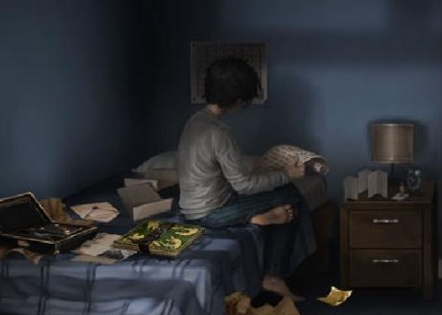

* What is a Sneakoscope?
* How does J.K. Rowling refresh our memory about what has taken place in the previous books, and why is this important?
* How well does this chapter function as an opening? Does it make us want to read on? What kind of questions does it leave unanswered?

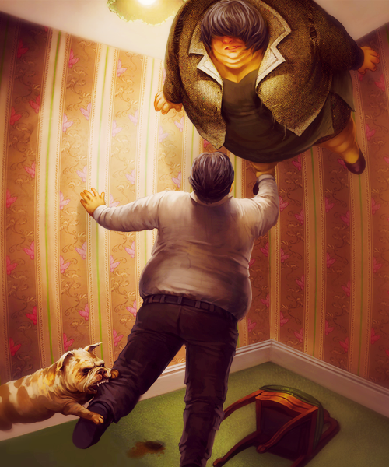

Chapter Two – Aunt Marge’s Big Mistake

Harry wakes the next morning and, as usual, the Dursleys make no mention of his birthday. A news report on the TV states that a convict by the name of Black has escaped from prison. Uncle Vernon then informs Harry that his Aunt Marge will be coming to stay. Harry, who detests Aunt Marge because of the way she treats him, uses the opportunity to convince Uncle Vernon to sign his Hogsmeade permission slip. He tells Vernon he will agree to behave like a ‘normal person’ if he agrees to sign the slip. Vernon begrudgingly agrees. Aunt Marge arrives, a woman who looks very much like a female version of Uncle Vernon, and immediately begins to pick on Harry. Harry only just manages to make it through the week, bar a few minor incidents, until the final evening. Aunt Marge begins insulting Harry’s family, which infuriates Harry. Aunt Marge begins to expand, like a balloon, and rise towards the ceiling. Completely enraged, Harry gathers his things and storms out of the house.

Questions

* Do we think Harry was right to get angry at Aunt Marge?
* What do we think about Marge’s comments on ‘bad blood’ and ‘breeding’, and how this ties in with our discussions about prejudice?
* Why do we think Harry gets so angry?

Chapter Three – The Knight Bus 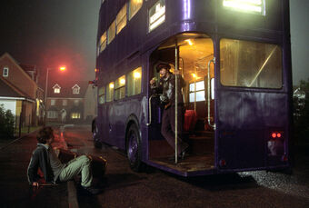

After his anger has worn off, Harry finds himself in a very difficult decision, stranded and with no muggle money. Just as Harry has decided to fly his broomstick to London (breaking even more rules) to access his money and begin his new life expelled from Hogwarts, he gets the sense that something or someone is watching him. Just then, however, a large, violently purple bus appears: the Knight Bus. Harry boards the Knight Bus, a service for stranded Witches and Wizards, and gets seated in a bed. The bus drives at some speed down the streets, while Harry considers his fate now that he is sure he has been expelled. Harry notices a picture of the escaped prisoner, Black, on the front of the Daily Prophet that Stan Turnpike is reading. He finds out that Sirius Black is a wizard who, having been put in Azkaban for killing 13 people with a single curse, has now escaped and is at large.

Harry asks Stan to take him to Diagon Alley. When Harry arrives, he bumps straight into Cornelius Fudge, the Minister of Magic. It turns out that Fudge has been expecting Harry. Fudge leads Harry into a private room and informs him that his Aunt has been dealt with, and there will be no punishments, which Harry can hardly believe. Without explaining why he has gotten involved with a case of underage magic, Fudge leaves Harry to stay at the Leaky Cauldron. Harry, exhausted with the day’s events, gratefully falls on to his bed and is quickly asleep.

Questions

* What do we think might have happened to Harry if the Knight Bus hadn’t arrived?
* How is tension generated in this chapter? What techniques does J.K. Rowling use to create a tense atmosphere?
* Describe Cornelius Fudge as a character. What is our first impression of him?

Chapter Four – The Leaky Cauldron 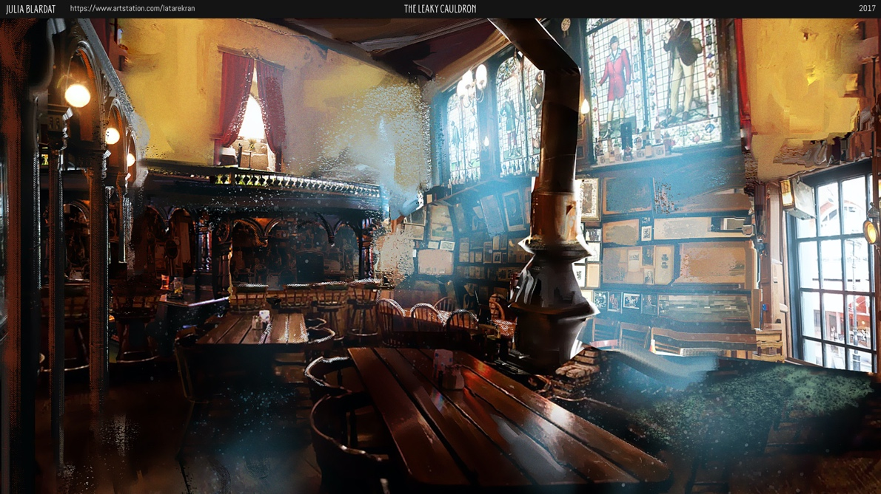

Harry enjoys his freedom while living at the Leaky Cauldron, and enjoys spending his days wandering about the shops, and staring at the new Firebolt broomstick in the Quidditch shop window. While purchasing his books for the coming year, Harry notices a book called ‘Death Omens – What to Do When You Know the Worst is Coming’, the cover of which is a big black dog, eerily familiar to the one Harry had seen in the alley the night he left the Dursleys. On the last day of the holidays, Harry finally bumps into Ron and Hermione. Hermione decides to buy an owl as an early birthday present, and Ron joins her in order to get some medicine for his pet rat, Scabbers. Instead of getting an owl, Hermione leaves with a rather grumpy looking ginger cat, and Ron worries for Scabbers’ health.

While packing for the Hogwarts Express the night before, Harry overhears Mr and Mrs Weasley arguing. It turns out they are arguing about him, specifically whether or not to tell him that the escaped prisoner, Sirius Black, is in fact after Harry. Harry, deeply troubled by what he has heard, returns to his room and concludes that he is going to be murdered.

Questions

* Do we think that Mr and Mrs Weasley should or shouldn’t tell Harry about Sirius? What would be the potential consequences of each option?
* Is Hogwarts really the safest place for Harry?
* How do we think J. K. Rowling might be foreshadowing in this chapter?

Vocabulary

* Shriek
* Downtrodden
* Reproachful
* Jovial
* Ruddy
* Insolent
* Protruding
* Contemptuous
* Venerable
* Raucous
* Podium
* Prototype
* Pompous
* Sumptuous
* Lenient

Themes

Injustice

* Part of Harry’s process of maturing and growing up is that he realises that there cannot always be justice in the world, and things are not always fair. What experience of this does he have so far? And how is that dealt with in these chapters?

Fear

* Fear, in this book, assumes a physical form in the shape of the dog, or death omen, that seems to plague Harry.
* What is the effect of externalising fear in this way?
* Why are images and symbols important within this book, and can we think of some other images or symbols that have been significant in the other books we have read?

Homework

Imagine that you are a reporter. Write an article covering the escape of Sirius Black. Think about the tone and language appropriate for a news article, and what sort of information or content a news article will need to contain. Think of the Five W’s – Who, What, When, Where, Why. I would also like you to try and include at least two of the words from our vocab list.